Early Help

Practice Handbook

**Multi-agency procedures for practitioners**

***This handbook is a ‘live’ document and will be amended as practice develops, therefore practitioners are reminded to refer for the current version via DSCP:***

[***https://dscp.org.uk/professionals/early-help***](https://dscp.org.uk/professionals/early-help)

**For all enquiries where Early Help is needed contact**

**MASH Early Help: 01302 734110**

[**EarlyHelpHub@doncaster.gov.uk**](mailto:EarlyHelpHub@doncaster.gov.uk)

**Or**

**Early Help Coordinators: 01302 736250**

**EarlyHCo@doncaster.gov.uk**

**Note**

**If at any stage through early help you have any concerns that a child or young person is at risk of harm, you must follow your agency’s safeguarding procedure and make a referral to Children’s Social Care Referral and Response Service on:**

**Telephone: 01302 737777 (available 8:30am – 5pm Monday to Friday)**

**Telephone: 01302 737033 (professionals –only line, as above)**

**Telephone: 01302 796000 (outside office hours)**

**Email:** [**ChildrenAssessmentService@dcstrust.co.uk**](mailto:ChildrenAssessmentService@dcstrust.co.uk)

# **Table of Contents**

Table of Contents 2

Introduction 4

Early Help in Doncaster 4

Purpose of this document 4

Early Help Case Recording 4

Abbreviations and Terminology 5

The Purpose of Early Help and Key Principles 6

Critical features of effective Early Help 7

Continuum of need - Thresholds 7

Your Family Triage and Local Solutions Teams 9

Your Family Local Solution Team Referral, Outcome and Workflow Map ………10

When is it Early Help? 12

Examples of when to consider Early Help 12

Step Down from Social Care………………………………………………………..…12

Stronger Families Outcomes Framework……………………………………………………………13

Graduated Approach…………………………………………………………………...15

Short Breaks ………………………………..……………………..………..…15

What if a Family Refuses Early Help 18

Early Help Pathway…………………………………………………………………………………………… 19

**Role of the Lead Practitioner**………………………………………………………….**20**

How to Undertake an Early Help Assessment……………………………………….21

A Good Assessment Conversation Should………………………………………......22

Approaches, Tools and Resources to Explore Needs………………………………23

Neglect Toolkit/Graded Care Profile…………………………………………………..24

**Good Early Help Case Management……………………………………………….…25**

Timeframes……………………………………………………………………………….25

Child's Voice……………………………………………………………………………...25

Whole Family Working…………………………………………………………………..26

Case Supervision……………………………………………………………………….. 27

Ready to Close……………………………………………………………………...……27

**Early Help Infrastructure and Support**………………………………………………..29

Multi Agency Safeguarding Hub………………………………………………………..29

Step Up to Social Care.………………………………………………..…………….….29

Early Help Pathway Leads………………………………………………………………30

Early Help Coordinators…………………………………………………………………31

Mosaic……………………………………………………………………………………..32

**Frequently Asked Questions**………………………….…………………….………….31

Appendices: forms 33

Early help for your family 33

Reviewed Consent Form 34

GP Template Letter 36

Local Solution Group Referral Form 38

# **Introduction**

## Early Help in Doncaster

“Early Help is not a service but a way of thinking and working. It is a collaborative approach between services with families that provides support as soon as a need is identified. Early Help is focused on prevention, early intervention, and the provision of support for families to prevent or reduce the need for statutory services. There are also examples in which it can prevent further challenges arising, for example if Early Help is provided as part of a support plan when a child or young person has returned home from a period of care or protection under Children’s Social Care. By working with families to identify their strengths, Early Help is focused on building resilience and creating sustainable change that enables families to overcome any future challenges. The Working Together to Safeguard Children 2018 document outlines the key benefit of having an effective Early Help strategy as being that it is far more effective to be proactive and promote the welfare of children than to be faced with the need to implement reactive measures.”

Doncaster Early Help Strategy 2022-25

Early Help in Doncaster is underpinned by several national strategic documents and the national Supporting Families programme, known in Doncaster as Stronger Families.

* Working Together to Safeguard Children 2018
* Children Act 2004
* Care Act 2014
* Keeping Children Safe in Education (updated annually)
* Children and Families Act 2014
* SEND Code of Practice: 0 to 25
* Best Start in Life: A Vision for the 1001 Critical Days’
* Department for Levelling Up, Housing and Communities and Ministry of Housing, Communities & Local Government Supporting Families Programme

This handbook must be used in conjunction with this legislation and statutory guidance; plus Doncaster Early Help Strategy 2022 and Doncaster Children’s Safeguarding Partnership (DSCP) Multi-Agency Threshold Document and Levels of Need appendix.

<https://dscp.org.uk/professionals>

## Purpose of this Document

This document has been produced to guide front line practitioners and their managers in providing Early Help to support children and families.

## Early Help Case Recording

This handbook provides guidance to using the DSCP agreed assess, plan, do, review cycle and forms within Mosaic, the electronic case recoding system for Early Help; in addition to practice information and guidance to support everyone to fulfil the Lead Practitioner role and provide good quality Early Help.

It is not acceptable for Early Help to be recorded and stored within an organisations own systems only; Mosaic enables the identified needs of children and their families plus the work undertaken to meet these needs to be recorded into one central place. One recording system ensures effective communication and shared understanding of a child’s journey.

If you require further information, help or support refer to page 30 of this handbook**.**

## 

## Abbreviations and Terminology

**CAF** common assessment framework (now superseded by the EHA)

**Child** refers to children and young people

**CSC** Children’s Social Care

**DSCP** Doncaster Children’s Safeguarding Partnership

**EHA** Early Help Assessment (which has now replaced the CAF)

**EHCP** Education Health and Care Plan

**FAP/EHP** Family Action Plan/Early Help Plan

**IAG** information, advice and guidance

**LSG** Your Family Local Solution Group

**LP** Lead Practitioner

**MASH**  Multi-Agency Safeguarding Hub

**MOSAIC** Online case management system

**Parents** refers to parents, carers and others with parental responsibility

**SOS** Signs of Safety

**TAC/F** Team around the Child/Family

# **The Purpose of Early Help and Key Principles:**

We want Doncaster to have thriving children, young people, and families. To achieve this a ‘think family’ approach to our Early Help and safeguarding work is essential. We know that some families at times have difficulties in their lives, and we recognise that to support families, we need to work with, and understand, all members of the family. The ‘Whole Family Approach’ provides children and adults with the tools they need to overcome challenges. Some services are already working within a ‘Whole Family Approach’ and we want to ensure that this is embedded in all services and agencies across Doncaster. The diagram below outlines the different elements of the approach.

## Critical features of effective Early Help

* Early identification of need.
* Child centred, solution focused and strengths based.
* Whole-family, considers and work with the needs and strengths of the whole family unit.
* Holistic, considers the views and experiences of the whole family and practitioners working with them.
* Voluntary, consent-based process, working with the family, empowering them to develop the capacity and resilience to resolve their own problems
* Simple, streamlined online enquiry, assessment and review process.
* Built upon relationship with a trusted lead practitioner who can engage with the child and their family, and coordinate support.
* Access for the family to a multi-disciplinary approach through a Team Around the Family (TAF) or additional support via Single Agency Plan.
* Your Family Local Solution Team for earliest help - strengths based, solution focused, preventative help embedded within local communities.

Early Help Assessment and Team Abound the Family Review process is a shared assessment and planning framework which is in use by all agencies across the borough and is employed in similar format throughout the country. It aims to help with the early identification of additional needs of children and promote a co-ordinated multi or single agency response to meet these.

**If you identify a child with additional support needs** **at level 2 or 3 of the continuum of need referenced below you must follow the early help pathway. Families with needs below level 2 not able to** be met through your own organisation can be referred with consent into the Your Family Local Solution Team.

## Continuum of need - Thresholds



The levels of need descriptors are a way of developing a shared understanding and explaining the Doncaster approach across all our services and partnerships, ensuring a consistent response is applied by all.

The windscreen and descriptors illustrate how we will respond to the requirements of children and families across the four levels of need. The hyperlinks at the bottom of this page take you directly to DSCP Threshold documents. Thresholds Training is bookable via Buy Doncaster: <https://buy.doncaster.gov.uk/training>

**Universal needs (Level 1)**

Children and young people at this level are achieving expected outcomes. There are no unmet needs or need is low level and can be met by the universal services or with some limited additional advice or guidance.

**Targeted Additional Needs (Level 2)**

Children and families with some emerging needs may require support of another service alongside universal provision to prevent an escalation of needs. An Early Help Assessment may be appropriate for some children at this level.

**Complex Multiple Needs (Level 3)**

Children and families with more significant complex need and who need targeted support without which they would not meet their expected potential. These children live in families where there is greater adversity and a greater degree of vulnerability. An Early Help Assessment and a Team around the Family (TAF) will be required to coordinate the response from multi-agency professionals and ensure effective communication with the child, family and all organisations involved.

Some Children identified as having level three needs will be opened to Children’s Social Care under Section 17 and have an allocated Social Worker.

**Statutory Specialist/Child Protection Needs (Level 4)**

Specialist services are required where the needs of the child have been significantly compromised, they are suffering or likely to suffer significant harm or impairment and statutory and/or specialist intervention is required to keep them safe.

A comprehensive statutory assessment under Section 17 of the Children Act 1989 will be required/ intervention under Section 47 of the Children Act 1989 may be required for those children who are at immediate risk of significant harm and legal action may need to be taken or the Local Authority may need to accommodate the child in order to ensure their protection.

## 



## Your Family Triage and Local Solution Teams

Your Family Local Solution Teams are place-based groups of practitioners from a wide range of organisations that come together to provide targeted support to local people. The focus is on earliest help, providing swift support through a ‘see and solve’ response. Think Family Local Solution Teams are rooted in place, connecting local practitioners with local people; this enables each group to understand and response to the needs of local communities.

**Core Team Members:**

* Triage Manager
* Communities Facilitation and Information Officer (FIO)
* Early Help Coordinator (EHC)
* Wellbeing Officer
* Business Support Officer

**Wider Team Members:**

* St Leger Homes
* Department for Work and Pensions
* RDASH
* Early Help and Localities Early Help Lead and Family Hub Manager
* Voluntary Organisations

Your Family Local Solution Teams support children and their families at Level 1 of the Continuum of Need shown in the dark blue segment of the image on page 6 of this handbook. Although families may need help this can be through signposting, guidance or a small amount of extra help from Universal services.

If a family has needs help at level 2 or above they should follow the existing pathway and be referred with consent into MASH (consent can only be by-passed should this put them at risk of further harm).

Families referred into the Think Family Local Solution Team who need more than the ‘see and solve’ response are escalated for further help to the Think Family Local Solution meeting; the meeting also manages ‘Place Based’ bases issues that affect the lives of local residents.

If the Think Family Triage or Local Solution process evidences the family has level 2, 3, or 4 needs they are moved into the appropriate pathway. If a family have clear need for Early Help with no previous involvement then the Triage team will complete the Early Help Contact Record and allocate the Lead Practitioner. If the level of need is unclear or there has been previous social care involvement this will be via a MASH Referral as described in the image below.

Local Solutions Teams cover all areas of Doncaster. There are many ways a family can access this help.

**South:** LocalSolutionSouth@doncaster.gov.uk

**North:** LocalSolutionNorth@doncaster.gov.uk

**East:** LocalSolutionEast@doncaster.gov.uk

**Central:** LocalSolutionCentral@doncaster.gov.uk

**Think Family Local Solution Team Referral and Outcome Work Flow Map:**

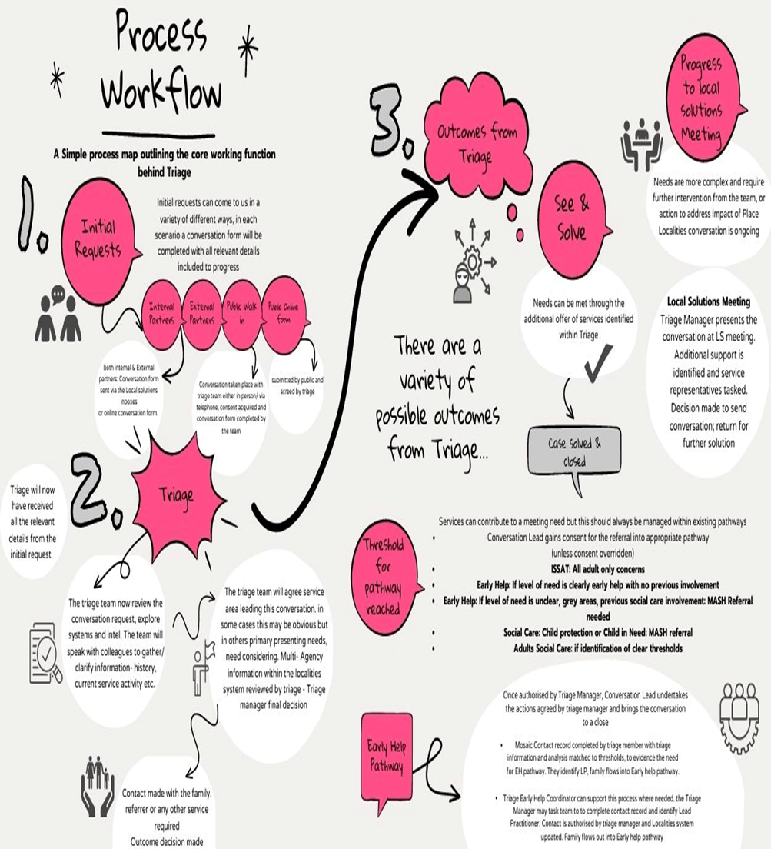

# When is it Early Help?

The Early Help is a way of working with children and their family; it is process that helps practitioners explore children and their family’s needs at an early stage; and then work with the child, their family and with other practitioners and agencies to meet these needs. More information about Early Help is available within the Working Together 2018; this is Government guidance that sets out clear what is expected from all professionals and organisations.

<https://assets.publishing.service.gov.uk/government/uploads/system/uploads/attachment_data/file/779401/Working_Together_to_Safeguard-Children.pdf>

Doncaster Early Help Strategy 2022-25 has been updated and due for launch Summer 2022. The strategy clearly sets out that it is the duty of anyone working with children and families to provide Early Help so that needs are met at the earliest opportunity, preventing escalation of need and enabling family and practitioners to work well together. The current Strategy sets out how organisations in Doncaster will work together to meet the needs of Children and their Families, it will be replaced by the new Strategy in Summer 2022.

<https://dscp.org.uk/sites/default/files/2020-09/Early%20Help%20Strategy%20Revised%202017%20to%202020%20Final.pdf>

Early Help is identified in the two central sections of the Continuum of Need image here and in **more detail on page 7** of this handbook. The blue Targeted Additional Needs section is level 2 Early Help; and the yellow Complex Multiple Needs is Level 3 Early Help Consent is always need for Early Help.

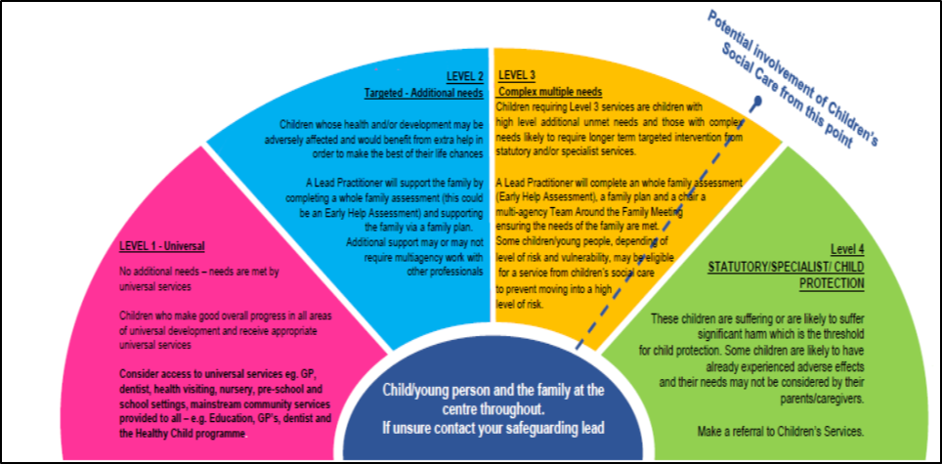

**Targeted Additional Needs (Level 2)**

Children and families with some emerging needs may require support of another service alongside universal provision to prevent an escalation of needs. An Early Help Assessment may be appropriate for some children at this level.

**Complex Multiple Needs (Level 3)**

Children and families with more significant complex need and who need targeted support without which they would not meet their expected potential. These children live in families where there is greater adversity and a greater degree of vulnerability. An Early Help Assessment and a Team around the Family (TAF) will be required to coordinate the response from multi-agency professionals and ensure effective communication with the child, family and all organisations involved.

## Examples of When to Consider Early Help

The situations a child and family may benefit from Early Help are wide ranging, the list below is not exhaustive:

* The child’s needs are unclear, or broader than your service can address alone.
* A significant change or worrying feature in a child’s appearance, demeanour, behaviour or health has been observed.
* A significant event in a child’s life has occurred, or where there are worries about the parents or home.
* Where a child, parent or another practitioner has raised a concern or requested help.
* Parental elements e.g. Parental Conflict, substance misuse, domestic violence, physical or mental health issues or criminality.
* Missing developmental milestones or making slower progress than expected in their learning.
* Health concerns including disability, physical or mental ill health, regularly missing medical appointments or a sudden change in the child’s health.
* Child presenting challenging or aggressive behaviours, misusing substances or committing offences.
* Child is undertaking caring responsibilities.
* Child is bereaved or experiencing family breakdown.
* Child is bullied or are bullies themselves.
* Disadvantage for reasons such as race, gender, sexuality, religious belief or disability.
* Homeless or being threatened with eviction and those living in temporary accommodation.
* Becoming a teenage mother / father or is the child of teenage parents.
* Not being ready to make the transition to post-16 services.
* Persistent absence from school or risk of permanent exclusion.

**Step Down to Early Help from Social Care**

Early Help can benefit families who no longer need help from Social Care because they have made good progress and no longer need a Social Worker but do need further assistance; or because following their statutory assessment has evidenced the need for Early Help. Families that need support following Social Care are ‘Stepped Down’ to Early Help.

When a child and their family have received Social Care intervention through Child In Need planning, readiness for step down to Early Help should be discussed at the Child In Need meeting and most appropriate Lead Practitioner agreed. Where the Child In Need group does not have suitable member to take on the Lead Practitioner role the Social Worker should seek step down to a suitable organisation.

Families First meetings are held during the Social Work assessment process to share information and identify if the family could step down to Early Help and to whom, these include practitioner already working with the child and family as well as Early Help Pathway Leads, Family Hub Managers and PAFS Managers.

**Other Situations or Signs Early Help Is Needed:**

**Stronger Families Outcomes Framework:**

Doncaster Stronger Families Outcomes Framework should be used to understand the needs a child and family have, the work undertaken to meet those needs and evidence change over time. Central Government calls this national approach the Supporting People Outcomes Framework; in Doncaster we have kept the name Stronger Families because practitioners and families are familiar with this; it is important to make clear this is the same national outcome framework. A practitioner should speak to the family about Early Help whenever they see a family is struggling to meet any of the 10 Stronger Family Outcomes. The Stronger Family Outcomes Framework provides a guide to families and practitioners about the signs a child and their family are doing well.

A Family should always be identified as a ‘Stronger Family’ when they have three or more of the ten outcomes they can’t reach without help. These needs should be explored through early help assessment which will enable the Lead Practitioner to identify which outcome subsections are met, this will focus the support plan on those specific needs. The Stronger Families Framework helps to focus family and Lead Practitioner on ‘what better looks like’ and the steps needed to get there. The four key principles of Stronger Families remain early intervention, whole family working, co-ordinated multi-agency working and measuring outcomes and data.

Plans are reviewed and as outcomes are met parents can see how they are now meeting their child’s needs; or what additional steps need adding to the plan to help them get there. The Lead Practitioner ensures evidence of positive change is added to the family’s case file within Mosaic.

The Stronger Families Outcomes Framework has been woven through the Mosaic case recoding system to support Lead Practitioners at every stage of the assess, plan, do, review early help cycle to identify outcomes and progress in meeting these. At the case closure stage it is important to review all the Stronger Family Outcomes identified throughout the help process to ensure progress has been made and evidence has been added to the case file. A good closure record should provides assurance that significant and sustained progress has been made for:

* All family members;
* All identified needs;
* Summarise what work happened with the family; and improvements made
* Quantify the needs and outcomes achieved with families
* Confirm that, in the practitioner’s and supervising manager’s judgement, the progress made is significant.
* Evidence linked to outcomes has been added to the casefile e.g. school attendance, police reports, DWP in work.

When a family is still able to meet their own needs for six months after help has ended additional funding is brought into Doncaster that enables other families to get the help they need too.

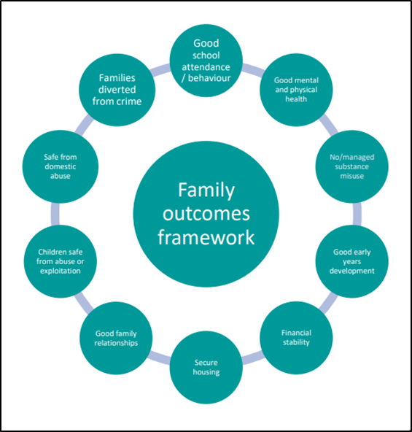

**Doncaster Graduated Approach:**

The Graduated Approach was rolled out in 2021; the approach supports practitioners to implement SEND Code of Practice (2015), to develop systems, skills and structures for responding to pupils needs across the four SEND areas of Cognition and Learning; Communication and Interaction; Physical and Sensory; and Social, Emotional and Mental Health.

The Graduated Approach works as a self-help guide for practitioners when exploring a child’s SEND needs and provides a reference point for deciding on the

most appropriate intervention level for pupils to support their learning. The approach can be used as an audit tool for individual children or across a whole setting to review implementation of the SEND Code of Practice (2015); it may identify gaps in provision or generate new ideas for working with individual children.

At the heart of the approach is partnership with the child, parents and carers to explore and meet holistic, whole family needs through Early Help; this enables the root causes of difficulties to be understood and addressed.

The Graduated Approach is embedded in Inclusion and SEND pathways with detailed information and toolkit available of Doncaster Council website.

<https://www.doncaster.gov.uk/services/schools/graduated-approach>

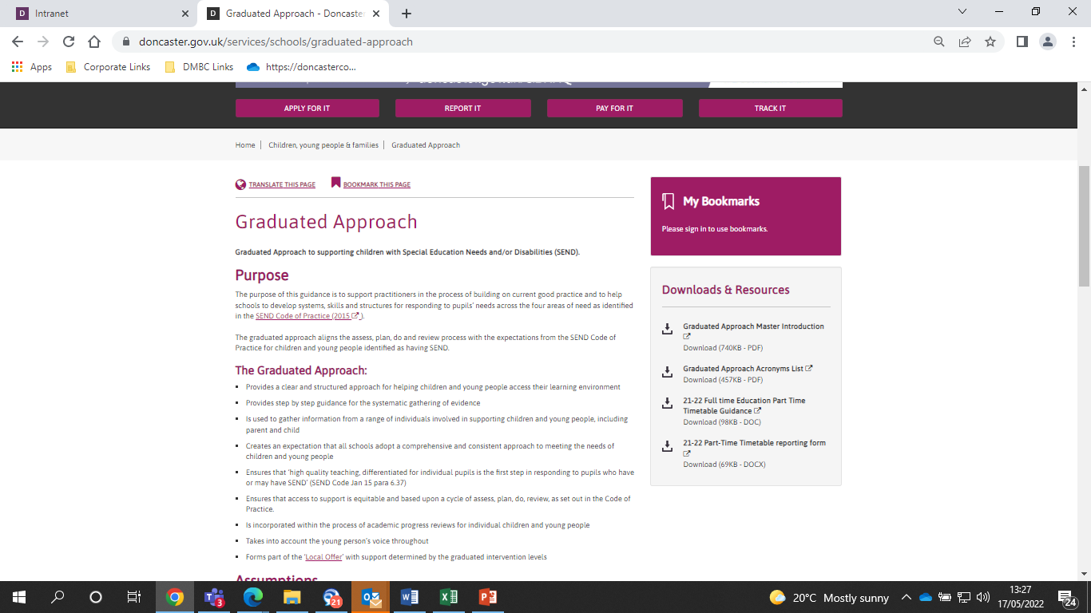

**Short Breaks for families with disabled children in Doncaster:**

Short Breaks funding enables children and young people with a disability or complex health need to access services and activities that will enhance their life experiences; whilst offering a break to families/carers. Short Breaks has a universal and a targeted offer. Children and their families requiring the targeted offer should have their holistic needs explored through Early Help Assessment.

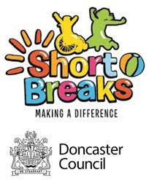

## Short Breaks Universal Local Offer:

Doncaster’s local offer provides information for children and young people with Special Educational Needs and Disabilities (SEND) and their parents or carers in a single place. Including leisure activities and transport support.

<https://www.doncaster.gov.uk/services/schools/local-offer-send>

To access the universal short breaks offer families must be registered with the Together Information Exchange (TIE). Doncaster's voluntary register of children and young people with a disability. The register is administrated by the short breaks team, which enables them to support families to access the local offer including holiday activities. TIE members receive:

* Access to the afterschool and weekend clubs funded by the short breaks service
* The holiday activity timetable run by the short breaks service which disabled children can book onto during the school holidays
* A free TIE membership card to receive discounts at various places including Yorkshire Wildlife Park, The Dome Leisure Centre, Vue Cinema and much more
* Regular information either through the post or via email alerts on events and holiday activities taking place

Families can apply directly themselves. Application forms to join TIE are available from the Short Breaks team by:

* Calling us on - 01302 735237 to request one
* Emailing us at - TIE@doncaster.gov.uk
* Message us through our Facebook page - www.facebook.com/Together-Information-Exchange

## Short Breaks Targeted Offer:

**Targeted support can be:**

* Daytime care in the homes of disabled children or elsewhere.
* Overnight care in the homes of disabled children or elsewhere
* Educational or leisure activities for disabled children outside their homes.
* Services available to assist carers in the evenings, at weekends and during the school holidays.

**Eligibility Criteria:**

* The child or young person will have special educational needs and/or disability regardless of whether the child is at SEN Support managed by the setting or has a Statement of SEN or an Education Health Care Plan issued by the Local Authority
* Children and young people whose need cannot be met by universal provision
* Family are in receipt of disability living allowance
* Needs of the whole family assessed by their named lead professional using the Early Help Assessment (EHA) or social care child and family assessment
* The EHA or Social Work Assessment identifies that the child or young person has high support needs and taking into account family context targeted short breaks are necessary to meet their needs

**Access:**

Prior to referral, you can contact the Short Breaks Team to discuss eligibility or clarify anything you are unsure about.

Once family consent has been gained, the ‘worried about a child form’ should be submitted to enable the family to be opened for Early Help and the actions taken recorded within Mosaic. The need for Short Breaks must be identified through a holistic and whole family assessment of need, either Early Help Assessment or Social Work Assessment. This is important as other needs may be identified at this stage. Once the needs for Short Breaks has been confirmed the Lead Practitioner completes the Short Break Referral form within Mosaic.

The referral will be reviewed and if considered to be appropriate, a Needs Based Assessment (NBA) will be completed by a Short Breaks Assessment Officer to assess levels of need within the household and potential funding required to meet this need. Where the family’s needs can be met solely through the provision of Short Break funding the Early Help case can be closed, as Short Breaks provision can now continue independently. It is important to seek advice from an Early Help Coordinator before closing the Early Help case in these circumstances. Where a family needs continued Early Help support alongside the Short Breaks provision it is important this continued and needs are reviewed alongside the child’s SEN/EHCP and Short Breaks review to ensure good multi agency working with the family.

**Contact:**

Call us on - 01302 737448 to request one

Emailing us at - [shortbreaksteam@doncaster.gov.uk](mailto:shortbreaksteam@doncaster.gov.uk)

**What if a Family Refuses Early Help?**

If parents and/or the child do not consent to Early Help, then the practitioner should make a judgement as to whether, without help, the needs of the child will escalate to a level likely to cause significant harm. If so, a referral to the Multi Agency Safeguarding Hub (MASH) should be made. It is important to review the DSCP Multi Agency Threshold and Continuum of Need document and appendix and contact your Early Help Coordinator for advice.

Keeping a chronology of worries that includes impact on the child along with your efforts to help the child and family can be useful in evidencing harm caused by neglect.

**Fraser Competancy:**

Gillick competency and Fraser guidelines help people who work with children to decide whether the child is mature enough to make decisions about things that affect them. The two terms originate from the same legal case in the 1980’s, the Fraser guidelines still apply to advice and treatment relating to contraception and sexual health; but Gillick competency is often used in a wider context to help assess whether a child has the maturity to make their own decisions and to understand the implications of those decisions.

There is no set of defined questions to assess Gillick competency. Professionals need to consider several things when assessing a child's capacity to consent, including:

* the child's age, maturity and mental capacity
* their understanding of the issue and what it involves - including advantages, disadvantages and potential long-term impact
* their understanding of the risks, implications and consequences that may arise from their decision
* how well they understand any advice or information they have been given
* their understanding of any alternative options, if available
* their ability to explain a rationale around their reasoning and decision making.

Consent is not valid if a young person is being pressured or influenced by someone else. Children's capacity to consent may be affected by different factors, for example stress, mental health conditions and the complexities of the decision they are making. The same child may be considered Gillick competent to make one decision but not competent to make a different decision.

## **Early Help and Local Solutions Pathway in Doncaster**

Professional worried about child / unmet need

**NOT safeguarding**

Early Help Coordinator support available through these stages

Level 2: EHA, Single Agency plan

Lead Professional identified and informed

LP accesses workflow for child on Mosaic and, building on information and analysis provided by Hub completes EHA within 30 working days.

Continue with universal services

Closure and impact assessment – needs met or escalation

L2: EHA Reviewed with parent/carer and child every 12 weeks

If things don’t improve case is stepped up to Level 3

Needs appear low level

Gain Consent and Complete Locality Triage Online Conversation form

TAF review minimum every 6 weeks to review plan

(Update FAC6_FORM)

L3: LP convenes TAF Review Meeting with appropriate professionals and family to review and coordinated plan. Meeting plan recorded on Mosaic

Referrer informed of outcome of enquiry

Level 3 or 4: Escalated to Children’s Social Care

Progress for Early Help

Complete on line referral form and consent form with family **CONSENT FORM to be emailed same day**

Locality Triage ‘See and Solve’

Needs unclear or already reached level 2 or 3

Link new information to existing workflow

Level 3: multi-agency EHA and plan

Screened by a Manager,

Respond with outcomes within 48 hours

## The Roles of a Lead Practitioner

* Act as a single point of contact for the family, a professional.
* Undertake the holistic, whole family Early Help Assessment
* To ensure Child’s voice is gathered, even if this is undertaken by another practitioner
* Ensure the Stronger Families Outcomes Framework is followed
* Co-ordinate the delivery of actions agreed in the Assessment Plan
* Lead Team Around the Family Review meetings and ensure that the package of support is regularly reviewed and monitored and MOSAIC is updated.
* Reduce any overlap and inconsistency in the services received
* Ensure all Early Help is recorded into MOSAIC.
* Support the child and family to ensure that a careful ‘handover’ takes place if it becomes more appropriate for someone else to be the lead practitioner.

The Doncaster Early Help Video explains the Lead Practitioner role and how this helps children and their family:



# <https://www.youtube.com/watch?v=I4FVGL5zOBg>

The Early Help Coordinator team deliver a range of training that supports practitioners to develop skills, knowledge and confidence in being the Lead Practitioner and providing Early Help; plus bespoke support to the Lead Practitioner throughout the Early Help process. See page 29 of this handbook for details.

How to Undertake an Early Help Assessment:

A family’s Early Help journey starts with a conversation; they may approach you for help or you may notice they need help and approach them. It can feel daunting for everyone when talking about worries, it is important to positive and welcoming, as well as factual, open and honest.

Once a family agree to Early Help their signed consent should be gained and submitted to MASH along with the ‘Worried About a Child form’. Signed consent means a family is happy for you to contact other organisations to share information and for that information to be recorded within Mosaic.

If MASH identify you as the most suitable person to be Lead Practitioner you will need to undertake the Early Help Assessment with the family. The Early Help Coordinator team deliver a range of training that supports practitioners to develop skills, knowledge and confidence in being the Lead Practitioner and providing Early Help.

The Early Help Assessment is a process of gathering information and analysing this to understand what needs to happen next and inform the support plan. Information is gathered from the child; their parents or carers; and practitioners who already know the family, such as childminder, Nursery, School, GP, Midwife, Health Visitor, School Nurse, Voluntary Organisations, Doncaster Council and Doncaster Children’s Services Trust.

An agreed process to ensure GPs are informed when children are supported by Early Help Assessment and Team around the Child/Family meetings. It is the responsibility of the lead professional to:

* Gain written consent
* Send the letter to the GP informing them of your involvement
* Record the receipt from the GP in case records

A copy of the template GP letter is available in the appendices of this document (page 36) or on the DSCP website alongside the full procedures: <https://dscp.org.uk/professionals/policies-and-procedures>

Your Early Help Assessment should:

* Use ‘user friendly’ language avoiding professional jargon and acronyms
* Your assessment should be balanced - if there is no problem in an area of the child and family’s life record what is going well.
* Focus on strengths as well as needs
* Include the fathers of all children and unborn children, unless this would put the child at significant risk of harm. When sharing information across separated families it may be necessary to redact information to comply with Data Protection legislation.
* Agree the plan with the family.
* Be given to the family once this has been completed.

## A Good Assessment Conversation Should:

Use the Assessment framework to ensure the holistic needs of the child and family are explored.

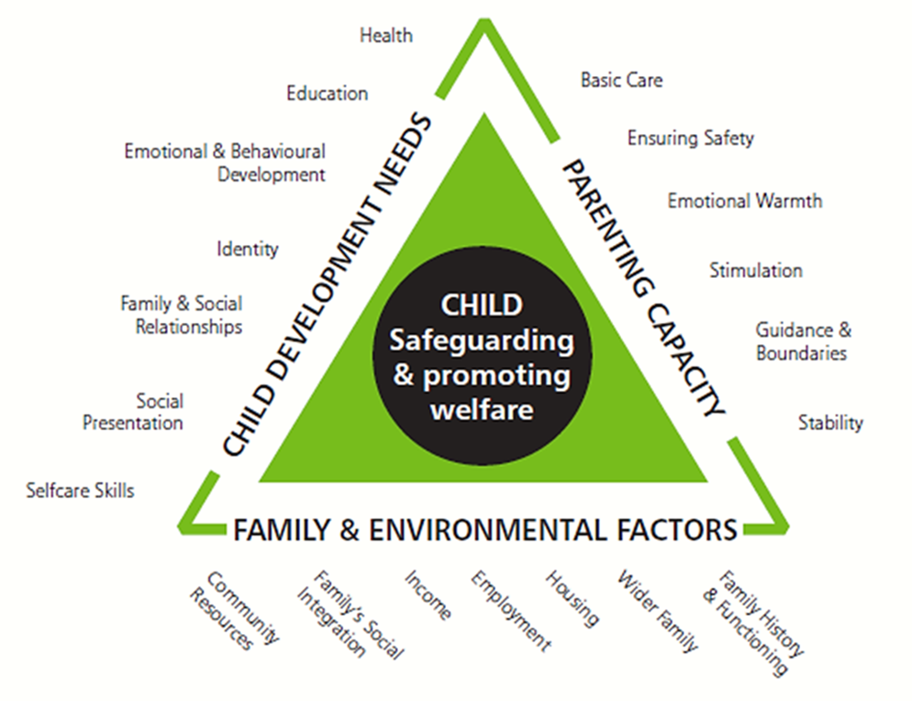

Be a relaxed informal conversation, not a series of questions or a ‘grilling’

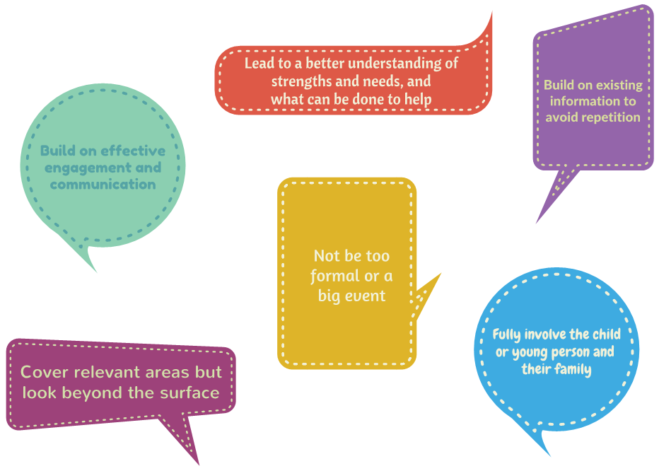

## Using Approaches, Tools or Resources to Explore the Child and Family Needs:

‘Tools’ mean the resources and activities used when talking to a child or their family to gain their voice; exploring the current situation and past events; their thoughts and feelings about this; plus the impact on them. Tools can make it easier to reflect and talk; they help everyone to ‘go a bit deeper’ than their initial responses.

**Signs of Safety:**

In Doncaster we use the Signs of Safety approach which is embedded throughout all Mosaic Early Help forms. The approach uses practical tools to ensure the voice of the child is clearly heard; such as 3 Houses (House of Worries; House of Good Things and House of Dreams); and Fairy and Wizard. Words and Pictures is a tool used with parents to help them to tell the story of the family situation to their child through a few pictures; it helps parents to understand and accept the impact of the situation on their child and generates motivation for change.

Signs of Safety is one of several Strengths based approaches to working with people; “*Strengths-based practice is a collaborative process between the person supported by services and those supporting them, allowing them to work together to determine an outcome that draws on the person’s strengths and assets.”* <https://www.scie.org.uk/strengths-based-approaches/guidance>

Strengths based approaches do not ignore worries, but openly and honestly talk about these needs in clear, simple language; then uses the strengths identified to work collaboratively to meet these needs.

There are a huge variety of tools available to practitioners, it is important to use ‘evidence-based’ tools because they have been researched and proven to be effective. It is important to use the right tool for the person or situation.

## Outcome Star

The Outcome Star Family Star Plus and MyStar are embedded within the Early Help Assessment, Review and Closure forms within Mosaic to make them easy record. Work continues to add the Carer Star and Relationship Star to Mosaic. The Outcomes Star is a unique tool for supporting and measuring change when working with families. The practitioner and family use the ‘Outcome Star’ tool together to explore and measure their level of functioning over a range of areas of need; these are the Early Help Assessment areas. These scores inform the Early Help Plan. The Outcome Star ‘Family Star Plus’ tool is embedded within the Early Hep Assessment and Plan; Team Around the Child/Family record; and Closure form. The ‘My Star’ captures the voice of the child by exploring their lived experiences; needs; and wishes. The Outcome Star is reviewed with family and child every three months this helps keep everyone focused on the changes needed; generates motivation and resilience; and enables the family and practitioner to track progress. The stars build over each other to map progress made.

Outcome Star training is booked through [www.buydoncaster.co.uk](http://www.buydoncaster.co.uk)

**Neglect and Graded Care Profile 2 (GCP2):**

Neglect occurs when a child’s basic care needs are not met, this could be physical, medical, educational and emotional. Neglect can be caused by a one-off event but is more likely to be chronic, poor care-giving over time; this means the Early Help process should be used to identify and address the root causes of the neglect as needs first emerge.

Doncaster uses the NSPCC tool, Graded Care Profile 2 (GCP2) measures the quality of care being given to children. The GCP2 identifies what areas of a child’s needs are being neglected and to what extent; this ensures the support plan meets needs. The GCP2 tool promotes a constructive working relationship with families. The GCP2 should be reviewed periodically to ensure progress is being made.

Training about Neglect at an Early Help threshold; and Graded Care Profile 2 is available through [www.buydoncaster.co.uk](http://www.buydoncaster.co.uk). The new DSCP Neglect Strategy is available on the Doncaster Children’s Safeguarding Board website at <https://dscp.org.uk/professionals/neglect>.

**Good Early Help Case Management:**

**Timeframes**

Research evidences for Early Help to be effective it has to be timely, when problems first emerge (Department for Education 2018; Early Intervention Foundation 2021). This means practitioners need to offer early help as soon as they notice a child and family needs help; and that they should make sure the Early Help they provide happens in a timely manner by adhering to agreed timeframes:

Once the Lead Practitioner has been identified they should:

* Complete the Early Help Assessment within 30 days
* Hold the initial Team round the Family review meeting within a further 30 days
* Hold regular Team Around the Family Review meetings, about every 6 weeks.

When a child and family’s needs have been assessed and identified at Level 2 and are they are supported by a single agency only, Team Around the Family meetings are not required; however it is important their support plan is reviewed after 12 weeks to ensure progress is being made. If the situation is not improving then the family should be escalated to Level 3 with 6 weekly Team Around the Family Review meetings.

Every Team Around the Family Review meeting or Early Help Assessment Review should have input from all practitioners and include the voice of the child and family.

It is good practice for a child to attend their Team Around the Family Review meetings but there are situations when this is not appropriate, in these situations the Lead Practitioner should meet with the child separately to explore their views and present them at the meeting on the child’s behalf.

**Childs Voice**

Child’s voice must be explored and understood at every stage of the Early Help process, it should be clear within the assessment, plan, review and closure forms; also within any direct work undertaken with a child. Tools are useful in gaining child’s voice, see page 23 and 24 of this document.

The child’s voice should be relevant to the situation, exploring their lived experience, thoughts and feelings. Observations of a child can contribute to their voice as this describes their reactions and can evidence impact of a situation on them. When a child is pre-verbal or non-verbal observations are essential in gaining their voice.

Direct work can be undertaken to explore or review a child’s needs; this could be planned activity sessions, incident management, or ‘meet and greet check-in’ conversations’. Direct Work should be recorded within Mosaic using the Direct Work forms.

**Whole Family Working**

Early Help is never just for a child, but their whole family. **Whatever difficulties a child may have it is essential their parent or carer and siblings needs are understood too; this is because a child is part of the family group**. Whatever affects one member of a family group will affect all members. Understanding and addressing the whole family’s needs will ensure the root causes of the need are addressed and not just the presenting issues, bringing about long term change.

If the Lead Practitioner doesn’t know the sibling of a child they should ensure the Team Around the Family includes a practitioner that does know that child.

Parents may have difficulties that are outside of the Lead Practitioner’s experience or require specialist input. It is important that the right help is given, with consent referrals should be made into specialist services; Early Help Coordinators provide guidance about this.

The family should be at the heart of the Team Around the Family Review meetings. The meeting should be planned carefully, and the lead practitioner should consider who and how many people should be at the meeting. Some families will be comfortable with bigger groups and some may find the presence of a large number of practitioners threatening or undermining; respond to parental preferences for date, time and venue of the meeting, they may also wish to be supported by family or friends.

In some instances you may need to hold separate Team Around the Family Review meetings for parents whose relationship has broken down, taking into consideration information sharing and Data Protection, contextualised separate minutes for all parties.

If a practitioner cannot attend a meeting it is essential to request an update and current information. Find out what assessment or update information they have and what support they have provided or can offer the family; this should be shared at the meeting by the Lead Practitioner and recorded in minutes.

Members of the Team Around the Family (TAF) take joint responsibility to develop and deliver a package of solution focused support to meet the needs identified through the Early Help Assessment using a whole family approach. **Each TAF member is responsible for and accountable to their home agency for the services they deliver to children and their families.** TAF members should:

* Deliver the service or activities they agreed to carry out in the plan
* Keep the other members of the team informed about progress in their area of responsibility, providing reports promptly and attending meetings
* Contribute to recording the child’s plan, chairing meetings and taking on other tasks as necessary
* Support the lead practitioner by providing information, offering guidance and advice
* Contribute actively and positively to solving problems or resolving difficulties
* Ensure that if the child is not present, the meeting remains child focused and their views are included.

**Case Supervision:**

It is important that everyone involved in the Early Help support given to children and their family, especially Lead Practitioners, receive good quality cases supervision. There is no single definition for Supervision, it is generally agreed to be a process of learning and development; oversight; and support to enable the supervisee provide the best care for the child and family. Supervision can be peer to peer, with a more experienced colleague or manager.

Doncaster supports use of the 4x4x4 model of supervision by Morrison, 2005. The model covers the support, management, mediation and development functions of supervision whilst enabling the supervise to move through the learning cycle (Kolb 1984).

* Personal support (support function)
* Competent, accountable practice (management function)
* Engaging the individual with the organisation (mediation function)
* Continuing professional development (development function)

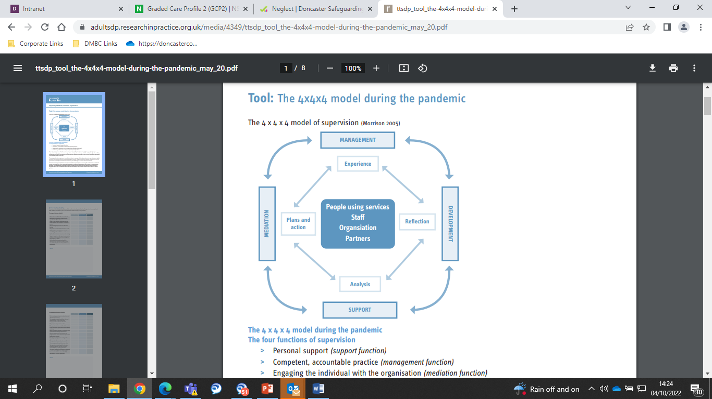

It is important that all managers of workers who undertake the Lead Practitioner role ensure their staff receive case supervision. Supervision for Early Help training is available from the Early Help Coordinator team, bookable via BuyDoncaster: <https://buy.doncaster.gov.uk/training>.

## Ready to Close

Early Help may no longer be required for a number of reasons, including:

* All identified needs met
* Family has requested closure or withdrawn consent
* The family moved out the area
* The family’s needs have escalated and Children’s Social Care are now involved

If it is agreed during the Early Help Review meeting that all needs have been met the Lead Practitioner will begin the Closure process with the family and record this within the Closure form in Mosaic. The same process should be undertaken when the family request closure or move out of the Doncaster area. If a family would like Early Help to continue in their new area their consent should be gained to share the Early Help information with services in their new home area. If the family step up into Social Care only the closure forms are completed.

**Outcome Star:** Update the Outcome Stars with Child and Parents/Carers to provide information about the areas of progress at point of closure.

If other tools such as the Graded Care Profile 2 has been used they should be reviewed.

**Reason for closure**: Record all factors relating to the decision to close the Team Around the Family.

**Effectiveness of plan:** Summarise the help undertaken with the family and the outcomes. **It is important to review all the Stronger Families Outcomes** identified during the episode of Early Help to ensure **significant progress** has been made and **evidence of this is within the Mosaic case record**.

**Child’s views**: Record comments made by the child and observations of them to inform about the readiness for closure. It is essential the child’s views are explored, understood and recorded in the closure form; this can be verbally expressed or observations made my lead practitioner about the child’s experiences and interactions, identifying any progress made, barriers experienced, current needs and wishes.

**Parents’ views:** Record the comments made by parents. If they have explicitly requested closure or withdrawn consent this should be clearly stated, together with any reasons given. Identify their understanding of their child’s needs, any progress made, barriers experienced and their current needs and wishes.

**Professionals’ views:** What work has been undertaken, what has been successful and what is the impact for the child and family? What were the barriers, how successfully where they overcome, what is the readiness for closure; and what are the current needs of the family?

**Case Closure Questionnaire;** What are families views on support they have received, do they feel support was appropriate, do they feel they were included in process, has positive changes been made, do they feel anything could be done differently.

Closures of all cases will be sent to the Mosaic Early Help Closures tray. Managers of internal Doncaster Council teams will authorise their staff closures. Partnership closures will be authorised by the Early Help Coordinators

# Early Help Infrastructure and Support

## Multi Agency Safeguarding Hub (MASH)

Doncaster Multi Agency Safeguarding Hub (MASH) is a multi-disciplinary team exploring both the Early Help and Social Care needs of children and their families. MASH functions are:

1. Providing information, advice and guidance to professionals who have queries about children who made need a coordinated early help response or social care intervention.
2. Progressing all ‘Worried about a Child’ referral forms to ensure an appropriate level of response for the child and family.

The MASH receiving manager will screen all referrals, those initially presenting with Early Help needs are screened by Early Help colleagues and those presenting initially with Social Care needs are screened by Social Work colleagues; screening informs the outcome of the referral:

* If an EHA has already been completed or there is an existing TAF, you will be asked to share your information and join the TAF
* Level 1 Your Family Triage and Local Solution required
* Level 2 Early Help required and Lead Practitioner identified
* Level 3 Early Help required and Lead Practitioner identified
* Level 3 or 4 Children’s Social Care is required.

The team is available from 8.30am to 5.00pm, Monday to Friday, and telephone messages will be responded to within one working day:

MASH Early Help

Telephone: 01302 734110

Email: [earlyhelphub@doncaster.gov.uk](mailto:earlyhelphub@doncaster.gov.uk)

If at any stage you have any concerns that a child is at risk of harm you must follow your agency’s safeguarding procedure and make a referral to MASH using the phone number below and follow this up by completing an online ‘Worried About a Child’ referral form the same day.

MASH Social Care

Telephone: 01302 737777 (available 8:30am – 5pm Monday to Friday)

Professionals Only Telephone: 01302 737033 (as above)

Telephone: 01302 796000 (outside office hours)

Email: [ChildrenAssessmentService@dcstrust.co.uk](mailto:ChildrenAssessmentService@dcstrust.co.uk)

## Early Help Step Up to Social Care

If a child is at risk of significant harm (Section 47 of 1989 Children’s Act) an urgent referral into Multi Agency Safeguarding Hub (MASH) should be made; consent can be by-passed if seeking consent would put the child at risk of further harm. The first step is to make a telephone referral into MASH, then follow this up with the online referral the same day, see above page for contact details.

When a family’s needs not able to be met through Early Help and reach the threshold for Child In Need is met (Section 17 of 1989 Children’s Act) it is necessary for the family to Step Up into Children’s Social Care. Consent is required.

* The Lead Practitioner should contact their locality Early help Coordinator to map the case and review threshold.
* If the Early Help Coordinator agrees the Step Up to Social Care is needed they will contact the Social Care Assessment team manager to discuss the case.
* Once the Social Care Assessment team manager agrees the family require Social Care the Lead Practitioner updates the Early Help Review form and Step Up is authorised.

If a child does not reach threshold for Children’s Social Care the Early Help Coordinator will provide help and guidance to the Lead Practitioner.

Early Help cases should not be closed until they have fully progressed for assessment by Children’s Social Care.

## Early Help Pathway Leads

Early Help Pathway Leads manage the Early Help Coordinator (EHC) and Family Lead Practitioner (FLP) teams within each locality. Early Help Pathway Leads oversee Early Help delivered by external partners to ensure this is safe and effective; and compliant with the Early Help strategy; and that Early Help is embedded within Inclusion, Special Educational Needs and Social Emotional and Mental Health panels and service delivery.

Early Help Pathway Leads review and allocate cases to Family Lead Practitioners and alongside the Early Help Coordinators provide case management and supervision to ensure quality service delivery.

Early Help Pathway Leads represent Early Help along with other services within Families First meetings. These meetings ensure children and families undergoing Social Care assessment are ready to step down into Early Help if this is what has been identified. Together with the family the assessing Social Worker, Early Help Pathway Leads and other partners identify what help is needed and who is best to lead on this.

**North:** Jackie Ward [jacqueline.ward@doncaster.gov.uk](mailto:jacqueline.ward@doncaster.gov.uk)

**East:** Jo Sherriff [joanne.sherriff@doncaster.gov.uk](mailto:joanne.sherriff@doncaster.gov.uk)

**South:** Cheryl Duffield [cheryl.duffield@doncaster.gov.uk](mailto:cheryl.duffield@doncaster.gov.uk)

**Central:** Ruth Parkes [ruth.parkes@doncaster.gov.uk](mailto:ruth.parkes@doncaster.gov.uk)

## Locality based Early Help Coordinators

Each locality has two Early Help Coordinators, their role is to provide support and guidance with any aspect of early help to partnership Lead Practitioners and to champion Early Help. Early Help Coordinators use their significant experience to develop the skills, knowledge and confidence of practitioners from any background. This is undertaken through a range of activities:

* Supporting professionals taking on the role of Lead Practitioner with Early Help Assessments, developing plans, holding Team Around the Family meetings and engaging families with help.
* Case mapping and thresholds guidance.
* Case oversight and tracking to ensure progress in made.
* Case Audits and post audit support.
* Writing and delivering a suit of Early Help training: Role of the Lead Practitioner, Introduction to Early Help, Early Help for the Experienced Worker, Assessments, Managing Engagement, Supervision for Early Help; and in partnership with PAFS Neglect and Early Help.
* Delivering evidence based training Outcome Star, Reducing Parental Conflict and Reducing Parental Conflict for Separated Parents.
* MASH case screening and allocation.
* Your Family Locality Triage ‘see and solve’ and case screening and identification of Lead Practitioner; and Local Solution Group activity.

The Early Help Coordinator training offer is regularly updated. The team currently deliver or support delivery of the following courses, booking is via the Buy Doncaster website: <https://buy.doncaster.gov.uk/training>

To register with Buy Doncaster contact: BuyDoncaster@doncaster.gov.uk

* Introduction to Early Help
* Early Help for the Experienced Practitioner
* Role of the Lead Practitioner
* Early Help Assessment (Signs of Safety)
* Outcomes, Plans and Closures
* Managing Engagement
* Supervision for Early Help
* Neglect and Early Help
* Parental Conflict
* Outcome Star

## Your Early Help Coordinator Team

**North:**   
Natasha Watts: [Natasha.Watts@doncaster.gov.uk](mailto:Natasha.Watts@doncaster.gov.uk)

Julie Magee: [Julie.Magee@doncaster.gov.uk](mailto:Julie.Magee@doncaster.gov.uk)

Your Family Triage: Joanne Nelson [Joanne.Nelson@doncaster.gov.uk](mailto:Joanne.Nelson@doncaster.gov.uk)

**East:**

Toni Tomlinson (07773227893) [Toni.Tomlinson@doncaster.gov.uk](mailto:Toni.Tomlinson@doncaster.gov.uk)

Stephanie Armstrong [Stephanie.Armstrong@doncaster.gov.uk](mailto:Stephanie.Armstrong@doncaster.gov.uk)

Your Family Triage: Rebecca Holmes/ Jody Holland

[Rebecca.Holmes@doncaster.gov.uk](mailto:Rebecca.Holmes@doncaster.gov.uk); [Jody.Holland@doncaster.gov.uk](mailto:Jody.Holland@doncaster.gov.uk)

**South:**   
Sarah Taylor (07971121710) Sarah.Taylor@doncaster.gov.uk

Gemma Sneddon: [Gemma.Sneddon@doncaster.gov.uk](mailto:Gemma.Sneddon@doncaster.gov.uk)

Your Family Triage: David Hamilton (07776454318) [David.Hamilton@doncaster.gov.uk](mailto:David.Hamilton@doncaster.gov.uk)

**Central:**

Paula Holland (07970967647) [Paula.Holland@doncaster.gov.uk](mailto:Paula.Holland@doncaster.gov.uk)

Lindsey Swain (07717320478) [Lindsey.Swain@doncaster.gov.uk](mailto:Lindsey.Swain@doncaster.gov.uk)

AP Taskforce: Liza Justice (07971944803) liza.justice@doncaster.gov.uk

Your Family Triage: Christian Brownless (07810 153 716) [Christian.Brownless@doncaster.gov.uk](mailto:Christian.Brownless@doncaster.gov.uk)

**Early Help Coordinator Duty phone and email lines:**

Telephone: 01302 736250 Email: [EarlyHCo@doncaster.gov.uk](mailto:EarlyHCo@doncaster.gov.uk)

Lead practitioner support sessions take place across the four areas weekly in a range of venues. To book on, please contact your Early Help Coordinator on the above numbers.

## Early Help Online Case Recording System: MOSAIC

All Early Help support will be captured and coordinated through the online case management system, known as MOSAIC.

If you need access to MOSAIC and/or training to use the system, contact the DIPs Support Team

Telephone: 01302 736036

Email: [DIPSSupport@doncaster.gov.uk](mailto:DIPSSupport@doncaster.gov.uk)

# **Early Help Frequently Asked Questions**

**If I do an early help assessment, do I have to be lead practitioner?**

You will be the lead practitioner until the first meeting, and then discussion should take place with the child and family as to who is best placed to take this role on an on-going basis. There is a range of criteria that can help inform the decision, based on the predominant needs of the child or family; the wishes of the child or family; or a previous or potential on-going relationship with the child. The other professionals will have an important contribution to make in delivering their agreed actions, the Early Help Assessment is a multi-agency approach.

**Can I fill in an early help assessment and share it with the family later?**

No. The early help assessment should always be undertaken with the child and family.

**What support can I get in undertaking early help or when things get stuck?**

The Early Help Coordinators are there to champion all aspects of early help across all agencies and services. For support, advice and guidance contact Early Help Coordinator Duty phone and email line, and if your query cannot be answered you will be directed to the EHC for your locality for further support.

**What do I do if a family won’t agree to the process?**

Continue to support the child and family from within your own agency, and continue to discuss the benefits of accessing support the Early Help way of working. Assess the risk to the child, and if you believe there is risk of significant harm, make a referral into MASH.

**Can a child under 16 consent to Early Help without their parents’ agreement?**

Yes, if you judge them to be competent and believe they understand what they are agreeing to and the implications for them and/or their family. This does not extend to all information they might share about adults.

**Can record early help without using Mosaic?**

No. All Lead Practitioners will be supported with access to the electronic case management system Mosaic. All Early Help activity must be recorded within Mosaic because this is important information that may be needed to make the right decision about what help to give a child and their family in the future. The Early Help Coordinator team will support you to access Mosaic.

**How long does the Early Help process last for?**

There is no limit on the length of time a child and family receive Early help. The key principle is that the process should support the child to meet their needs and achieve their potential. As long as the process is reviewed regularly and appropriate services are being provided then this can continue indefinitely until the child reaches 18 years of age. Professionals within the TAF need to assess the impact of the support to the family and come to a view whether the actions being taken are having a positive impact on the child. This should inform decisions whether the risks are at a level which may require statutory social care intervention, or can step down to universal service. Decisions should always be taken in the interests of individual children.

**Is the lead practitioner responsible for delivery of services?**

No. Each professional remains accountable for their practice. If a service is agreed but isn’t delivered then the agency that agreed to provide the service is accountable. The lead practitioner is responsible for coordination, not delivery of another service, but should take responsibility for raising concerns with their own line manager and the Early Help Coordinator team in such circumstances.

**What are my organisations responsibilities for help my undertake Early help and providing supervision**

Organisational managers with responsibility for staff providing Early Help, such as Schools Designated Safeguarding Leads must have access to Mosaic, the case management system and a virtual tray will be allocated to you (please speak to your Locality EHPL). This will allow you to allocate cases to relevant named LP's and ensure you have management oversight of all open cases and are able to provide case supervision.

**How can I access early help Training**

All early Help Training is available on the buy Doncaster site. To access training register and enrol on relevant course.

<http://buy.doncaster.gov.uk/Search/introduction%20to%20early%20help>

# **Appendices: forms**

## Early help for your family

A family friendly guide to early help with privacy statement and consent form





## **Reviewed Consent Form**

**Consent Statement**

Single Agency support and The Early Help Assessment and TAF is a voluntary process and consent from the Child, Young Person and Family is required before the information in this assessment is shared outside of your agency.

|  |  |  |
| --- | --- | --- |
| **Doncaster Safeguarding Children Board**  **Children and Young People’s Services**  **Family Consent Record** | | |
| Informed consent for:  Parent/Carer  Parent Carer  Child/young person  Child/Young person |  | |
| Consent Dates |  | |
| Privacy Notice Issued? *(If no, please action this as soon as possible)* |  | |
| Consent Decision | Child can make his/her own decisions and has  agreed to the single agency support or an Early Help Assessment  One Parent has agreed to single agency support or to the Early Help Assessment  Both parents have agreed to single agency support or the Early Help Assessment  Child & Parents have agreed to single agency support or to the Early Help Assessment  Parent (s) have agreed to single agency support but NOT agreed to the Early Help Assessment  Neither child nor parents have agreed to the Early  Help Assessment. | |
| *If proceeding with enquiry without consent please specify the reason for this* | This is mandatory to be completed if consent not sought | |
| Related Person(s) deciding on the consent | | |
|  | | |
| Other Person(s) Deciding on Consent | | |
|  | | |
| Further Details |  | |
| **Consent Restrictions** | | |
| Consent given for ALL departments and user | Yes  No | |
| **Comments** |  | |
| **Signatures of Consent**  **I agree to single agency support or to an Early Help Assessment taking place.**  **I understand that the information that is relevant for my child’s / my needs will be recorded and securely stored as a paper or electronic file.**  **I agree that information can be shared with other professionals in order to help provide and co-ordinate support to my family.** | | |
| **Name:**  Parent / Carer / Child / YP | |  |
| **Signed:**  Parent / Carer / Child / YP | |  |
| **Name:**  Practitioner | |  |
| **Signed:**  Practitioner | |  |
| **Date:** | |  |

## GP Template Letter



**Senders own address (please complete)**

Date:

Dear,

I would like to inform you that [**name of child]** and **[DOB]** is now subject to an Early Help Assessment, (EHA). This assessment was completed on date and the family are now supported at Team Around the Child process (TAC).

I am the lead professional for the family and would appreciate your acknowledgement of this letter by signing the declaration at the bottom and posting it back to me please at the above address. If you have any information that you feel may be relevant for me to know, please indicate below and I will make contact with you.

I have attached a copy of the signed consent for your records.

Yours sincerely

**[Name]**

**[Signature]**

**[Title]**

---------------------------------------------------------------------------------------------------------------------

This is a declaration of any information to be shared is to be returned to the above address.

I (Name of GP) declare that I have received this letter in acknowledgement of the above named child and have shared relevant information.

I do / do not hold relevant information in respect to this child or family at this time.

Please contact the GP for all relevant information sharing

Telephone: ………………………………………………………………………………………………………

Email: ……………………………………………………………………………………………………

## Local Solution Group Referral Form

**Initial Conversation**

|  |  |  |
| --- | --- | --- |
| Name:  Gender: |  | Contact number: |
|  |  |  |
| Address: | | |
|  |  |  |
| Nationality and Ethnicity:  Communication needs: |  | Disability: |
|  |  |  |
| Members of your Family: | | |
|  |  |  |
| What are you Worried About? | | |
|  |  |  |
| What is Working Well? | | |
|  |  |  |
| What do you need right now to make things better?  **Does anyone in the household have COVID symptoms Y/N**  **Has anyone in the household tested positive of COVID and is still self-isolating Y/N**  **Has anyone in the household had a COVID test and is waiting for results? Y/N** | | |
|  |  |  |
|  |  |  |
|  |  |  |
| |  |  |  |  |  | | --- | --- | --- | --- | --- | | Identified need | Family Plan | | | | | Self: What can I do? | Family: What can my family/ friends do? | Community: How can my community support me? | Service: How do I think services can help me? | |  |  |  |  |  | | | |
|  |  |  |

**Privacy Notice: What we will do with your data**

The information we will be asking you to provide will be used to help us to understand how we can support you and your family. In order to provide you with the most appropriate services(s) we may need to share your information or gain further information from other agencies as required.

We will not re-use your information unless the law allows us to or unless you give us further permission for the re-use of your information. All information supplied will be stored securely in accordance with General Data Protection Regulation. If you have any questions about the collection of your information or if you wish to ask about what rights you have or wish to complain about the use of your information, please visit <https://www.doncasterchildrenstrust.co.uk/privacy-policy>

**Family Consent Statement**

I have read and understood the Privacy Notice in full (found here <https://www.doncasterchildrenstrust.co.uk/privacy-policy> or I read a printed copy) and agree that information about my family can be shared and discussed at the Local Solution Group and other agencies as required to help find me support. I understand that my information will be stored securely in accordance with the General Data Protection Regulation.

|  |
| --- |
| Please specify any organisation, department or people who information **cannot** be shared with: |

**Informed Consent given for:**

|  |  |  |  |
| --- | --- | --- | --- |
|  | Name | Signature | Date |
| Adult (1) |  |  |  |
| Adult (2) |  |  |  |
| Child/Young Person |  |  |  |
| Child/Young Person |  |  |  |
| Child/Young Person |  |  |  |

Please confirm that family members have been made aware of the request for additional support, that they have been informed of the next steps and that they will be seen by an identified professional if needed to complete and develop a Family Plan

|  |  |  |  |  |
| --- | --- | --- | --- | --- |
| Referrer Name: | Referrer Contact Details and those of colleague substitute | Referrer Role and Organisation | Referrer Signature | Date |
|  |  |  |  |  |