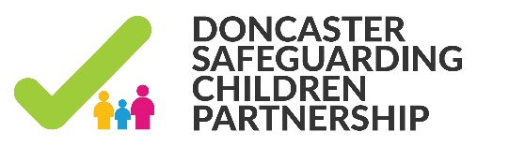
Practice Briefing:
Learning Points from a multi-agency audit into child sexual abuse.

A recent audit of cases relating to child sexual abuse identified two key learning points.
- There is a lack of awareness regarding the role of the Sexual Assault Referral Centre.
The SARC for children and young people in South Yorkshire is located within the Sheffield Children’s Hospital. The SARC will carry out a full forensic examination if a child/young person has been a victim of sexual assault. However this is not the only service provided by SARC; other core services include medical examinations; one-to-one counselling; screening for sexually transmitted infections and HIV counselling; prescription of post-assault contraception and pregnancy testing. Therefore even if a practitioner believes the time delay in a particular case means that forensic evidence may have been lost there are still a number of benefits to taking a child/young person to the SARC in terms of their sexual health and emotional well-being. The SARC strongly recommends that young people who have been sexually assaulted or raped access a full STI test. They offer an STI screen at the time of the examination, where appropriate. The child/young person may also be referred to A CISVA (children's independent sexual violence advisor) who will support them prior to and during a court case. A CISVA can also help to access services such as counselling. With consent nursing staff can let the child/young person’s school nurse/mentor or a teacher know about the visit. Specialist doctors will discuss the incident with the police, while the child/young person is looked after by the nursing team.
- The difference between burden of proof in civil and criminal proceedings is not always fully understood
‘The balance of probabilities’ is the standard of proof used in all civil court proceedings, so includes care proceedings. The other standard of proof used is the one in criminal cases which is ‘beyond a reasonable doubt’ or that the jury must be ‘sure’ a crime was committed, which is a higher standard due to the very serious consequences that can follow a criminal conviction, such as loss of liberty. If a criminal trial takes place and the person is found “not guilty” then this does not necessarily mean that the offence did not take place. Instead it means that the prosecution has failed to prove their allegations “beyond all reasonable doubt.” A person being found not guilty of an alleged offence should not be used as a reason to close a case as it is always possible that the offence has still been committed. Sexual offences in particular can be difficult to prove sufficiently to meet the criminal threshold. Prior to closing any case a full risk assessment should be undertaken and if concerns still exist the case should not be closed as this is likely to put any children in contact with the offender at risk of further abuse.
The South Yorkshire SARC provides a confidential 24/7 service to men, women and children over 16 living in South Yorkshire who have experienced rape or sexual assault, whether this has happened recently or in the past. Contact them on 0330 223 0938 or 0330 223 0099. The Children’s SARC (Sexual Assault Referral Centre) is part of the Safeguarding Support Unit at Sheffield Children’s Hospital (Tel 0114 226 7803)

December 2019
Ben Brown, DSCP Development Manager

