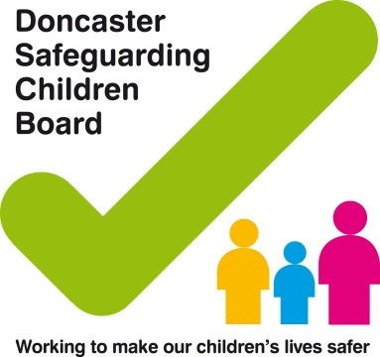

Neglect Strategy

**Why do we need a strategy?**

The DSCB recognise that more needs to be done to tackle neglect, and reduce both its prevalence and its harmful effects on children and young people in Doncaster. This new DSCB strategy sets out our multi-agency approach to addressing this pervasive problem. All children and young people in Doncaster have a right to be looked after properly and kept safe. This remains our priority.

The impact of neglect on children and young people is enormous. Neglect causes great distress to children and young people, leading to poor health, educational and social outcomes and is potentially fatal. Lives are destroyed, children and young people’s abilities to make secure attachments are affected and their ability to attend and attain at school is reduced. Their emotional health and well-being is often compromised and this impacts on their success in adulthood and their ability to parent in the future. The purpose of this strategy is to set out the strategic aims and objectives of the DSCBs approach to tackling neglect.

The over-arching aim of the strategy:

**‘To improve outcomes for children, young people and families in Doncaster by reducing the incidence and impact of neglect’**

In order to achieve this there will be three distinct strands of work:

* Communication and awareness of neglect to families, children and young people, professionals and the public
* Working with children, young people and families to reduce the effects of neglect. To develop tools and guidance to support practitioners to assess and work with neglect.
* Profiling and quality assurance to better understand the prevalence and nature of neglect and measure outcomes.

**What is Neglect?**

In terms of statutory responsibilities for safeguarding and child protection ***Working Together to Safeguard Children 2015*** defines neglect as:

The persistent failure to meet a child’s basic physical and/or psychological needs, likely to result in the serious impairment of the child’s health or development. Neglect may occur during pregnancy as a result of maternal substance abuse. Once a child is born, neglect may involve a parent or carer failing to: provide adequate food, clothing or shelter (including exclusion from home or abandonment); protect a child from physical and emotional harm or danger; ensure adequate supervision (including the use of inadequate caregivers); ensure access to appropriate medical care or treatment. It may also include neglect of, or unresponsiveness to, a child’s basic emotional needs.’ (*Glossary, p93)*

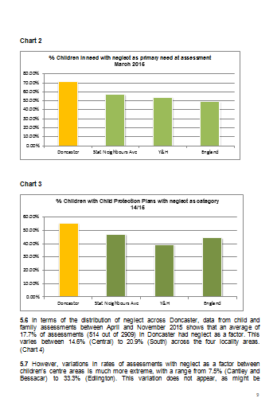

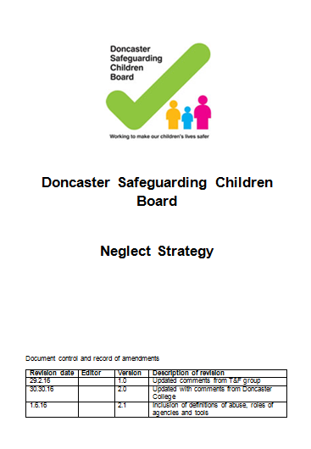

**Your Role…**

There are no specific services that exist for supporting neglectful families. Neglect is a form of abuse and as such is the responsibility of all agencies to identify the signs at an early stage and to be able to either provide support themselves, signpost to a service which can provide support or, if the threshold for social care is met, make a referral to Doncaster Children’s Services Trust (DCST). Currently support is provided through a number of key agencies such as schools, health, the Council through its early help services, health, housing services and DCST.

Professionals across all agencies who come into contact with families will need to be able to spot the signs which identify that neglect is occurring and be able to signpost or make a referral to social care.

Those agencies who provide any type of family support service, whether that be in a school setting, a children’s centre or youth hub need also to know how to assess risk and provide support to prevent the neglect from continuing.

Those social care services will need to be able to assess the parent’s ability to change to ensure that unnecessary drift isn’t caused by adopting a ‘start again’ approach when families have been known to services for a long time.

For neglect training please visit: [www.engagedoncaster.co.uk](http://www.engagedoncaster.co.uk) or contact the Doncaster Safeguarding Children Board on 01302 734214.

A copy of the strategy and toolkit can be located on the DSCB website [www.doncastersafeguardingchildren.co.uk](http://www.doncastersafeguardingchildren.co.uk)

If you have **concerns about a child or young person** then please contact the Referral and Response Team on 01302 734100 between 8:30am and 5pm, Monday to Friday or email [childrenassessmentservice@doncaster.gcsx.gov.uk](mailto:childrenassessmentservice@doncaster.gcsx.gov.uk)Outside of these hours call 01302 796000.

Early Help Hub:

T: 01302 734110

E: [EarlyHelpHub@doncaster.gov.uk](mailto:EarlyHelpHub@doncaster.gov.uk)

**Underlying Principles to tackling neglect**

All interventions whether early help or statutory interventions will hold to the following principles: Families are best supported when neglect is identified in its early stages

* The safety, well-being and development of children and young people is the overriding priority.
* Working in partnership with children, young people and families is essential to better outcomes.
* Working together with other professionals is essential to providing effective support.
* Building resilience is key to sustaining the safety of children and young people into the future.
* Children and young people with additional needs such as special education needs and disabilities are more vulnerable to the effects of neglect.
* Consideration of historical information is essential to inform the present position and identify families at risk of inter-generational neglect.
* Effective information sharing needs to take place between agencies to inform assessments and evaluations of risk.
* Decisive action needs to be taken to avoid ongoing neglect when improvements are not seen.

The below supporting documents can be found on the DSCB Website;

* Doncaster Early Help Strategy
* DSCB Thresholds Document
* Early Help Handbook for Practitioners
* DSCB Multi Agency Safeguarding Procedures
* Neglect Toolkit

Further information and useful advice can be found on the below websites:-

NSPCC: <https://www.nspcc.org.uk/preventing-abuse/signs-symptoms-effects/>

Signs of Safety: [signsofsafety.net](https://www.signsofsafety.net/)