

**DSCB Annual Report 2017-18**

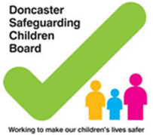

**Foreword**

|  |  |
| --- | --- |
| Report Author | John Woodhouse, DSCB Independent Chair |
| Date of Publication | June 2018 |
| Availability and accessibility advice and directions | [www.doncastersafeguardingchildren.co.uk](http://www.doncastersafeguardingchildren.co.uk)  Children’s Version also available |
| Contact details | 01302 734214  [dscb@dcstrust.co.uk](mailto:dscb@dcstrust.co.uk) |

**Contents**

|  |  |  |  |
| --- | --- | --- | --- |
| **Section** | **Content** | | **Page No.** |
|  | Foreword by the Independent Chair | | 1 |
|  | Contents | | 2 |
|  | Executive Summary | | 3 |
| 1. | Purpose of the Report | | 4 |
| 2. | What is the Local Safeguarding Children Board?  2.1 Functions  2.2 Governance and accountability  2.3 Budget | | 4-10 |
| 3. | Safeguarding in Context | | 11-15 |
| 4. | Progress against Strategic Priorities | | 16-25 |
| 5. | Effectiveness of the Safeguarding arrangements  5.1 CIN  5.2 CP  5.3 LAC  5.4 Private Fostering  5.5 LADO  5.6 CDOP  5.7 Workforce Development  5.8 Multi-agency audit  5.9 Lesson from case reviews | | 17-41 |
| 6. | Partner Contributions  6.1 Children’s Social Care (including DMBC, DCST, CAFCASS)  6.2 Health Services (including DCCG, DBTH, RDaSH, NHS England, Primary Care)  6.3 Police/YOS/Probation - NPS and CRC  6.4 DMBC, Schools and Doncaster College  6.5 Other Partners (St Leger Homes, SYFR,) | | 42-64 |
| 7. | Conclusion and Recommendations for Future Actions | | 65-66 |
| **Appendices** | | **Appendix No.** | |
| Business Plan 2017/18 (with Strategic Priorities) | | 1 | |
| Glossary of terms | | 2 | |

**Executive Summary**

This report provides detailed information on the effectiveness of children’s safeguarding in Doncaster. It provides an overview of the work of the DSCB and its partners to promote the welfare of children and young people and demonstrates the impact of the work undertaken.

Section 2 of the report provides an overview of the role of the Board and how it links with other governance arrangements in Doncaster. It also demonstrates how partners have contributed financially and in kind to the Board and where the money has been spent.

Section 3 provides demographic information on Doncaster, giving a context to the environment in which safeguarding work takes place. It identifies the high levels of deprivation, poverty and people claiming out of work benefits. It provides data on the health of children including the high levels of infant mortality.

The DSCB set its strategic priorities to ensure that it was able to have a clear line of sight on key safeguarding functions including early help, child protection, looked after children, domestic abuse and child sexual exploitation. Section 4 of the report provides a brief overview of the work undertaken to meet these priorities.

It notes progress in early help and understanding thresholds, whilst recognising that there is still work to do to understand why many referrals made to social care front door are assessed as requiring no further action. Progress has been noted in relation to the partnership response to child sexual exploitation (CSE) and tackling domestic abuse. The Board has developed its performance framework, however it is recognised there is still work to be done to refine and analyse this information. The Board has undertaken a number learning lessons reviews and the learning from these has been shared across the partnership. There has been good progress in the implementation of Signs of Safety as a strength-based approach to working with families.

Section 5 provides information on the effectiveness of key areas required by Working Together 2015. The Board has evaluated this through assurance reports, audits and performance data. For example this section identifies the high number of children and young people who are now being looked after and the work being undertaken across the partnership and through the Clinical Commissioning Group Place Plan activity to try and ensure these children are cared for as near to home as possible or supported to return home if it is deemed safe.

In Section 6, DSCB partner organisations have provided an evaluation of the work they have undertaken individually to safeguard children and how they have supported partnership working. This illustrates the amount and variety of work which is undertaken across the partnership to safeguard children. It includes such diverse projects as the work South Yorkshire Police are undertaking with schools and DCST on Operation Encompass to support young people affected by domestic abuse and the work DMBC is undertaking with Expect Youth to ensure there are positive opportunities for young people within their communities.

Section 7 evaluates the progress made and identifies challenges for the future. It shows that the partnership is working well together and that progress has been made in most areas. This is supported by the finding of the Ofsted Inspection into children and young people’s safeguarding which judged that services in Doncaster are now ‘good’.

Finally, the report identifies the areas which require more scrutiny by the Board and which the Board will be focussing on during 2018/19. This includes the implementation of the new safeguarding arrangements legislated for through the Children and Social Work Act 2017.

1. **Purpose of the Report**

This is the annual report and business plan for the Doncaster Safeguarding Children Board. It covers the work undertaken in the financial year April 2017 to March 2018 and incorporates emerging themes in quarter 1 2018/19. It evaluates the overall effectiveness of local safeguarding arrangements in Doncaster, identifying the key issues and constructive challenges for organisations that have safeguarding responsibilities. The report assesses the progress made by the Board in delivering its Business Plan and outlines ways in which the Board itself can perform its functions to better effect. It is a statutory requirement under Working Together 2015.

The report is intended for professionals in partner agencies and voluntary organisations as well as others who have an interest in the safeguarding of children and young people, not least children, young people and their families and carers whose lives we look to improve through the work of DSCB. A child-friendly version of the report is being developed and will be available on the DSCB website.

The report has been prepared by John Woodhouse, Independent Chair and Rosie Faulkner, Board Manager with contributions from Board partners and the DSCB Business Unit. Information in the main body of report has been provided by DCST and DMBC. An overview of effectiveness of each agency has been provided by each of the partners in Section 6.

The report will be considered formally by the Mayor of DMBC, the Chief Executive and the Health and Wellbeing Board. It will also be shared with the Schools, Children and Young People Scrutiny Panel, and the Children and Families Strategic Partnership Board, who all have a wider remit to promote better outcomes for children. DSCB leads and influences the children’s safeguarding agenda in these wider political and partnership arenas and is held to account for its impact.

1. **What is a Local Safeguarding Children Board (LSCB)?**

The remit for DSCB is set out in Section 13 of the Children Act 2004 as well as in the statutory guidance ***‘Working Together to Safeguard Children’*** (2015)

The statutory objectives of any LSCB are to:

* Coordinate what is done by each person or body represented on the Board for the purpose of safeguarding and promoting the welfare of children in the area of the authority; and
* Ensure the effectiveness of what is done by each such person or body for that purpose.

**2.1 Functions of Doncaster Safeguarding Children Board**

Detailed guidance on the organisation of LSCBs is set out in Chapter 3 of ***Working Together 2015.*** In the light of this guidance DSCB defines its key functions as:

* Developing policies and procedures for safeguarding and promoting the welfare of children, including on:
  + Action where there are concerns, including thresholds
  + Training of people who work with children
  + Recruitment and supervision
  + Investigation of allegations
  + Privately fostered children
  + Co-operation with neighbouring authorities.
* Communicating the need to safeguard and promote the welfare of children and young people.
* Monitoring the effectiveness of what is done to safeguard and promote the welfare of children and young people.
* Participating in the planning of services for children in Doncaster
* Undertaking Serious Case Reviews.
* Procedures to ensure a co-ordinated response to unexpected child deaths
* Collecting and analysing information about child deaths

These functions are the shared responsibility of all the DSCB member agencies.

In order to fulfil its functions the DSCB must as a minimum:

* Assess the effectiveness of the help being offered to children and families, including early help
* Assess whether partners are fulfilling their statutory obligations to safeguard children
* Quality assure practice, including through case file audits
* Monitor the effectiveness of training to safeguard and promote the welfare of children.

Working Together 2015 also requires that the Chair of the Board publishes an annual report. This report should contain:

* Rigorous and transparent assessment of the performance and effectiveness of local services
* Identify areas of weakness, the causes of those weaknesses and the action being taken to address them
* Include lessons from serious case reviews, child death reviews and other relevant reviews
* Report on the outcome of assessments undertaken on the effectiveness of Board partners’ responses to child sexual exploitation.
* Include an analysis of how the LSCB partners have used their data to promote service improvement for vulnerable children and families
* Include data on children missing from care, and how the LSCB is addressing the issue.

Working Together 2018 is currently in draft and in the coming year numerous changes will be taking place to incorporate the changes identified in the new version. This report however, has been written to comply with the current version of Working Together 2015.

**2.2. Governance and accountability**

**2.2.1 Chairing**

The DSCB is chaired by an Independent Chair who was appointed in October 2017 by the Local Authority Chief Executive in conjunction with the DSCB partners and lay members. The chair, John Woodhouse has been appointed on an interim basis while the new arrangements for safeguarding (under Working Together 2018) are put in place. John also chairs the Doncaster Safeguarding Adults Board.

The Chief Executive holds the Chair to account for the effective working of DSCB. A performance management framework is in place to assist the Chief Executive in holding the Chair to account for his work. The Board has a Vice-Chair, who complements the role of the Independent Chair and has oversight of the coordination of the Board’s business plan. Doncaster Children’s Services Trust has responsibility for administrating the Board and employs and line-manages the DSCB Business Support Unit.

**2.2.2 Membership**

In order to fulfil its core functions, DSCB is made up of one designated representative from each of a number of partners who form the DSCB. The Board members are:

* Doncaster Metropolitan Borough Council (DMBC)
* Doncaster Children’s Services Trust (DCST)
* South Yorkshire Police (SYP)
* Doncaster Clinical Commissioning Group (CCG)
* South Yorkshire National Probation Service (NPS)
* Youth Offending Service (YOS)
* NHS England
* Rotherham, Doncaster and South Humber NHS Foundation Trust (RDASH)
* Children and Family Court Advisory and Support Service (CAFCASS)
* Doncaster and Bassetlaw Teaching Hospital (DBTH)
* St Leger Homes
* Primary, Secondary and Special Schools
* Doncaster College
* 2 Lay Members
* Safe@Last
* The South Yorkshire Community Rehabilitation Company Ltd (SYCRC)
* Doncaster Safeguarding Adults Board (DSAB)
* South Yorkshire Fire and Rescue Service (SYFR)
* HM Prison Service
* Primary Care
* Yorkshire Ambulance Service NHS Trust
* Expect Youth

The Board has ensured the voices of children and young people influence its work in a number of ways. These are detailed in Section 4 on strategic Priorities.

Designated representatives of the statutory Board members are expected to serve a minimum of three years on the Doncaster Safeguarding Children Board. The DSCB also has a small number of professional advisors from key agencies. Members of the DSCB are Chief Officers from within their own organisation with a strategic role in relation to safeguarding and promoting welfare of children and young people within their organisation. They are able to:

* Speak for their organisation with authority
* Commit their organisation on safeguarding and promoting welfare policy and practice matters
* Hold their own organisation to account and hold others to account and collate management information to demonstrate effectiveness.

DSCB Board members have a clear role description, which includes disseminating the work of the Board within their respective agencies. They self-assess their effectiveness within an agreed performance framework. DSCB has appointed two lay members who operate as full members of the Board with defined roles and responsibilities. They are both active members of Doncaster community. They bring their local knowledge and expertise to support the work of the DSCB. Both are regular attenders of the Board and its sub-groups.

**2.2.3 Board Structure**

The Board is supported in its work by a number of sub-groups as depicted below:

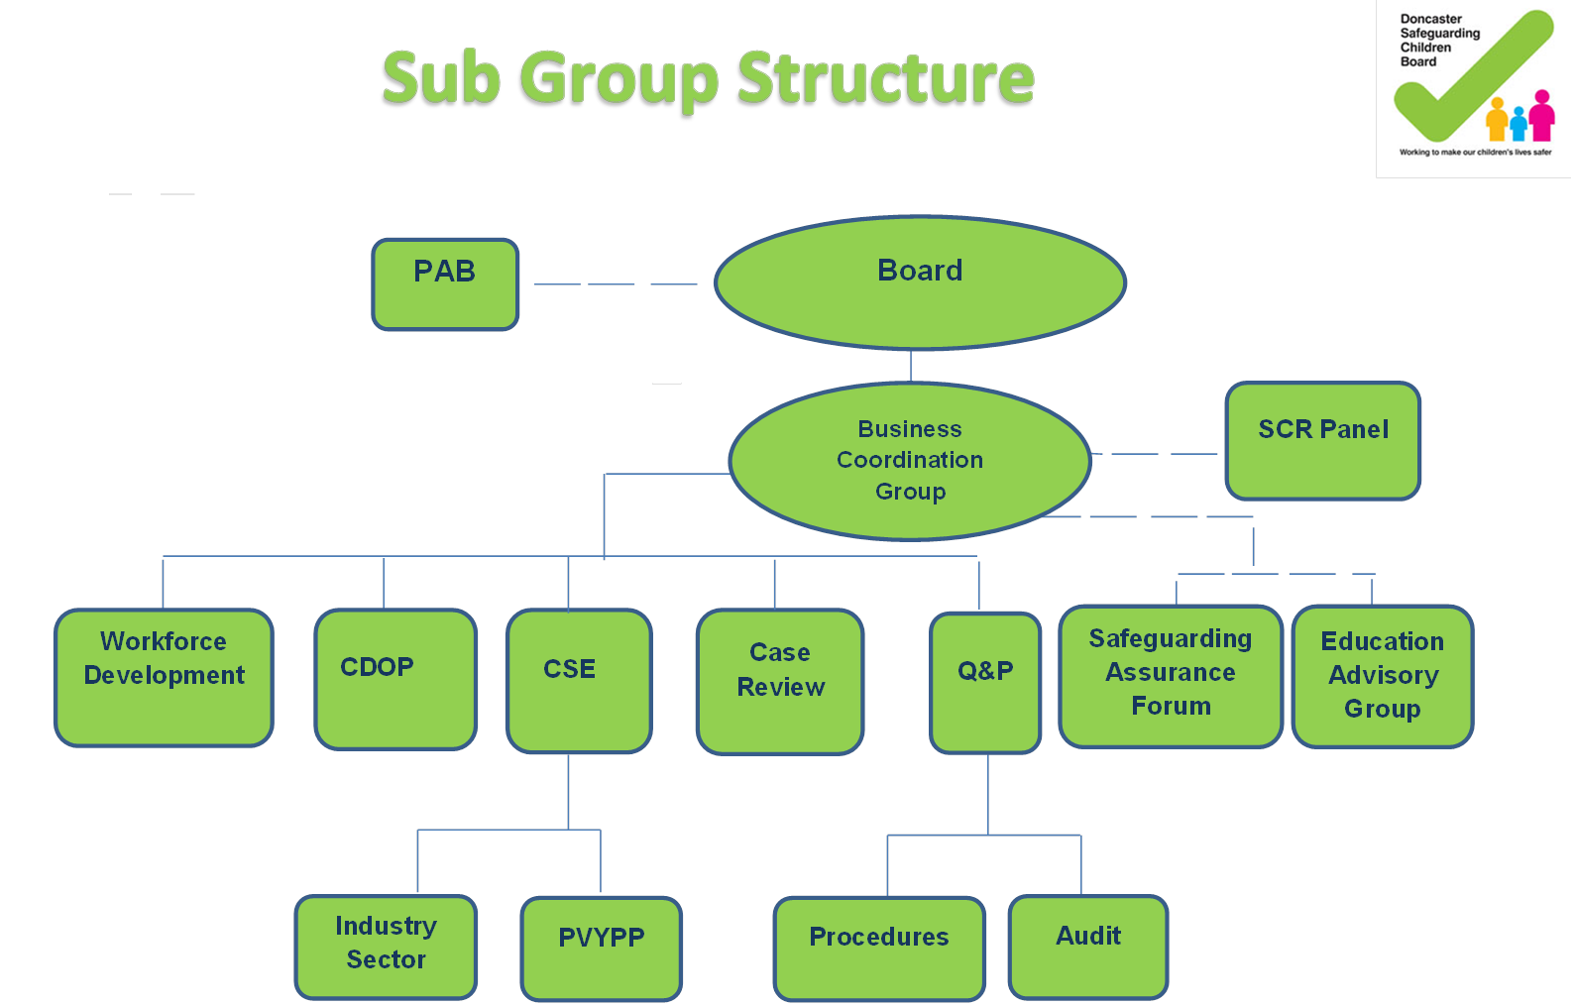

The sub-groups progress the Board’s strategic priorities and ensure the Board meets its statutory functions. The Health Assurance Forum and Education Advisory groups encompass their respective communities and are administered through the CCG and DMBC. Task and finish groups are established to work on specific themes as required. Attendance and commitment of partners has been good and has enabled the Board to take forward its priorities.

In January 2016, the Performance Accountability Board (PAB) was created. Its key purpose was identified in its terms of reference as:

* To act as a ‘strategic summit’ group for the DSCB at Chief Executive level to oversee improvement in children’s safeguarding, focusing in particular on cross-cutting issues that require effective interdependent working from partner organisations
* To review progress with improvement plans following inspection
* To identify and resolve key areas of performance risk
* To identify barriers to progress and agree solutions

The PAB was established to meet the expectation from the Department for Education (as part of the Secretary of State’s Direction to the Council) that there is a partnership body at executive level to oversee, monitor and challenge improvement. Given the leadership role of the DSCB in challenging and assuring the effectiveness of local safeguarding arrangements, it was agreed by partners that the PAB would operate within the governance framework of the DSCB and would be chaired by the Independent Chair of the DSCB. It is attended by chief officers from the key agencies: SYP, RDASH, CCG, DBTH, DMBC and DCST. The group is administered by the DSCB.

**2.2.4 Board Meetings in 2017-18**

The Board has met four times during 2017/18 and also held a Board Development Day in January 2018. Attendance at Board level is good. Low attendance tends to be from agencies where there is only one representative from that agency or where an agency represents a number of Boards in the region.

**2.2.5 Links with other strategic partnerships**

The DSCB is supported by established protocols to ensure good communication, collaboration and alignment with the Doncaster Safeguarding Adults Board, Health and Wellbeing Board and Safer Stronger Doncaster. There is reciprocal attendance on the Safeguarding Adult and Safeguarding Children Boards by the Board Managers. The two Safeguarding Boards work collaboratively to undertake a joint self-assurance exercise (more commonly known as Section 11 audit). This assessment is undertaken every two years and was under taken during 2017.

The DSCB receives assurance reports from the Safer Stronger Doncaster Partnership in relation to Prevent and domestic abuse. Assurance reports have been provided from the Health and Wellbeing Board regarding the progress of the Mental Health and Wellbeing Transformation Plan.

The diagram below illustrates how the DSCB links with other strategic partnerships.

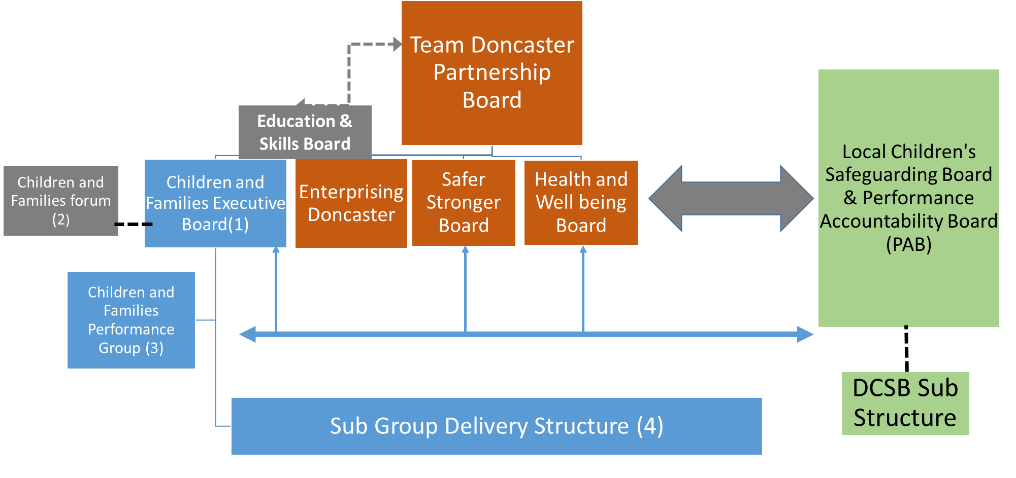

The Children and Young People’s Plan, 2017-20 is based around four key themes: healthy and happy, equality, safety, and achievement. Through the Children and Families Executive group, the partnership is held to account for the delivery of the plan. The DSCB receives assurances from the Children and Families Executive Group in relation to the plan and specifically on the theme of ‘Safe’. This will include for example, the coordination of partnership activity in relation to early help and neglect.

The Doncaster Place Plan, jointly developed by health and social care commissioners and providers, was agreed in October 2016 with the aim of developing a joint vision and a plan to maximise the value of the partnership’s collective action and accelerate the ability to transform the way we deliver services.

The plan includes seven key strands of work across both children’s and adult’s arenas:

1. Urgent and emergency care
2. Dermatology
3. Learning disability
4. Vulnerable adolescents
5. Starting well (first 1001 days)
6. Intermediate care
7. Complex care

Work has been taking place during 2017/18 and assurance has been sought by the DSCB to understand the impact of the work on safeguarding children and families. The whole family approach embodied through the Place Plan is consistent with the direction of travel for the DSCB as it begins to work more closely with the DSAB and implements new streamlined arrangements for safeguarding in Doncaster.

**2.2.6 DSCB Business Support Unit**

DSCB is supported by a Board Manager and dedicated business support team which is managed within the Safeguarding and Standards Unit of the Doncaster Children’s Services Trust. The recruitment issues reported in last years’ report were finally resolved in July 2017 with a further change in the Quality Assurance Manager post occurring in January 2018. This post is currently on a temporary basis to allow for any changes which the new safeguarding arrangements may bring.

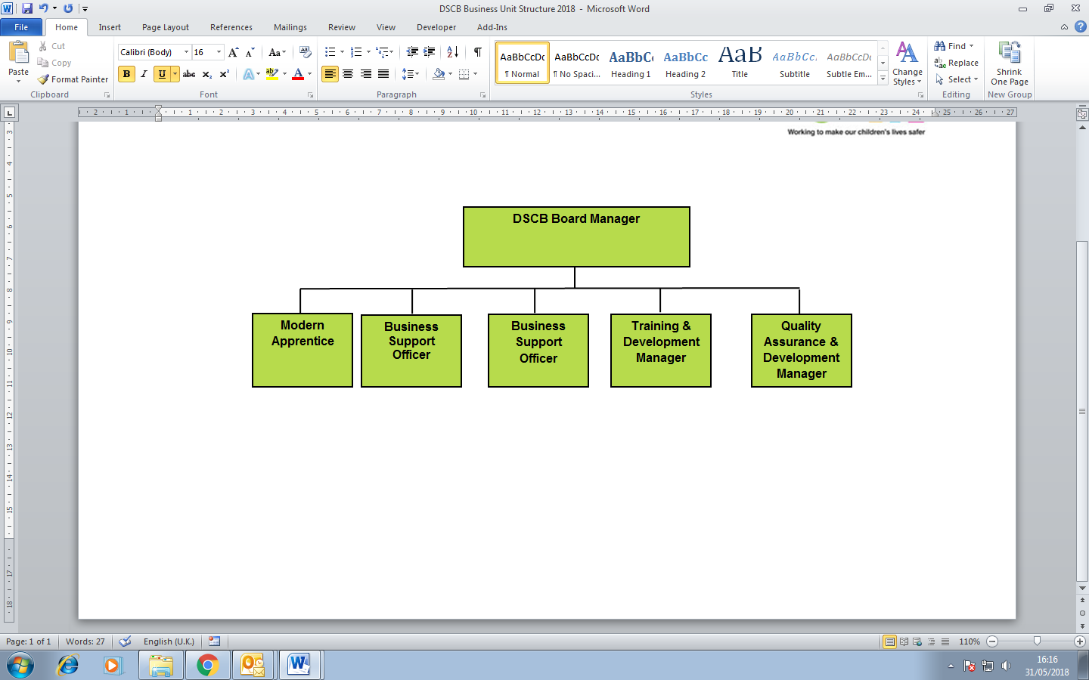

**2.3 Board Partner Financial Contributions and Board Expenditure 2017/18**

The table below sets out the financial contributions of partner agencies to support the   work of the Board and the expenditure in 2017/18. Partner agencies continue to manage increasing financial pressures however once again they have provided the same level of contribution to the Board as in previous years.  In-kind contributions are received from a number of partners to support the training offer. DCST provide support through line-management, HR functions and other back office support.

|  |  |
| --- | --- |
| **DSCB**  **Budget Report 2017/18** | |
| **Employee costs** | **218,270.00** | |
| **Supplies and services** | **42990.30** | |
| **Training** | **21,024.70** | |
| **Total expenditure** | **282,285.00** | |
| **Funded by:** |  | |
| **Doncaster CCG** | **97,880.00** | |
| **CAFCASS** | **550.00** | |
| **South Yorkshire Police** | **26,000.00** | |
| **NPS** | **2,050.00** | |
| **DMBC** | **177,675.00** | |
| **Total income** | **304,155.00** | |
|  | **21,870.00** | |

Due to savings on vacant posts there has been an underspend of £21,870. It is envisaged that this will be used to redevelop the DSCB website and support publicity and communications in the coming year.

The budget for 2018/19 has been agreed and partner contributions have once again stayed at the same level. This budget is in line with other LSCBs of similar size to Doncaster and will be sufficient to meet current needs.

Due to the implementation of the new safeguarding arrangements under the Children and Social Work Act 2017, a review of the Business Unit will take place to ensure the new arrangements are fully supported; this may affect contributions going forward. The new arrangements may also lead to changes in the way the safeguarding arrangements are funded in future.

|  |  |
| --- | --- |
| **SAFEGUARDING BOARD 18/19 BUDGET** | |
| DMBC | 177,675 |
| POLICE | 26,000 |
| CAFCASS | 550 |
| PROBATION SERVICE | 2,050 |
| CCG | 97,880 |
| **TOTAL** | **304,155** |

**3. Safeguarding in Context**

**3.1 Context for Safeguarding Children and Young People in Doncaster**

Approximately 307,374 people live in Doncaster, in terms of the Indices of Multiple Deprivation (IMD) 2015 Doncaster is:

* 48th most deprived out of 326 local authority areas in England
* 4th most deprived out of 21 local authority areas in the Yorkshire and Humber Region
* The 2nd most deprived area in South Yorkshire
* The 4th most deprived area in its comparator group
* 1 in 5 Lower Super Output Areas in Doncaster is in within the most deprived 10% of the UK.

A rise in the number of cohabiting partners, step families, lone parents and the recording of same sex relationships in the past 10 years has changed family composition in Doncaster. The latest ‘Information for Doncaster’ (information provided by DMBC) shows that nearly 71.9% of families with dependent children are a couple; which means nearly 1 in 3 families (28.1%) are lone parent families. The main difference between Doncaster and the national picture is the higher proportions of families that are cohabiting, particularly where this involves step-families.

The population of young people aged 0-24 is 89,500 which is 29.1% of the total population. This is the same as our comparator group and but slightly lower than national proportions at 30.2%.

The number of children in poverty in Doncaster is 21.0%, which is higher than the national average of 16.6%. This equates to around 13,930 children and young people aged 19 and under. Poverty is not distributed equally across the borough with some lower super output areas (LSOA) having over 50% of children in poverty compared to other area only having 5%.

In Doncaster, 6.2% of residents were born outside the UK. The main group outside of white British is ‘white other’ which equates to 3.1% of the population aged 0-24. The main language in Doncaster, for people aged 3-15, if not English, is Polish.

Doncaster is the second largest economy in South Yorkshire; a large proportion of the population is in receipt of state benefits. Approximately 3.3% of the population in Doncaster claim job seekers allowance or universal credit compared to 2.2% nationally. In the 18-24 age category, 5.5% of the population are claim job seekers allowance or universal credit compared to 3.0% nationally.

The number of 16-18 years old not in education, employment or training is 5.3% of the population as at June 2017. This is higher than the national average.

The proportion of people in Doncaster who achieve a Level 2 or level 3 qualifications by the age of 19 is 78.9% and 44.5% respectively. This is lower than the regional (81.6%) and (53.6%) and national (83.6%) and (57.5%) averages respectively.

The NSPCC have estimated that one in five children in the UK is impacted by domestic abuse. However, Growing Futures estimate that in Doncaster this is one in three children. This suggests that more children compared to the national average are entitled to services to achieve their best outcomes.

**3.2 Population**

The population of young people aged 0-24 in Doncaster is **89,500** representing **29.1%** of the population. The relative age profile, with national and regional comparisons, is shown in the table below.

|  |  |  |  |  |  |  |  |  |
| --- | --- | --- | --- | --- | --- | --- | --- | --- |
|  | **Age** | **Doncaster** | | **Yorkshire and**  **The Humber** | | **Great Britain** | |  |
|  | **number**  **%** | | **number**  **%** | | **number**  **%** | |  |
|  | Aged under 1 year | 3,600 | 1.2 | 64,500 | 1.2 | 758,000 | 1.2 |  |
|  | Aged 1 - 4 years | 15,100 | 4.9 | 266,800 | 4.9 | 3,131,600 | 4.9 |  |
|  | Aged 5 - 9 years | 19,500 | 6.4 | 335,000 | 6.2 | 3,909,900 | 6.1 |  |
|  | Aged 10 - 14 years | 17,200 | 5.6 | 303,500 | 5.6 | 3,511,800 | 5.5 |  |
|  | Aged 15 - 19 years | 16,800 | 5.5 | 322,600 | 5.9 | 3,660,600 | 5.7 |  |
|  | Aged 20 - 24 years | 17,300 | 5.6 | 385,400 | 7.1 | 4,135,000 | 6.5 |  |
|  | **Total** | **89,500** | **29.1** | **1,677,700** | **30.9** | **19,106,800** | **30.0** |  |

**3.3 Ethnicity**

The numbers of pupils in Doncaster are predominantly White British (34,458), and White other (2,639).

Doncaster has fewer school age children from ethnic minority groups than regional and national averages. The percentage of primary and secondary school age children from ethnic minority groups is 15.9% and 13.0% respectively. This is much lower than the regional (26.3% and 23.3%) and national (32.1% and 29.1%) averages respectively.

**3.4 Supportive Health Data**

The health and wellbeing of children in Doncaster is generally worse than the England average. The infant mortality rate of 4.8 per 1000 is higher than both the regional and national rate of 4.1 and 3.9 respectively (2014-16).

The smoking status of mothers at time of delivery in Doncaster is higher, at 13.0%, compared to the national average of 10.7% (2016/17).

Children in Doncaster have average levels of obesity: 23.0% of children aged 4-5 years and 35.8% of children aged 10-11 years. (2016/17)

The live birth rate has decreased steadily since 2008 as shown in the table below. No update for this data is available at the time the report was produced.

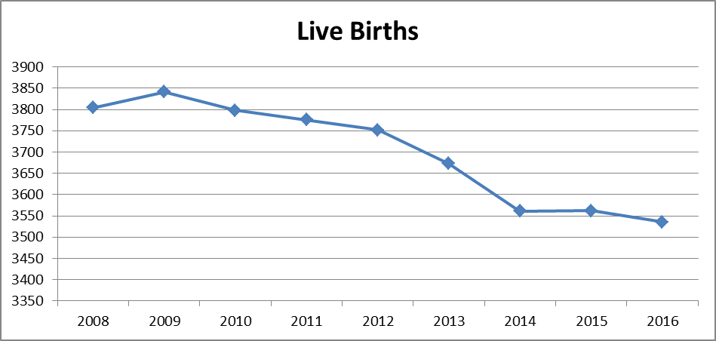

Life expectancy at birth for males, in Doncaster is 77.8, lower than the regional and national averages in 2014-2016. There is a higher life expectancy for females at 81.5 however this still compares unfavourably with regional and national averages.

|  |  |  |  |
| --- | --- | --- | --- |
|  | Doncaster Average | Yorkshire and Humber Average | National Average |
| Males | 77.8 | 78.7 | 79.5 |
| Females | 81.5 | 82.4 | 83.1 |

**3.5 Family Composition**

Family composition is changing in numbers, with variable arrangements rather than the traditional married family household. A rise of cohabiting partners, step families, lone parents and same sex relationships in the past decade has resulted in a very different profile of family composition in Doncaster. The latest information shows that over 71.9% of families with dependent children are couples, with almost one in three children living in lone parent families (28.1%). A key difference between the family composition profile in Doncaster and that found nationally, is the higher proportion of families that are co-habiting.

**3.6 Deprivation (*the last release of Index of Multiple Deprivation was 2015; therefore this section has not been updated from last year’s report)*.**

Doncaster is currently ranked 48 out of 326 local authorities according to the index of multiple deprivation and is fourth worst of the 21 Yorkshire and Humber local authorities. One in five of LSOA areas in Doncaster is in the most deprived 10% nationally.

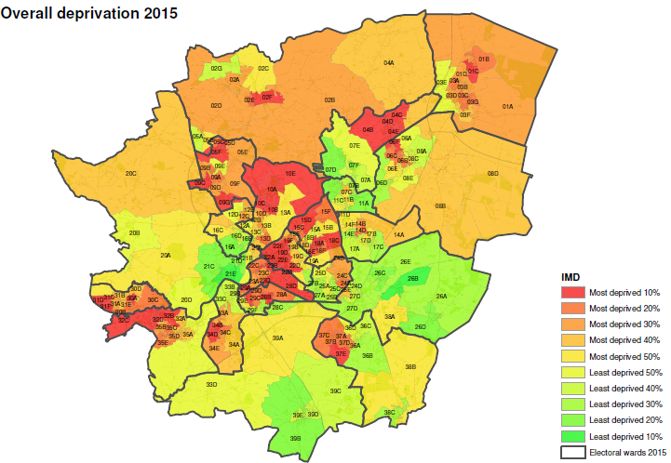

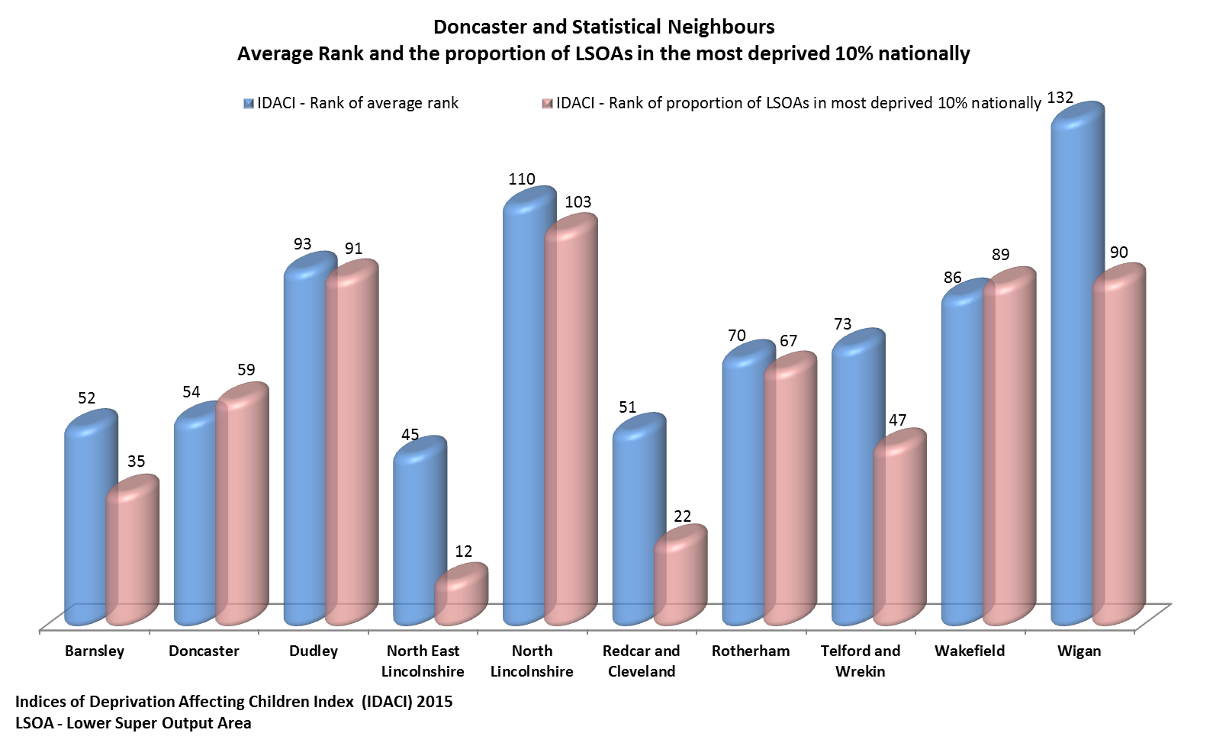

The levels of deprivation in Doncaster reflects in the number of issues relating to school aged children, for example, the number of pupils eligible and claiming free school meals is higher than the national average at 17.1%.

|  |  |  |
| --- | --- | --- |
| Doncaster average | Yorkshire and The Humber average | England average |
| 17.1% | 16.8% | 14.7% |

Proportion of primary age pupils eligible for Pupil Premium is higher than the regional and national average.

|  |  |  |
| --- | --- | --- |
| Doncaster Average | Yorkshire and Humber Average | National Average |
| 30.0% | 26.5% | 23.9% |

Proportion of secondary age pupils eligible for Pupil Premium is higher than the regional and national average.

|  |  |  |
| --- | --- | --- |
| Doncaster Average | Yorkshire and Humber Average | National Average |
| 33.7% | 30.2% | 28.6% |

In summary, this data suggest that the challenges Doncaster and its Children’s Services face are greater than those found nationally. Therefore, it is essential that the local authority and partner agencies commission an appropriate range of services that meet the needs of the area, particularly in relation to health and education. Children and families should also have access to a wide range of early help, including parenting and wider family support.

**4.**  **Progress against Strategic Priorities**

The DSCB was last subject to an Ofsted inspection in its own right in October 2015. At this inspection the Board was judged to require improvement. The Board developed an action plan to address the Ofsted recommendations and these were aligned with its own strategic priorities. Since that time Children’s Services has been re-inspected and services are now judged to be good, although this did not specifically include an inspection of the DSCB itself. Below is a summary of the progress the Board has made against its strategic priorities, indicating where this also met the Ofsted recommendation (OR).

**4.1 Strategic Priority 1: DSCB is assured that effective arrangements are in place for responding to key safeguarding risks and that there is consistently good practice across safeguarding services.**

**4.1.1 - 1(a) The early help strategy is effectively implemented and there is evidence of the impact this has had on outcomes for children, young people and their families**

**(OR1, para 147) Monitor partner agencies contribution to early help through robust audit and tracking of the number of early help assessments completed and lead professional roles undertaken.**

The DSCB receives regular assurance reports from the DMBC Early Help lead. It receives assurance through its performance report on the progress of early help in terms of number of agencies taking on lead professional role, number and quality of early help assessments, outcomes for children, step-up and step down processes. The DSCB provides training through a training pool and a suite of courses to drive up practice standards in early help.

The DSCB has supported the work of the Early Help Strategic Group to re-launch the early help hand book and associated paperwork. The Early Help website is housed within the DSCB website to ensure there is one point of access to documentation for all agencies. Future work will include an increased focus on ‘Universal plus’ services.

**Impact and challenges**

The performance data is beginning to show an improvement in key areas such as the increase in early help assessments undertaken, the quality of the assessments and improved outcomes for children subject to an early help assessment. External and internal audits have identified that thresholds are well embedded although there still appears to be a high number of contacts to social care which do not result in a referral. This may indicate that many contacts did not meet the threshold for social care involvement. The DSCB will continue to seek assurance on the progress of early help and the application of thresholds when referring to social care.

**4.1.2 - 1(b) DSCB thresholds are understood by practitioners and are embedded in practice**

The DSCB thresholds document has been amended in line with changes in early help and the development of the SEND agenda. Regular training is provided by the DSCB to ensure professionals understand thresholds. Audit activity undertaken by the DSCB addresses whether thresholds are appropriately applied and single agency audits provide assurance to this affect.

**Impact and challenges**

Feedback from Ofsted and independent reviews such as the Ingson report during this reporting period have identified that thresholds are well understood and this is borne out by internal and multi-agency audit activity.

Nevertheless, it was noted at the PAB that too many children are referred to the children’s social care front-door who do not go on to receive a statutory intervention after a children and family assessment, suggesting that these families did not reach the threshold for social care. DSCB will continue to seek assurance on the application of thresholds across the spectrum of need to ensure services are provided at the right time. It will do this by including application of thresholds as a standard question in its multi-agency audits.

**4.1.3 - 1(c) Systems are in place to effectively meet the needs of victims of sexual exploitation including an understanding of the scope of child sexual exploitation in Doncaster and of offender management programmes**

DSCB child sexual exploitation sub-group meets regularly and has progressed its strategic plan. The Board produces a quarterly performance report which identifies key issues and strengths. The sub-group measures progress against other national guidance and reports and against serious case reviews undertaken by other local authorities which have a child sexual exploitation element. The sub-group receives assurance from protecting young vulnerable people and the Industry Sector Group, ensuring it is kept informed about work with perpetrators, hotspots, as well as support for victims. The Industry Sector group has undertaken reality testing in hotels to ensure hotel staff know how to spot the signs and what to do if they believe a young person may be at risk of child sexual exploitation.

The Doncaster CSE Strategy has been updated to include other forms of child exploitation and the sub-groups terms of references have been amended to include criminal and other forms of exploitation. The CSE team has provided a wide range of training and awareness raising sessions both for professionals, public and young people. This included holding a CSE Day within the “Safeguarding Fortnight” and supporting the National CSE Awareness Day.

**Impact and Challenges**

The most recent Ofsted report states “Targeted multi-agency support from a dedicated service effectively meets the needs of children at risk of sexual exploitation. The trust’s multi-agency ‘Protecting Vulnerable Young People’ group shares intelligence on local ‘hotspots’ for child sexual exploitation and missing children. Return home interviews are offered, take up has increased and intelligence informs future planning to reduce risk.” This indicates there is strong and effective strategic and operational leadership in response to CSE in Doncaster.

The offender profile data could be better understood if information was included in the child sexual exploitation performance report from SYP, YOS and NPS and this will be included as an action for 2018/19. The widening of the exploitation agenda to include criminal and other forms of child exploitation has been recognised by the group and the 2018/19 strategic plan includes actions to address these issues. The Community Safety Partnership has the lead for dealing with exploitation of adults. Future discussion will also include a consideration of whether a joint approach would be more efficient and effective.

**4.1.4 - 1(d) Domestic abuse services are in place which reduce the risk of harm to families who have experienced domestic abuse and Doncaster communities better understand the harm caused by domestic abuse**

The DSCB receives regular updates on the progress of Growing Futures. Audit information has been shared with the Board and a multi-agency audit of the MARAC process is being undertaken by Safer Stronger Doncaster as part of the DSCB audit cycle.

Work to reduce domestic abuse across the partnership continues to be effective with no repeat referrals where DANs have previously worked with the family in the last six months. During their inspection in quarter 3, Ofsted noted that “the response to domestic abuse has led to some excellent practice”

Domestic abuse referrals are by far the largest category of referrals into children’s social care. Many of these referrals result in children being made the subject of child protection plans and this has accounted for the high numbers of children under the category of neglect. Work has now been undertaken by DCST to re-categorise these children as for many, the more appropriate category would be that of emotional abuse. As a result emotional abuse is now the highest category, this will provide a clearer focus for the work to support these families, ensuring that more appropriate assessments of risk are undertaken.

**Impact and challenges**

DSCB is assured of the progress being made and that children at risk of harm through domestic abuse, are appropriately safeguarded. Through the Section 11 process partner agencies provided assurances about their services to demonstrate there is an awareness and understanding of the impact of domestic abuse on children.

**4.1.5 - 1(e) Practitioners understand and are able to respond to the early signs of neglect and this can be evidenced by a reduction in the number of families accessing social care services where neglect has been identified**

The DSCB Neglect task and finish group was established in 2016 to provide a greater focus on neglect. The Neglect Strategy was launched and a programme of training delivered. A multi-agency assessment tool kit was also launched based on the graded care profile. Extensive work took place through the task and finish group to ensure that the strategy and associated tools were disseminated across the partnership, for example Doncaster Policing Teams have raised awareness as part of their team briefings, whole school training has been updated to include the toolkit.

As a result of this work, in 2017 Team Doncaster placed neglect as a key priority within the Children and Young People’s Plan 2017-2020 and the work of the DSCB task and finish group was adopted by the Children and Families Partnership themed group on Neglect. This demonstrates a decisive cross organisational commitment to ensure no child living in Doncaster suffers significant harm as a result of neglect. DCST has been successful in its bid to become one of the DfE’s Partners in Practice. As part of this DCST have been awarded funding to develop an MST team that will focus on neglect of adolescents with a particular focus on those at risk of wider child exploitation issues.

The CYPP group has developed the performance framework to ensure there is a clearer picture of neglect and the impact of the strategy. Assurance reports will be provided to the DSCB on progress. A review has been undertaken of all children subject to a child protection plan under the category of neglect which has resulted in a change in categorisation. (see 1(d) above)

**Impact and challenges**

The DSCB undertook an audit in February 2018 to evaluate the impact of the strategy; however this has indicated that the toolkit is still not being widely used. To address this additional training has been provided with nine courses arranged on a monthly basis which will enable 230 staff to be trained. Work needs to be undertaken with partners to ensure appropriate staff have received the training and are supported to use the toolkit. It has been agreed that neglect will be added to the early help audits as a means of ensuring that the toolkit is used to support families before problems become entrenched.

**4.1.6 - 1(f) Services are in place to support young people’s mental health and the impact of these services can be seen in a reduction of hospital admissions for self-harm and attempted suicide**

**(OR6, Para 152) Undertake a review of those children and young people admitted to hospital for self-harm and attempted suicide to determine reasons that will inform suitable preventative work.**

The DSCB continues to build on its previous work in relation to young people’s mental health. In 2016 the DSCB undertook an audit of young people who had been admitted to hospital as a result of attempted suicide or self-harm. The audit identified that CAMHS tends to work in isolation from other agencies and on occasions young people’s health needs wait until they are in crisis before support is provided. The Local Mental Health Transformation plan was presented to the DSCB and outlined how it intended to support young people earlier by appointing mental health specialist workers to provide advice in schools. The impact of this work on young people’s resilience has yet to be evaluated.

In 2017, the DSCB Case Review Group (CRG) was notified of two young people who had been admitted to hospital after attempting to take their own lives. The CRG undertook a learning lessons review which identified a number of issues including the shortage of ‘tier 4 beds’ for young people assessed as having a mental health diagnosis. Also noted was the importance of partners working together to support young people where it is unclear if behavioural issues are caused by underlying mental health problems. The DSCB have developed an action plan which is being progressed by the Mental Health & Wellbeing Strategy Group.

**Impact and challenges**

Our data shows that recently there has been a decrease in the number of young people presenting at Emergency Department who have self-harmed. Although this may be an indication of positive impact it is not yet clear that this is a causal relationship, further investigations will be needed.

The Board is also aware that there are still issues about the availability of tier 4 beds. Although this is a national issue, work being undertaken through the Doncaster Place Plan, to ensure a robust partnership approach to young people by intervening earlier, is likely to reduce the demand for beds.

The Board will seek assurance on the effectiveness of early support for mental health provided through the Consultation and Advice Service and on the impact of the Place Plan. The action plans from the case reviews will be evaluated. The Board will also seek assurance on the impact of work being undertaken to promote resilience in young people.

**4.1.7 - 1(g) Signs of Safety model is rolled out across the partnership and the DSCB is provided with evidence to demonstrate the effectiveness of the approach in Doncaster**

The DSCB is supporting the roll-out of Signs of Safety (SoS) across the partnership as a way of improving risk assessment and ensuring a consistent approach to working with vulnerable families. The DSCB Training Manager undertook a gap analysis to identify who requires training at what level. This has proved effective ensuring the right people have been trained. The DSCB currently runs regular road shows to raise awareness as well as more in depth courses for those who will regularly use the approach. Members of the DSCB training pool are now actively involved in the delivery of the SoS training. The training manager and training pool members have developed an in house two day training which is now being rolled out to multi agency partners.

There is evidence through file audits that the model is widely used and embedded in practice. It is also being used by the DSCB in its performance reporting to help identify risks and what needs to change.

**Impact and challenges**

The DSCB multi-agency audits include questions on the use of Signs of Safety and have identified that professionals are increasingly using the model for evaluating risk. The DSCB has undertaken an audit on the implementation of the model. This demonstrated that the model was being effectively used across the partnership.

**4.2 Strategic Priority 2: DSCB has a clear understanding of the effectiveness of the safeguarding system in Doncaster and can evidence how this is used to influence the Boards priorities**

**4.2.1 - 2(a) DSCB data set provides the Board with appropriate information to enable it to identify the key safeguarding issues in Doncaster**

**(OR3, para 149) Ensure that high quality performance data is available and robust analysis occurs to enable the Board to have a good understanding of child protection and safeguarding activities across Doncaster.**

**(OR7, para 153) Improve the measurement of the impact of the DSCB work, including ensuring the experience of the child is at the centre of partnership working and monitoring of activities**

The DSCB now has a suite of performance reports which enables the Board to be assured of progress on a wide range of performance indicators across the safeguarding agenda. The report is based on the Munro dataset and is made up of a performance outcomes report, child sexual exploitation performance report and performance data on the effectiveness of the Board. The Quality and Performance group scrutinises the performance reports, develops actions as a result of data analysis and provides the Board with an assurance summary report.

In an attempt to streamline processes and reduce duplication, the partnership agreed that the Children and Families Partnership performance report would replace the DSCB performance outcomes report in the suite of reports. In Quarter 3, the quality and performance group received the first of these reports. This is a work in progress; the quality and performance group will review the new reporting formats to ensure they provide sufficient assurance for the Board.

**Impact and Challenges**

The performance data has been used to inform the work streams of the quality and performance group. For example, the report highlighted concerns about the number of young people being referred to substance misuse services (Project 3) by DBTH. A performance challenge meeting took place to explore the issue more fully. As a result an audit was undertaken by DBTH which demonstrated that most young people who attended the emergency department would not have required a referral to Project 3. Nevertheless, Public Health information suggests that numbers should be higher. Work continues to try and reach agreement on the way forward.

The performance report also identified an increase in the numbers of re-referrals into DCST and a single agency audit was completed to identify the cause and take appropriate action.

**4.2.2 - 3(2) DSCB disseminates the lessons from case reviews, audits and complaints to practitioners and can evidence the impact this has had on practice**

**(OR4, para 150) Ensure there is a programme of audits, and re-audits, to identify the strengths in multi-agency practice and where weaknesses are identified these are addressed promptly.**

**(OR8, para 154) Implement a system to evaluate the effectiveness of training delivered and monitor the impact on practitioner’s work.**

The Case Review Group has met regularly throughout the year and has considered seven cases. In four of these, a Learning Lessons Review was undertaken using the Welsh Methodology. One of these is still ongoing. The learning from these reviews has been incorporated into the DSCB training, disseminated through learning briefs and through workshops at the DSCB Conferences. A further two cases have been considered by the Serious Case Review Panel, both of these are awaiting further information before a final decision is made.

The Board has a programme of multi-agency audits and also receives information from partners on single agency audits. Multi-agency audits have been undertaken on Children in Custody and Secure Accommodation, Signs of Safety, a re-audit of neglect and a joint audit with the Community Safety Partnership on the effectiveness of MARAC arrangements. The quality and performance group has received a range of single agency audits from across the partnership.

The effectiveness of training is measured on a number of levels including numbers trained, evaluations received and impact on practice. The Workforce Development Group has continued to refine its data collection to ensure the number of training places made available is sufficient. This has been particularly effective in the roll out of Signs of Safety training where a gap analysis has been completed to ensure the training is reaching the right people. A more strategic approach is being taken in relation to safeguarding training, acknowledging the role which single agency training has in ensuring we have a skilled and knowledgeable multi-agency workforce.

**Impact and Challenges**

Actions from case reviews have included changes in or development of new procedures and guidance such as the development of multi-agency Child in Need procedures and good practice guidance for children in secure accommodation. Audits are being undertaken to evaluate the impact of changes, such as the improved process for ensuring GPs are notified where a child becomes the subject of CIN or Early Help.

The Board has not always disseminated lessons in a timely way and this is an area which needs to be improved to ensure that there is greater impact of the work. The Business Unit has now developed a ‘2 minute’ briefing’ format which enables lessons to be disseminated quickly across the partnership. These have been positively received by practitioners.

Through its gap analysis the Workforce Development Group has effectively embedded Signs of Safety training across the partnership. This model is now being repeated in relation to the Neglect Toolkit.

**4.2.3 - 2(c) DSCB members have an understanding of the issues affecting front-line practitioners and can evidence how this has influenced the development of services**

The DSCB holds a quarterly Practitioner Forum which enables a direct line between the Performance Accountability Board (PAB) and frontline practitioners. This is facilitated through the attendance of the Independent DSCB Chair at both meetings. Key topics from PAB are also discussed at the Practitioner Forum and the discussion is used to influence the development of services. The forum has covered topics such as barriers to early help, help for young people who self-harm, the new Child in Need Procedures, Criminal Exploitation and learning from case reviews.

The views of practitioners are also sought in the DSCB multi-agency audits and through the practitioner groups established when a learning lessons review is undertaken.

**Impact and Challenges**

The work of the Practitioner Forum has been an effective mechanism in helping the PAB understand the operational safeguarding system. The DSCB needs to ensure that feedback from practitioners is incorporated into the communications plan under the new safeguarding arrangements.

**4.3 Strategic priority 3: DSCB communicates effectively to ensure that the work of the Board is well publicised, that learning is disseminated and that the voice of children, young people, practitioners and the wider community (including minority groups and faith groups) are able to influence the Board’s work.**

**4.3.1 - 3(a) Ensure the effective implementation of the communications strategy by the sub-groups, clearly identify what key messages will be shared with whom and that the impact is evaluated**

**(OR9, para 155)** **Develop a communication strategy for the Board to ensure that the work of the Board is well publicised and that the learning identified through the Board’s scrutiny and review functions is disseminated across the children’s services workforce and the communities in Doncaster**

The DSCB has a communications strategy which indicates how information will be disseminated cross the partnership. In order for each sub-group to be aware of what communications need to be shared this is a standing item on all the sub-groups agendas. Any communications are posted on the Boards website, sent out through the DSCB mailing lists, emailed to all Board and sub-group members for dissemination in their own agency. This method of communication is still being embedded but appears to be effective.

The Board held a Safeguarding Fortnight in October 2017, which was in collaboration with the Safeguarding Adult Board. All partners contributed to this, a range of activities took place across the borough highlighting some of the Boards key messages such as neglect and safer sleeping.

Recently ** the Board promoted the Lullaby Trusts Safer Sleeping week by purchasing publicity materials which were distributed across the partnership and by holding its own media campaign through its website, Facebook page and twitter.

The DSCB communications is carried out by the business unit. It does not have any trained communications or marketing officers and develops its own communications. Last year the Board was provided with a new website but this has not proved very effective: it is hard to navigate, does not have the facility for a private Board member area and although a great deal of information is stored on the website; this is often lost due to unclear signposting. Attempts have been made by the Business Unit to improve the website but due to its inflexibility little improvement can be achieved. The Board has now agreed that it will purchase a new website to have greater flexibility, functionality and impact.

The Business Unit keeps a mailing list of 3000 professionals across the partnership which it shares communications with; an evaluation of impact has yet been undertaken.

**4.3.2 - 3(b) Ensure partners demonstrate how they are communicating with children and young people and how this influences service provision**

**(OR7) Improve the measurement of the impact of the DSCB work, including ensuring the experience of the child is at the centre of partnership working and monitoring of activities. (See also OR9 above)**

The Board has ensured that children’s views are included in audit activity and through case reviews. This has only been partially successful as young people are often reluctant to contribute to such work.

The Board provided a young person’s version of the annual report which is available on the DSCB website. Young People provided a session at the Autumn Conference focussing on a contemporary view of mental health. The child sexual exploitation team engage well with schools around issues of sexual health and the safeguarding fortnight targeted many of its events in schools.

The partnership is in the process of developing a Young Advisors group. DSCB representatives are contributing to this so that in future the Young Advisors will also provide the voice of young people to the DSCB. Partners provided assurance through their Section 11 returns stating how they incorporate the voice of children in the development of services.

**Impact and Challenges**

An area for development will be to improve the collation of young people’s views where an audit or case review has taken place.

The DSCB challenged Public Health regarding the provision of health carousels in schools with the effect that these continued albeit in the short term. It is expected however that schools will book in sessions themselves and there is a concern that this is patchy. The DSCB will be seeking further assurance to ensure this valuable information source for young people continues.

**4.3.3 - 3(c) DSCB ensures community groups such as Faith and Culture groups and sports clubs understand safeguarding issues and can demonstrate that they have key safeguarding standards in place as identified by the DSCB**

The DSCB has worked closely with Doncaster Expect Youth to ensure the sport sector has appropriate safeguards in place for young people. This commenced with supporting some key groups to undertake a self-audit, then providing safeguarding training and support with procedures.

Work has continued by DCST providing a resource to work with the DSCB Training Manager to make wider links with the sector. Smaller non-statutory organisations including youth, sports, faith and community groups have been particularly targeted. Other organisations that may not be voluntary like theatre, dance and martial arts groups have also been included. An online survey has been developed in order for groups to express their views about what support they feel would be helpful from DSCB. Training for trainers session has taken place with a view to developing a pool of trainers to enable the sector to be self-supporting.

Work has continued to provide training to the faith sector although there has been less emphasis on this work during 2017-18.

**Impact and Challenges**

The PAB has considered the partnership links with the voluntary community support team. In order to ensure a more coordinated approach the DSAB, DSCB and the DMBC Voluntary Sector Coordinator will work together to ensure there is a cohesive approach to safeguarding in the voluntary community support.

**4.3.4 - 3(d) DSCB partners demonstrate how they are ensuring that the children’s workforce understands the importance of cultural competency in safeguarding children**

Partners were asked through the Section 11 audit to provide assurance to the DSCB on cultural competency. Most agencies provide this through its training, although few seem to have courses which cover this topic specifically.

**Impact and Challenges**

This will continue to be considered through the self-audit processes.

**4.4 Strategic Priority 4: DSCB is aware of emerging issues which have implications across the partnership and works effectively to ensure appropriate action is taken**

**4.4.1 - 4(a) The Performance Accountability Board continues to ensure there is a coordinated approach to priority issues which have cross-cutting agendas, in particular Early Help, Missing Children and demand management at Children’s services ‘front door’**.

The PAB has continued to meet quarterly and has a high level of commitment at Chief Officer level. Topics which have been shared at the PAB include:

* Ensure joined up work with Community Safety Partnership (CSP) in identifying and responding to child sexual exploitation hotspots
* Understanding of thresholds
* Screening of domestic abuse referrals from SYP at the front door
* Support for children at risk of self-harm
* Children who go missing
* Voluntary community support

**Impact and Challenges**

Outcomes which have come from this work include: the provision of a worker within Multi-agency safeguarding hub to filter domestic abuse referrals, a review of children missing from care which has led to the development of the Protecting Vulnerable Young People Group (PVYP) and the provision of joint planning for the most vulnerable young people.

SYP brought a challenge to the Board regarding the high number of police resources involved in dealing with young people who go missing from independent children’s homes in Doncaster who are placed with other local authorities. This is a theme across many LSCBs as the ‘home’ local authority has no jurisdiction over these children. The work of PVYP does not extend to these young people. Further discussions are underway at PAB to consider how this can be improved.

An agreement has been reached with the DMBC VCS Coordinator to ensure Safeguarding Board representation of key VCS groups to ensure more effective links are in place.

**4.4.2 - 4(b) DSCB promotes opportunities for working across geographical areas where this would provide a more cost-effective response or improvement to current working arrangements**

SYP have developed a South Yorkshire Safeguarding Forum and initiatives such as female genital mutilation are being taken forward on a sub-regional basis. Going forward opportunities for sub-regional training and procedures will be pursued, however as all LSCBs are currently in the process of implementing the changes brought about by the Children and Social Work Act 2017, joint regional working opportunities have been delayed until local arrangements are in place.

**Impact and Challenges**

The DSCB will continue to make links across the sub-region to consider joint initiatives which will benefit the safeguarding agenda in Doncaster.

**4.4.3 - 4(c) DSCB promotes opportunities for working with other strategic partnerships where this would provide a more cost-effective response or improvements to current working arrangements**

The DSCB has worked collaboratively with DSAB on the Safeguarding Fortnight and on a joint self-assessment process challenge (Section 11). Opportunities for joint training have been utilised to avoid duplication, for example with regards to Female Genital Mutilation, Modern Slavery and Prevent.

The DSCB is currently working with Safer Stronger Doncaster to undertake a joint audit of MARAC processes and SSD provides updates to the DSCB on its progress in domestic abuse.

**Impact and Challenges**

The new safeguarding arrangements are incorporating the streamlining of strategic groups. This work will review current working arrangements and make proposals for the future.

**4.4.4 - 4(d) DSCB establishes appropriate processes to ensure the implementation of the Wood Review**

The work to progress the implementation has been awaiting the publishing of the Government guidance, “Working Together”. However, due to the delay in this guidance, work has now commenced on those areas where there has been a consistent Government view. Details may need adjustment when the final guidance is produced but this is unlikely to affect the overall direction of the work.

The DSCB, DSAB and SSD are working together to consider how the work of the three Boards can be streamlined. The work is currently in a consultation phase across the partnership. A Project Initiation Document has been developed and a governance structure agreed. The action plan is being progressed and the new arrangements are expected to be in place well ahead of the government deadline of April 2019.

**Impact and Challenges**

This work will continue to be progressed to ensure implementation of the changes within the timescale of 2019.

**5. Effectiveness of the Safeguarding Arrangements**

This section covers the statutory responsibilities which the Board must have oversight of as identified in Working Together 2015. It provides a statement on the sufficiency of arrangements to ensure children are safe and identifies challenges and priorities for the coming year.



**5.1 Children in Need**

Doncaster has a higher number of child in need cases than the national average. The average rate of child in need cases, under the age of 18 years, for 2016/17 was 404, and this has risen by 22.5 cases to 435 in 2017/18 per 10,000 of the population. The latest national annual figure stands at 330 (LAIT table November 2017) which indicates a slight decrease of 7.3. Doncaster statistical neighbours average at 402.81 which is an increase by 28.87. The most recent national data confirms that the Yorkshire and Humber district saw a rise in child in need cases by 16.10 from the previous year.

|  |  |  |  |  |
| --- | --- | --- | --- | --- |
| **Performance Indicator** | **National Average**  **2016/17** | **Doncaster Average**  **2015/16** | **Doncaster Average**  **2016/17** | **Doncaster**  **Average**  **2017/18** |
| Number of CIN cases per 10,000 of population under the age of 18 years. | 330.4 | 382 | 404 | 435 |



DCST ensures that child and family (C&F) assessments are updated every six months in order to ensure cases are held at the correct level. It is noted however there are a significant number of C&F assessments which result in no further action (NFA); this has been the trend throughout the whole of 2017/18. National figures indicate that year on year Doncaster has typically had more numbers of assessments resulting in NFA than both statistical neighbours and the rest of the country. There was a slight reduction in Q4 in the number of assessments leading to NFA to 887 of from 955 in Q3 but this number remains very high placing significant demand on resources. The DCST are completing ongoing work to address this and DSCB will seek assurance as to how the progress of such work early in 2018/19.

It is reassuring to note there has been an increase in cases being stepped down to early help to ensure families are supported to sustain changes with the correct level of service provision. This demonstrates commitment to the early help agenda; although there is still work to be done to understand the reasons why many children are referred to DCST without having first been offered Early Help services; this work is being addressed through the Early Help Strategic group, again DSCB will seek assurance in the upcoming year.

DSCB have updated Multi Agency child in need procedures in order to ensure there is a robust multi-agency approach to providing children with child in need plans are provided with an outcome focused service.

Recent audits of child in need cases have shown much greater consistency and improved practice providing assurance that these children are receiving a quality service at the right level.

**5.2 Child Protection**

The year 17/18 began with 417 children subject to child protection plans, and closed with 381 children subject to child protection plans.

|  |  |  |  |  |  |  |  |  |  |  |  |
| --- | --- | --- | --- | --- | --- | --- | --- | --- | --- | --- | --- |
| **Apr** | **May** | **Jun** | **Jul** | **Aug** | **Sep** | **Oct** | **Nov** | **Dec** | **Jan** | **Feb** | **Mar** |
| 417 | 392 | 377 | 359 | 377 | 356 | 361 | 357 | 385 | 377 | 394 | 381 |

September witnessed the lowest month of child protection plans at 356, and February was the highest at 394. The number of initial child protection plans per month has similar to the previous year; however the length of time children have been subject to a plan has reduced. At the end of Q4 March 17, there were six children that had been subject to child protection plans for over three years, as of November 2017 no child has been subject to a child protection plan for over three years. During 2017/18 83% of plans had ended by the 2 year mark with only six cases subject to a plan for more than 2 years range and no children were subject to plans for more than three years. Reducing the time children are subject to a plan suggests a more timely and robust approach to addressing the child’s needs, rather than leaving cases to drift without a clear course of action.

The faster through-put can be credited to improvements in social work practice, improvement in the public law outline process and children becoming looked after. Partnership working has also improved, as has the quality of planning and monitoring arrangements such as the use of midpoint audit reviews. The embedding of the Signs of Safety model across the social work teams, which was firstly introduced in the conference service, has also supported the planning and aligned practice across the partnership to the conference process.

**5.2.1 Child Protection Conference held per month 17/18**

|  |  |  |  |  |  |  |  |  |  |  |  |  |  |
| --- | --- | --- | --- | --- | --- | --- | --- | --- | --- | --- | --- | --- | --- |
| Month | Apr | May | Jun | Jul | Aug | Sep | Oct | Nov | Dec | Jan | Feb | Mar | Total |
| ICPC / transfer in () | 24/1 | 17/1 | 25/1 | 22 | 23/3 | 25/1 | 28/3 | 25/1 | 33 | 27 | 31 | 23/1 | 315  (310 16/17) |
| RCPC | 43 | 52 | 53 | 49 | 31 | 60 | 48 | 48 | 42 | 53 | 46 | 60 | 585  (632 16/17) |
| Total families conferenced per month | 68 | 70 | 79 | 71 | 57 | 86 | 79 | 74 | 75 | 80 | 77 | 84 | 900  (942 16/17) |

The volume of work remains high. There are 6.6 full time equivalent chairs undertaking this work. Of the 900 conferences only 3 that took place through the year were held out of time scales. These were initial conferences and were held between 1 and 3 days late. This was due to late request and to support the family’s attendance at the conference.

**5.2.2 % Children subject to a child protection plan for a second or subsequent time 17/18**

|  |  |  |  |  |  |  |
| --- | --- | --- | --- | --- | --- | --- |
| **Statistical neighbour average 2015/16** | **National average 2015/16** | **2013/14** | **2014/15** | **2015/16** | **2016/17** | **17/18** |
| 18% | 18% | 18% | 19% | 18% | 16% | 23% |

There has been an increase from 16% to 23% in the children who have been subject to a child protection plan for a second or subsequent time. In real terms this equates to six children. Whilst this is something the Trust is watchful of, it is not considered to be a significant leap from 2016/17.

The category of abuse has altered significantly this year. At the start of 2017/18 there were 298 children subject to a child protection plan under the category of neglect, 64 children for emotional abuse, 27 for physical abuse and 28 for sexual abuse. Concerns were raised that the correct category of abuse may not have been used in some of those categorised as neglect, meaning that support for families may not have been appropriately targeted. For example, in some case there was an over reliance on the term ‘failure to protect’ in cases of domestic abuse. The conference has become more astute in acknowledging that the risk and concern is that the child witnessing adult behaviours which result in emotional harm, rather than neglect.

**5.2.3 Percentage of categories used at the end of 17/18**

|  |  |  |  |
| --- | --- | --- | --- |
| **Category of abuse** | **% of children under each category end of 2017/18** | **% of children under each category end of 2016/17** | **% of children under each category end of 2015/16** |
| **Emotional** | **48%** | **14.9%** | **20.50%** |
| **Neglect** | **39.1%** | **74.9%** | **69.24%** |
| **Physical** | **9.7%** | **4.9%** | **5.86%** |
| **Sexual** | **3.1%** | **5.3%** | **4.31%** |

Work was undertaken with the conference chairs and partners to look at categorisations, this included utilising the Signs of Safety model to explicitly name the concerns, and workshops for the conference chairs to ensure a better understanding of neglect. By January 2018 the number of children subject to a child protection plan under neglect was 153 whereas the numbers under the category of emotional abuse had risen to 163 (The other 2 categories remained relatively stable at 47 for physical abuse, and 14 for sexual abuse).

In 2017/18, regular meetings have taken place between the service manager of the child protection conference service and partners from South Yorkshire Police, Probation, RDaSH, DBH, CCG, GPs, and Education. The aim was to improve working relationships and have resulted in improved attendance and contributions to conference and improved working relationships. This work has targeted attendance, reports to conference, categories, thresholds and the conference process. The impact can be evidenced in the reduction in length of child protection plans.

**5.2.4 Agency representation at child protection conferences (CPC) 2017/18**

|  |  |  |  |  |  |  |
| --- | --- | --- | --- | --- | --- | --- |
| **Agency** | **Initial CPs and Transfer in 2017/18** | **Initial CPs and Transfer in 2016/17** | **Review CP’s 2017/18** | **Review CP’s 2016/17** | **Total % 2017/18** | **Total 2016/17** |
| Social Worker | 100% | 100% | 100% | 100% | 100% | 100% |
| Education | 92% | 88% | 97% | 93% | 95% | 89% |
| School Nurse | 96% | 79% | 97% | 74% | 97% | 75.8% |
| Health Visitor | 95% | 91% | 97% | 83% | 97% | 85.7% |
| Midwifery | 92% | 66% | 89% | 81% | 92% | 69.6% |
| Probation | 87% | 33% | 86% | 51% | 86% | 44.4% |
| SYP | 89% | 45% | 5% | 4% | 35% | 36% |

There have been improved arrangements in joint working with the conference service and South Yorkshire Police. Agreements have been reached to ensure improved police representation at conferences and improved opportunities for information sharing outside of the conference process.

The DSCB Training Manager supported the child protection conference team to deliver target safeguarding training to 300+ GPs from across the borough. This was positively received with feedback on how useful the workshops were. A further networking event was held for GPs and DCST focussing on referral processes, pathways and thresholds into social care and how GPs can better contribute to children’s safeguarding. Due to the success of these events it has been agreed that future to have three events a year with the next two events already planned.

While GPs do not routinely attend conference, there has been a significant increase in their contributions through the provision of a report to the conference as the table below demonstrates.

|  |  |  |  |  |  |  |
| --- | --- | --- | --- | --- | --- | --- |
| **Agency** | **Initial CP’s and Transfer In 2017/18** | **Initial CP’s and Transfer In 2016/17** | **Review CP’s 2017/18** | **Review CP’s 2016/17** | **Total 2017/18 %** | **Total 2016/17 %** |
| GP reports | 45% | 34% | 41% | 14% | 42% | 20.8% |

**5.2.5 Participation of children and young people**

The child protection team have prioritised participation of children and young people in the conference meeting. The strategy has included:

* A conference chair taking a lead for participation
* All children over the age of ten being automatically considered for invite - an opt out to invite opposed to an opt in to invite. It may be that it is not appropriate for some children to attend due to the nature of the concerns, and the child’s resilience and capacity to engage and be present in such a meeting.
* Chairs have to consult with all children over the age of 10 and offer a visit if they did not attend their conference to discuss the safety plan, even if only in part; and look at how the child would like to be involved in the next  meeting or core group
* Pre and post child friendly consultation documents
* Child power point presentations to the conference
* Childs world tools used in the meeting to support the child and encourage participation and sharing of views
* Older children part-chair their conference with support from the chair, and preparation.
* Voice group - Speak out Loud (child in need and child protection young person’s participation group)
* Late (after school) conference slot and conferences held in a venue of convenience to the young person

**5.2.6 Total participation for 2017/18 of eligible children invited to conference**

|  |  |  |  |  |  |
| --- | --- | --- | --- | --- | --- |
|  | **Invited** | **Attended** | **Report** | **Total 2017/18 %** | **Total 2016/17 %** |
| Year end total | 154 | 101 | 4 | 66% | 50.3% |

The percentage of children who were invited to and attended their conference increased by 16% in 2017/18. This is a significant increase and can be attributed to the participation strategy applied, a concerted effort by all conference chairs to include children and young people and listen to their voice, and a commitment from social work staff across DCST to seek out and listen to the voices of children and promote this in conference. Participation continues as a priority for 20918/19 and we hope to build on the success through reviewing how we promote participation and a review of the participation strategy. It is our aim and commitment to build on the success we have already achieved in 2017/18.

**5.3 Looked after Children**

The DSCB receives the Independent Reviewing Officer Annual Report to provide assurances about services for looked after children. This service undertakes independent reviews of all looked after children to ensure their care plan meets their needs.

As at 31 March 2018, there were 570 children in care. This is an increase of 60 children over the last year. Although the number of children who have left care has fluctuated slightly as children have entered and exited care overall there has been a gradual increase (all figures may change due to final verification being completed).

|  |  |  |  |  |
| --- | --- | --- | --- | --- |
|  | **1st April 2014** | **1st April 2015** | **31st March 2016** | **31st March 2017** |
| **Number of children in care in Doncaster** | 512 | 483 | 487 | 510 |

**5.3.1 Children entering care 01/04/2017 – 31/03/2018**

Much work is being undertaken under the Doncaster Place Plan to put in place a more robust multi-agency approach to enable young people to return to their families where possible and reduce the number of children coming into care. Through the reviewing process no children have been identified who should not have been placed in care.

The number of children being cared for by family or connected people has seen a significant increase. This identifies that social workers are effectively identifying more family members, both within and outside Doncaster, who can safely care for children.

Carers have been successfully supported by the Trust to apply to the courts for Special Guardianship Orders (SGO) and Child Arrangement Orders (CAO). This has ensured that many children have, following appropriate assessment, been able to remain with family members or friends and do not require the protection of a formal looked after status.

Robust monitoring and frequent reviews of children’s cases continue to ensure DCST are compliant with the Judgements by HHJ Munby and HHJ Bellamy in line with children who are accommodated under Section 20 of the Children Act 1989.

The types of placement identified for children in care indicates that there has been an increase in the number of unaccompanied minors over the last year, with nine more children entering care with this status.

There has been an increase in children being placed outside of the local authority. One reason for this may be the increase in use of early permanence placements for children awaiting adoption. These children would be classed as looked after whilst the care proceedings are undertaken. This is considered to be good practice as it reduces the number of placement moves a child will experience.

|  |  |  |
| --- | --- | --- |
| **Type of placement** | **No. of children placed during 2016/17** | **No. of children placed during 2017/18** |
| Unaccompanied Asylum Seeking Children | 3 | 12 |
| Placement in adjacent local authorities | 80 | 86 |
| Placement in distant local authorities | 95 | 110 |
| Children placed out of authority in foster care | 119 | 124 |
| Children placed out of authority with families and friends carers | 15 | 17 |
| Children placed in DCST  with families and friends carers | 32 | 54 |
| Children who became LAC as a result of remand into custody | 0 | 2 |
| Placed in DCST  children’s homes (inc. CWD) | 16 | 22 |
| Children placed in DCST foster care | 228 | 293 |

|  |  |
| --- | --- |
| **Legal Status of children in care** | **Number of Children** |
| CLA - C1 - Interim Care Order | 99 |
| CLA - C2 - Full Care Order | 331 |
| CLA - E1 - Placement order granted | 39 |
| CLA - J1 - Remanded to Local Authority accommodation or to Youth Detention | 1 |
| CLA - L1 - Under police protection and in local authority accommodation | 2 |
| CLA - V2 - Single period of accommodation under Section 20 | 97 |
| CLA - V4 - Accommodated with breaks (no care episodes recorded) | 1 |
| **Total** | **570** |

**5.3.2 Placement stability**

It is fundamentally important to children who enter the care system that they receive high quality of care which provides them with a stable home. Placement stability provides a good indicator of whether this has been achieved. Children who have remained in the same placement for two or more years has increased by 1%. Although this is a small increase it is in line with statistical and national neighbours and also should be considered within the context of the high number of children who became looked in the last year and as such would not be counted as a stable placement.

The proportion of children experiencing three or more placement moves has remained stable. Disruption meetings are held to review these cases and ensure support is in place to prevent future breakdowns.

**5.4 Private Fostering**

**5.4.1 Introduction**

Under Working Together 2015, one of the Board’s statutory functions is to develop policies and procedures to ensure the safety of and welfare of children who are privately fostered. Private fostering is an arrangement made by a child’s parents for a child under the age of 16 (or under 18 if the young person disabled) to be cared for by someone other than a parent or close relative with the intention that it should last for 28 days or more.

As part of its challenge and assurance process the DCSB is provided with an annual report on the arrangements for privately fostered children.

**5.4.2 Private Fostering Notifications/Arrangements in the Year Ending 31 March 2018**

In summary:

7 new private fostering notifications were received

7 progressed to full assessment

4 arrangements ended

**5.4.3 Promoting Awareness of Private Fostering Notification Requirements**

Private fostering materials have been sent to social care teams and other partner agencies.

Private fostering awareness raising undertaken through the Multi-agency Private Fostering Focus Group which meets at quarterly intervals. The group which consists of representatives from partner agencies provides a forum for professionals to discuss strategies for undertaking a more proactive approach in private fostering publicity and awareness raising within their organisations, with the Private Fostering Co-ordinator taking the lead and overseeing agencies cooperation and effective partnership working in this regard. The group focuses on sharing responsibility for raising awareness of private fostering.

* Private fostering information is included in the DSCB’s website and all board members are requested to promote the understanding and reporting of private fostering within their own agencies.
* Statements about private fostering ‘Looking after Someone Else's child' and ‘What is the carer’s relationship to the child’ are included in the Doncaster Council Transfer Request Form and also the school nursery application forms.
* Private fostering is embedded in the local authority schools model safeguarding policy, so all schools know the procedures and also all staff know how to access support. The Safeguarding in Education lead also uses Engage Doncaster to keep the messages going into schools on a regular basis.
* Doncaster College Lead Practitioner Safeguarding include private fostering in their mandatory staff safeguarding training. All new Student Performance and Progress Tutors (SPPTs) been made aware of the requirement to report potential private fostering arrangements.
* Private Fostering is included in the ‘Refresher in Safeguarding Children Training’ pack delivered annually to all Private Nursery Managers in Doncaster.
* The Named Nurse Safeguarding Children has raised awareness of private fostering within NHS by including private fostering information in the staff monthly ‘Trust Matters’, newsletter and intranet.
* Private fostering information is included on the fostering service website and promoted through our Facebook page.
* The Private Fostering Co-ordinator has liaised with the Chair for the Faith and Culture groups to raise awareness of private fostering with black minority ethnic and faith communities.
* Women’s Centre Manager has raised awareness of private fostering with the Centre staff. Information leaflets in English and eight different languages which include Polish, Czech, Slovak, Nepalese, Bulgarian, Mandarin, Russian and Urdu are displayed at the Centre.
* Activities were undertaken during the private fostering awareness raising week which took place from 3rd to 7th July 2017. The awareness raising and publicity activities were targeted towards the public, professionals working with children and young people and adults, communities including faith and culture groups.

**5.4.4 Safeguarding and promoting the welfare of children who are privately fostered**

Social care has a responsibility for ensuring that the welfare of privately fostered children is promoted and safeguarded. Each child known to be living in a private fostering arrangement in Doncaster has been monitored and supported through Regulation 8 statutory visits. This requires the child to be seen alone during each visit unless this is thought to be inappropriate in which case the social worker would record the reasons for not seeing the child alone.

**5.4.5 Priorities for 2018/19**

The following action will continue to be undertaken in 2018/19 in an attempt to increase notifications:

* Private Fostering Focus Group will continue to undertake action to promote awareness of Private Fostering.
* Private fostering information to continue to be cascaded to internal and partner agencies.
* To continue to provide children and young people, parents and carers with private fostering information to ensure clear understanding of the requirement to notify private fostering arrangements.
* To raise the profile of private fostering at strategic level with the support of Team Manager. The effectiveness of private fostering promotion requires to be monitored by a committed management staff, which will scrutinise practice and set targets to improve public awareness. The private fostering service would require an annual review of the provision and of the service plan, while focusing on trends in the overall impact of the private fostering arrangements.

**5.5 Local Authority Designated Officer (LADO)**

**5.5.1 Background**

The role of the LADO (Local Authority Designated Officer) is to have management and oversight of allegations of abuse against people that work with children. This includes providing advice and guidance to employers and voluntary organisations, liaising with the police and other agencies and monitoring the progress of cases to ensure they are dealt with as quickly as possible, consistent with a thorough and fair process.

In Doncaster the LADO service is part of the Safeguarding, Standards and Policy Unit of Doncaster Children’s Services Trust. The LADO is supported by the Child Protection Conference Chairs who provide cover when the LADO is not available.

**5.5.2 Analysis of Data and Outcomes**

Work has continued to raise the awareness of the LADO role across a number of agencies. From November 2017, initial calls for advice from schools are now being dealt with by the Education Safeguarding Team. Referrals from educational establishments that do meet the threshold are still being dealt with by the LADO. This has resulted in a decrease in referrals that do not meet the threshold by 12%. When compared to 2016/17, the numbers of referrals that do meet the threshold to hold a strategy meeting has increased by 11%. Although the number of referrals meeting the threshold from educational settings has remained the same other areas of the children’s workforce has increased.

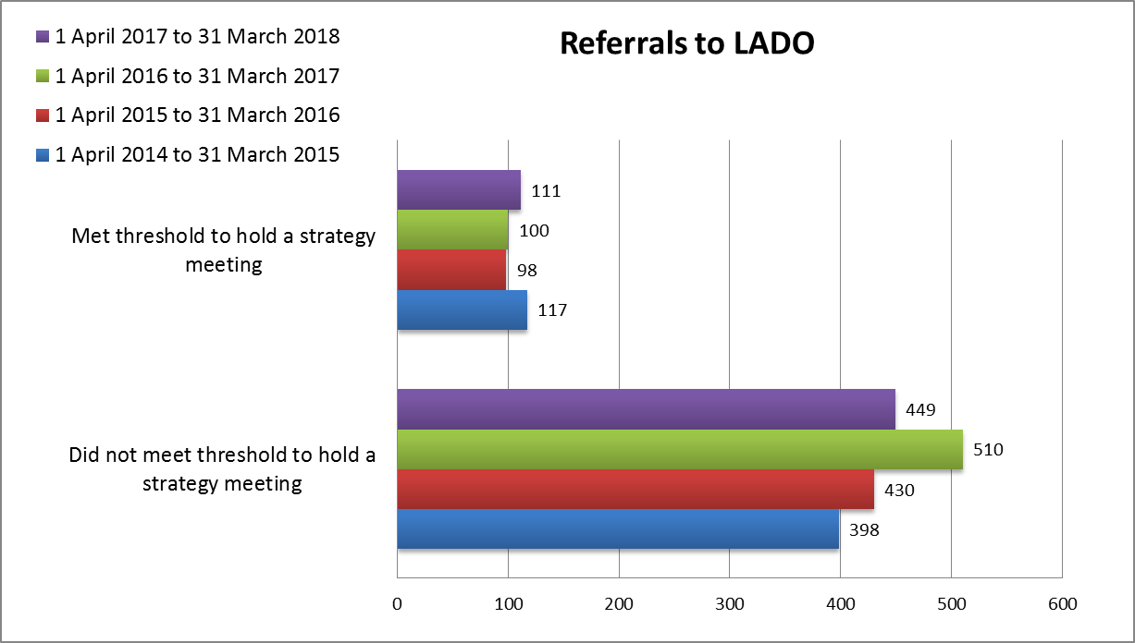

**Referrals that met the threshold by primary category of concern**

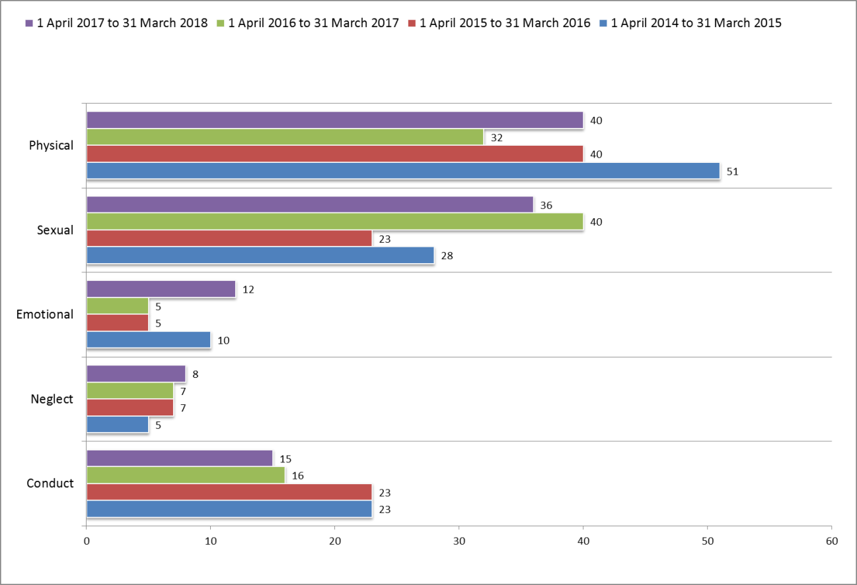

**Referrals that met the threshold by primary agency of accused adult**



*Self Employed are not appointed by any agency, group or organisation and can include –   
home tutors, dance instructors, martial arts instructors, child minders.

Only the adult’s primary role has been recorded in this report to avoid duplication. If an accused adult has more than one role working with children safeguarding representatives from each of these agencies will be invited to the strategy meeting and the risk to children in each of the settings will be considered.

**Referrals that met the threshold by outcome of allegation**

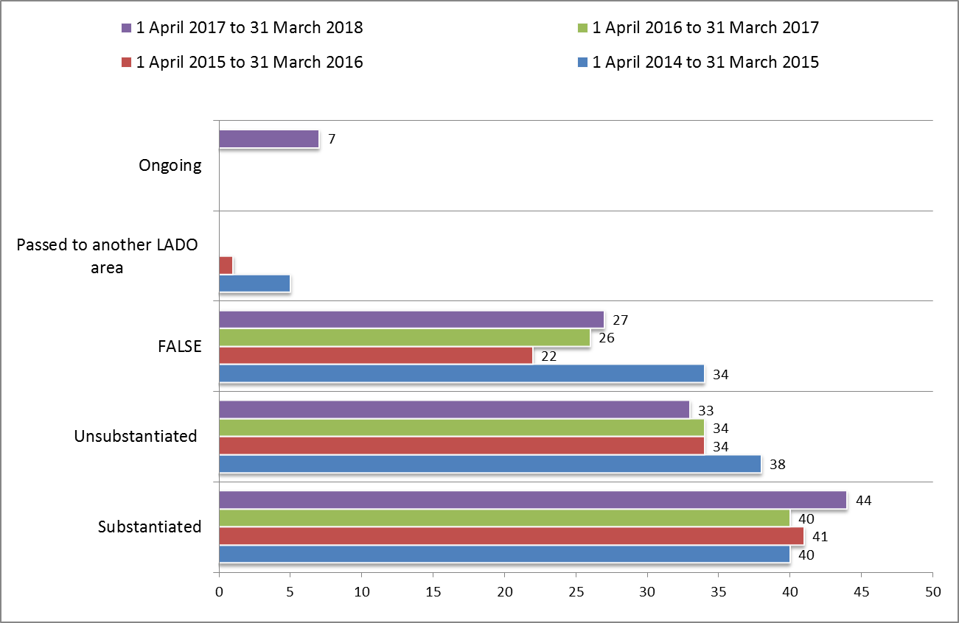

In the majority of cases the allegation was substantiated indicating that referrals are generally appropriately made and thresholds for referral to the LADO are understood.

**5.5.3 Working together with other agencies**

There is clear evidence of good working together with other agencies as LADO strategy meetings are regularly attended by the police, children’s social care, adult social care and other key agencies as necessary.

The LADO works closely with the adult safeguarding team to ensure the right service area is dealing with safeguarding allegations whether this involves children or adults at risk of harm.

In the Ofsted inspection published on 19 January 2018. The role of the LADO was judged as follows:

*14. Designated officer (DO) responsibilities are effective and show that there is good liaison between agencies when there are concerns that professionals or adults who have contact with children may potentially be putting them at risk. The DO ensures appropriate child-centred decision-making in relation to risk.*

An electronic survey was sent out in January 2018 to everyone who has attended a LADO evaluation or strategy meeting from 1st April 2017 to 31st Dec 2017. There were 83 respondents which represents 29% of those who were contacted. Of this cohort 49 identified themselves as making a referral to the LADO service; the others were invitees to the meeting. The feedback on the service was very positive describing it as timely, effective and professional.

**5.5.4 Areas for Development in 2018/19**

1. Further development of a system for auditing the work of the LADO that reflects the national handbook and standards when these have been agreed nationally.

2. Develop a system to ensure that referrals are dealt with consistently by the Child Protection Chairs when the LADO is not available.

* 1. **Child death Overview Panel**

The Regulations relating to child death reviews The Local Safeguarding Children Board (LSCB) functions in relation to child deaths are set out in Regulation 6 of the Local Safeguarding Children Boards Regulations 2006, made under section 14(2) of the Children Act 2004.

The LSCB is responsible for: a) collecting and analysing information about each death with a view to identifying:

1. any case giving rise to the need for a review mentioned in regulation 5(1)(e);
2. any matters of concern affecting the safety and welfare of children in the area of the authority;
3. any wider public health or safety concerns arising from a particular death or from a pattern of deaths in that area; and (b) putting in place procedures for ensuring that there is a coordinated response by the authority, their Board partners and other relevant persons to an unexpected death.

During 2017-18 the Panel met on five occasions and reviewed 27 deaths.

Of these deaths 18 were identified as having modifiable factors and eight had no modifiable factors. In one of the deaths there was insufficient information to determine whether a factor was modifiable or not.

One of the cases reviewed had been subject to a published serious case review. The panel accepted the recommendations of the serious case review.

Since 2012 there has been an increase in the number of modifiable factors identified in child deaths. This is in keeping with the national trend. This is thought to be due to the CDOP process evolving and developing a more consistent approach to understanding ‘modifiable factors’. In addition, local trends may have begun to emerge which would suggest that deaths should be assessed as having had ‘modifiable factors’ when previously this would not have been the case.

Factors identified as modifiable does not mean the factors fully explain the child death but they are considered to be contributing factors. Some examples of the modifiable factors found in the reviews include:

* Smoking during pregnancy or by the parent or carer in the household
* Parental mental health
* Domestic violence in the household
* Underlying health conditions
* Access to medical services

This categorisation does not indicate any implication of blame on any individual party but acknowledges that where factors are identified, the death may have been preventable if that factor had been addressed. Nationally, the trend has been for a gradual year on year increase in the percentage of child death reviews identified as having modifiable factors: 24% in 2017 compared to 20% in 2011.

Following the review of a child death, the CDOP has the ability to take action or make recommendations. In the last year the CDOP has:

* Undertaken a further Safe Sleeping Campaign to enhance the information already provided to new parents
* Reviewed the response to parents smoking in pregnancy to consider whether or not it is sufficient. This work is ongoing at the time of writing
* Mapped bereavement support to ensure sufficiency

Overall attendance at the panel has been good. The majority of agencies have achieved 100% attendance at the panel meetings.

There are a number of relative strengths of the Doncaster CDOP:

* The panel generally has a high level of attendance indicative of strong multi-agency engagement
* Recording of ethnicity has improved significantly.
* The number of child deaths awaiting review is minimal.
* Learning and engagement with other panels within South Yorkshire is continuing. This is done via quarterly meetings and newsletters. An audit of modifiable factors across South Yorkshire has taken place to ensure greater scrutiny of modifiable factors and ensuring that local practice reflects national practice.

**5.6.1 Areas for Development**

CDOP will continue to evolve and develop in line with the recommendations of the Wood Review and the guidance contained within the new Working Together 2018.

* 1. **Workforce Development**

The period 2017-18 saw a continuation of the significant progress over the last four years in relation to multi-agency workforce development. In 2016-2017, the Workforce Development Sub Group (WDSG) reviewed its Terms of Reference to provide a focus on the production of a quarterly report detailing both multi agency and single agency training delivered alongside gap analyses in respect of strategic priorities. The outcome of the review was that single agencies will be required to provide an annual report detailing training delivered and assurance of workforce competence against strategic priorities.

The Board has a strong commitment to multi-agency training and continues to invest in developing a multi-agency training pool. The role is supported by a person specification and job description. There have been significant contributions from members of the multi-agency training pool and the training pool continues to deliver high quality training. The DSCB training offer continues to span a range of safeguarding subjects outlined in the table below:

The chart above demonstrates strong engagement from across all of the key agencies involved in children’s safeguarding. In total 1,991 training places have been utilised. This positive engagement allows key messages and information to be easily shared.

**5.7.1 Range of Courses Delivered by the Doncaster Safeguarding Children Board 2017-18**

|  |  |
| --- | --- |
| **Courses Delivered** | **Number of Sessions** |
| Effective Partnership | 4 |
| Neglect Toolkit | 4 |
| Child Hood Neglect | 3 |
| Child Sexual Exploitation | 9 |
| Delivering Early Help Role of the Lead Practitioner | 11 |
| Recognising and Responding to Sexually Harmful Behaviour | 1 |
| Signs of Safety Roadshows | 7 |
| Hidden Harm | 1 |
| Domestic Abuse Seminars | 6 |
| Welsh Method Training | 1 |
| Introduction to Early Help | 20 |
| Signs of Safety two day training | 4 |
| Signs of Safety three day training | 1 |
| Young people Risk Taking and behaviours | 2 |
| Early Help Outcomes and Plans | 5 |
| Understanding Eating Disorders | 1 |
| LADO Seminar | 2 |
| Introduction to ‘Getting on’ programme | 1 |
| VCS Training for Trainers | 1 |
| **Total Number of Courses** | **84** |

The period April 2017 to March 2018 saw a broad range of courses delivered. These varied in length in accordance with the Board’s approach to flexible learning. This allows participants to be selective in choosing which courses they wish to undertake matching them to their individual learning needs.

**5.7.2 DSCB Conferences**

During the year the Board ran two conferences at the Keepmoat Stadium. Both conferences were very well attended by the range of agencies represented on the Board, with over 180 delegates from the statutory, voluntary and private sectors. The Spring Conference welcomed “Annie - Safeguarding Survivor” who shared her parental experience of the child protection system. The delegates also had the opportunity to view a dramatic performance based again on parental experiences of care proceedings. Feedback was very positive and typified by the following comment:

*“****The dramatic performance was really powerful and identified how early help is so important ………Thank you for an informative day providing me with a lot to reflect upon about my own practice and working with other agencies****”*

The Autumn Conference considered “Multi-agency perspectives in addressing mental health issues within Families”. Although attendance for this conference was low compared to previous events feedback was generally positive particularly regarding the workshops. The conference formed part of a “Safeguarding Fortnight” in partnership with the Doncaster Safeguarding Adult Board. This consisted of a range of training events across Doncaster.

**6. Partner Contributions**

**6.1 Children’s Social Care Services (DMBC, DCST, CAFCASS)**

**6.1.1 DMBC/LOCYP**

In Doncaster, Learning and Opportunities: Children and Young People is a lead partner in delivering against some of the DCSB priorities. Although the social care functions are remitted to the Doncaster Children Services Trust, the statutory responsibility remains with the director of children’s services. The senior leadership team are active members of the DSCB.

**EXPECT Youth Alliance**

The council has a duty to provide access for children and young people to good youth provision. Since 2016, Expect Youth have been commissioned to deliver the universal youth provision previously provided through the council. Under the EXPECT umbrella engagements with young people has increased. Recently, EXPECT were successful in receiving funding through the Social Mobility Opportunity Area to provide an extended range of holiday activities, as well as support those children and young people at risk of “holiday hunger”.

Expect Youth also sit on the child sexual exploitation sub Group board. The council’s contribution to the youth offer is through youth hubs which bring together services for all young people but particularly offering targeted support such as Learning difficulties and/or disabilities and Lesbian Gay Bisexual Transgender and Questioning.

The local authority is leading on developing a comprehensive borough wide youth strategy.

Family Hubs are the conveners and co-ordinators of the local early help offer; and bring together services to be the “go to place” for all families with a focus on how they respond together for families when there are additional, multiple or complex needs. This could include services such as Family Group Conferencing, CAMHS, Stronger Families support or domestic abuse services.

Focus continues to be on how services respond together to work with families, through a team around the family approach and underpinned by the Early Help Assessment. It is our ambition to develop whole family work over the coming year.

Over the last year (Q4 15/16 and Q4 16/17) requests into the early help hubs have increased by 31% The number of cases has also increased in the past 12 months with on average between 1500 – 2000 cases open at any one time. Demand across the EH and SC system has increased and as a partnership there is a need to consider our response to managing demand – this is a key priority for 2018/19. In addition, up to May 2017 of the cases closed 44% had de-escalated.

**Services for 0 -5s**

DMBC’s commitment to early help is also being delivered through the services for 0-5s. An outreach offer has been developed to work directly within family homes to support childhood development, improve outcomes and encourage access to universal services for identified vulnerable families. Clear protocols and policies are in place to ensure that staff follows safeguarding procedures. Safeguarding is routinely discussed at team meetings and there is an expectation that staff is trained to level three. Action plans are in place to evidence the implementation of the signs of safety and the neglect strategy. Partnership working with a range of services also supports more complex needs within families. Registration and engagement figures to family hubs are improving.

The Early Years’ Service continues to support the public voluntary industry sector which has resulted in all public voluntary industry settings being Good or Outstanding - no recommendations for safeguarding, and continued improvement in Ofsted judgments for Childminders (Good -85%). Safeguarding audits (Section 11 audits) are near completion for all newly registered settings and for those settings where there is an identified cause for concern’. Follow up and intensive support has been provided to monitor the impact of these. These will all be completed by May 2018.

Basic Awareness and Refresher in Safeguarding and Child Protection training has been provided, as well as WRAP training to raise awareness of the Prevent duty guidance. Providers are signposted to relevant safeguarding training to enhance their knowledge. In addition, safer recruitment is a strand of the safeguarding training and forms part of the section 11 audits.

**The Education Service (Learning Standards and Effectiveness)**

The Head of Service for Education works closely with the CYPS Safeguarding Manager. Developments this year include the implementation of a new virtual system to analyse section 175/157 reports, enabling greater efficiency and targeted support.

This service handles all Ofsted complaints related to schools. The number and frequency of these has lessened in the last six months although there are a number of very complex cases that require a multi-agency response. Termly meetings are held with senior Her Majesty’s Inspectors to discuss any emerging safeguarding issues across the authority.

The Education Advisory Group (EAG) has been relaunched and will meet on a termly basis, reporting to the DSCB. This representative group monitors developments and issues around safeguarding in schools providing support for DSCB safeguarding priorities.

Since September 2017, no school has received an ineffective safeguarding judgement. Partners in learning offer a safeguarding health check to all educational establishments. This supports leadership teams to review safeguarding provision prior to inspection.

**CYPS / Education Safeguarding Team**

The CYPS Buy Doncaster Safeguarding Training offers a range of training and network support. Termly Designated Safeguarding Lead Networks are very well attended, with over 300 staff attending once a term to receive safeguarding updates and training. The safeguarding manager is a registered Home Office Trained Trainer and works in partnership with The South Yorkshire Police Prevent Team to train more staff to deliver PreventWrap3 workshops.

This team cascades all DSCB and other agency information via the school portal, Buy Doncaster and SMG/ELG meetings.

This team also offers child exploitation online protection ‘Think U Know’ training to enable staff to deliver on line protection / safety to children, families and those who care for them.

**Services to Vulnerable Children**

The local authorities’ Special Educational Needs and Disabilities (SEND) team continues to deliver all statutory duties under the SEND Code of Practice 2015 on behalf of the local authority. Strong links are in place with the wider system, for example special schools, children’s commissioning, the local authorities safeguarding lead, Standards and Effectiveness Team, the Children’s Trust and health agencies to share information and support safeguarding practice for children with SEND. Through these partnerships the team is able to respond promptly for example when regional or parental concerns are raised.

All children’s statements have been converted to Education, Health and Care plans (EHCPs) by the DFE deadline set at the end of March 2018. There is a growing demand for educational placements for children with SEND, in particular autistic spectrum disorder. Plans are underway to build a new special school for children with communication and Interaction needs. We are expecting the SEND inspection imminently and plans are underway to complete a comprehensive SEND review.

**Behaviour Services**

The council has undertaken a systemic review of inclusion, including a full review of all the commissioned services for young people accessing alternative provision. All provision has been inspected and given improvement plans to secure and develop better outcomes.

The service has led on the establishment of a behaviour network including primary and secondary colleagues to develop stakeholder voice and contribution.

Within the off-site provision team, the roles of co-ordinators have been strengthened to ensure personalised planning for young people, giving them daily contact and ensuring safeguarding across the board. A three year plan is being implemented which will see the development of a Big Picture Learning School (American education model), refocussing of the pupil referral provision and better management of attendance and exclusions within schools.

The Admissions, Attendance and Pupil Welfare Service (AAPSW) has prioritised the tracking of children missing education, supporting protecting vulnerable young people and child sexual exploitation meetings. The team has also focused on children who are provided with elected home education. Any child reported home alone is also included in their duties to safeguard. The voice of the child within case notes show impact and the team have regular case file supervision and audits. Challenges are that concerns raised in regard to education are not always seen as safeguarding issues, but more attendance issues.

**Virtual School looked After Children and Gypsy Roma Traveller**

The new personal education plan process requires schools to offer a view on the emotional health and well-being of any child in care and where they are unable to do so the virtual school is supporting them to be able to assess it through the strength and difficulties questionnaire. The framework provided by Signs of Safety has positively influenced the new personal education plan.

Work is happening to involve the Roma community in more whole school activities which allow safeguarding messages to reach them effectively despite language barriers. Close and effective working relationships have been developed with the Doncaster Children’s Services Trust, raising the profile of the Virtual School.

Through Strategic Commissioning & Transformation there has been a continued focus on quality and safeguarding in 2017/18, in particular strengthening the quality aspects within the commissioning cycle. This comprises of a Commissioning Toolkit which incorporates as a minimum DCSB standards, safeguarding within all service specifications, evaluating the suitability of providers using pre-qualification questionnaire process, the use of the section 11 self-assessment as a pre-qualifying criteria and annual self-assessment for all external providers, a continuous safeguarding issues log and dashboard, contract monitoring including quality assurance frameworks.

**Plans and priorities in safeguarding children for 2018-19**

The continuing functional review of LOCYP will ensure that services are delivered by the council that are fit for purpose. Whist the review continues it is essential that this does not hinder the pace of change or improvement.

In addition a Safeguarding Development Review was commissioned to consider the following:

* Training Needs Analysis for the Children & Young Person’s Directorate in line with safeguarding regulations, Working Together, local policy decisions e.g. Signs of Safety, escalation of safeguarding issues, etc.
* Standard Induction pack for Head of Service, Service Manager, and Team Manager levels.
* Systems and processes for the above, such as a grab pack for urgent/emergency safeguarding issues.

The findings and recommendations of this review will be developed and embedded into practice across the whole of LOCYP in 2018 -19.

**6.1.2 Doncaster Children’s Services Trust (DCST)**

The past year has been an important year for Doncaster Children's Services Trust (the Trust). In 2014 when The Trust was established, children’s social care in Doncaster was evaluated by Ofsted as “inadequate”. The Trust was set the target by the Department for Education of achieving a grade of “good” by the end of 2017.

In November 2017 the Trust was again inspected by Ofsted. The report was published on 19 January 2018 and the Trust was evaluated as “good” across all areas of judgment. To achieve this level of improvement in such a short space of time was a major achievement for our staff and partners.

The inspection report stated that:

“There have been significant improvements in the quality of support for children in Doncaster.”

And in addition:

“The trust is highly effective in developing a culture for good social work to flourish. As a result, the quality of social work is good and is supported by a well-embedded model of social work practice.”

The report particularly outlines our strengths in ensuring that we listen to the views of children and young people and concluded that this:

“is at the centre of everything that social workers do”.

The Trust has an established framework for quality assurance that enables senior managers to be well-sighted on the quality of front-line practice. The core of this system is the individual audit of approximately fifty children’s cases per month across all social work teams including our children with Disabilities Team. Audits are undertaken by all operational managers including senior managers, as well as our Independent Reviewing Officers and Child Protection Conference Chairs. In addition regular thematic audits are undertaken by colleagues in the Centre for Excellence in partnership with operational staff.

In 2017 the inspectors stated:

“There are highly effective performance and quality assurance systems, which provide a framework to continually improve services. Fifty audits are completed each month by trained and supported managers across the trust. Additionally, thematic audits are routinely undertaken and have recently considered the quality of supervision and the rate of re-referrals. Findings from audits are discussed in regular performance meetings and good practice is celebrated.”

The proportion of cases graded as inadequate or requiring improvement has reduced significantly with almost two thirds of cases being graded as “good” or “outstanding”. A system is in place to ensure that any actions identified in audits are swiftly addressed.

The Trust has a comprehensive performance framework that provides high quality and up to date information to senior managers but which is also very accessible to operational managers, enabling managers to address performance deficits and enabling achievements and improvement to be acknowledged and celebrated.

In 2017/18, we have continued to embed Signs of Safety across all of our services and this has been instrumental in helping us to maintain the pace of change and engage with children and their families.

Key to the success of the Trust has been our ability to develop a stable and supported workforce. The number of agency staff has reduced significantly since the establishment of the Trust and a significant number of social workers employed in an agency capacity have chosen to take up permanent posts with us.

All senior management posts are filled on a permanent basis and this has enabled consistent, stable and highly visible leadership to our staff.

Our children’s homes continue to provide safe care for young people who need this type of accommodation and all our homes have been graded as “good” by Ofsted including our short break home for children with disabilities. This reflects the skilled and committed staff who work in our homes and who regularly “go the extra mile” for the young people they look after. We confidently predict that our homes will continue to grow from strength to strength in 2018/19.

As a result of our successes in 2017/18, the Trust has now been awarded Partners in Practice status by the DfE meaning that the Trust will now be providing peer support to colleagues in other areas of the country.

**Plans and priorities in safeguarding children for 2018-19**

The Ofsted inspection made four recommendations for further work:

* Ensure that all social workers receive high-quality supervision, which is recorded in a timely manner.
* Ensure that assessments, plans and subsequent actions are completed to The Trust’s standards for all children
* Continue to improve the availability of local placement options and ensure that national guidance is followed when placing children.
* Ensure that all children looked after and care leavers have easy access to leisure facilities.

An action plan is now in place and our progress is monitored closely via our monthly “Good to Great” meetings, chaired by the Trust’s Chief Executive.

In 2018/19, our quality-assurance programme will continue to be used as a means of identifying our impact on the children and young people who need our help. The programme will be enhanced by the inclusion of observations of social work practice as part of each case audit.

A key focus for 2018/19 will be ensuring that we maximise our internal capacity when children and young people need to become looked after, in order to reduce our reliance on private accommodation providers and the number of children who need to be cared for outside Doncaster. With the support of our partner agencies we have recently opened our own supported independent living home for young people aged 16 and over. We will also be expanding our cohort of foster carers with a focus on recruiting carers who are able to work therapeutically with young people who have experienced traumatic lives.

A key challenge will be to not only maintain but further improve our services in order to achieve our “outstanding” target while working within the strict financial envelope and in the context of increased demand for services.

**6.1.3 Child and Family Court Advisory Support Service (CAFCASS)**

Cafcass (the Children and Family Court Advisory and Support Service) is a non-departmental public body sponsored by the Ministry of Justice. Cafcass represents children in family court cases, ensuring that children's voices are heard and decisions are taken in their best interests.

The demand on the family justice system and on Cafcass services remained very high throughout the year, with rises in local caseloads varying across the country. Overall, Cafcass has seen a rise in private law applications (involving arrangements for children following parental separation) and a small decrease in public law applications (involving the local authority), Cafcass is actively contributing to the Care Crisis Review, a sector-wide initiative that aims to stem the increase in care cases and promote safe and beneficial outcomes for children. We are also undertaking innovative projects that seek to improve practice, promote good outcomes for children and make better use of limited resources. An example is the three assessment pathways that we have been developing – domestic abuse; high-conflict; and parental alienation.

Cafcass’ strategic priorities in 2017/18 were to: continue to improve our performance and the quality of our work; contribute to family justice reform and innovation; use our influence to promote knowledge and best practice; bring the uniqueness of each child (including diversity considerations) to the court’s attention; be efficient and effective in light of high demand and financial constraints.

In February and March 2018, Ofsted undertook its second national inspection of Cafcass, making an overall judgement of outstanding. Ofsted found that practice was effective and authoritative, helping courts to make child-centred and safe decisions, adding value and leading to better outcomes for children. The overall judgement was influenced by many factors including: the exceptional corporate and operational leadership; sensitive and knowledgeable direct work undertaken with children in relation to a wide range of diversity issues; the culture of continuous learning and improvement; and a strong aspiration to ‘get it right’ for vulnerable children. The inspection identified some areas for Cafcass to improve relating mostly to the quality of recording and to explaining to court consistently when issues of diversity are not relevant to the application. We will be working on these in the year ahead and will continue to try to improve our services, and to contribute to family justice reform.

**6.2 Health Services including Doncaster Clinical Commissioning Group (DCCG), Doncaster and Bassetlaw Teaching Hospital NHS Foundation Trust (DBTH), Rotherham, Doncaster and South and South Humber NHS Foundation Trust (RDaSH), NHS England and Primary Care.**

**6.2.1 Doncaster Clinical Commissioning Group (DCCG)**

As a commissioning organisation Doncaster Clinical Commissioning Group (DCCG) has a responsibility for ensuring that health care across Doncaster is delivered to a high quality standard. Doncaster CCG’s with its strong Designated Safeguarding Professional function has the capacity and capability to support the DSCB in its statutory role to safeguard and promote the health and welfare of children across Doncaster. DCCG has continued to actively support health and multi-agency partners in their commitment to provide high quality practice across safeguarding services. Endorsing organisational responsibilities as outlined through the DSCB, successfully led the multi-agency Child Sexual Abuse T&F Group throughout 2017-18. The multi-agency action plan is now complete. A major piece of work from this group was the development and implementation of the multi-agency policy for safeguarding children and young people who may have been sexually abused. This work will now feed into the board’s daily business throughout 2018-19.

The Deputy Designated Nurse for Safeguarding children successfully led the DSCB Neglect Task & Finish group; following completion of the assigned action plan, the chair recommended to the board that work must continue to ensure neglect remains a priority. The Doncaster Children and Young People’s Plan 2017-2020 has placed neglect firmly into its agenda. A neglect theme group has now been set up in order to develop a strategy and work plan. The Deputy Designated Nurse for Safeguarding children continues to support the strategy as vice chair of theme group.

DCCG is fully engaged in activities that promote the DSCB communication strategy, endorsing the need to consult with children, young people and families in service delivery, development and planning. DCCG remains in a position that ensures it is fully sighted of any presenting and emerging issues that may impact on service deliver and safeguarding practice across the multi-agency system. This enables DCCG to influence decision making at all levels of concern.

**Plans and priorities in safeguarding children for 2018-19**

Following the Alan Wood Review 2016 and the subsequent amendment to legislation under the Children and Social work Act 2017, Working Together to safeguard children 2015 is now under review and consultation. Any amendment to the HM Government Working Together document will require due consideration by Doncaster Safeguarding Childrens Board and partnership. Doncaster CCG will be integral to any review and development process. DCCG remains committed to support the Doncaster partnership in shaping, implementing and embedding any transformation programme within the DSCB that is in line with any legislative change or amendments in the formal national guidance.

**6.2.2 Doncaster and Bassetlaw Teaching Hospitals – NHS Foundation Trust (DBTH)**

The safeguarding team continue to work together with partners to safeguard children across Doncaster and Bassetlaw geographical area. This includes a plethora of meetings both internal and external to the organisation. In respect of DSCB the safeguarding nurses have regularly attended Workforce Development, CSE & Missing, Case Review Group and Performance and Quality Sub groups. The Deputy Director of Nursing attends the Board Meetings.

NHS England have tasked provider health organisation with priority areas including Child Protection Information Sharing (CP-IS) and Prevent. DBTH are now live with CP-IS in maternity services despite Doncaster local authority not having a live status, going live in our Emergency Department has caused frustrations due to information technology problems which we anticipate be resolved in the near future. CP-IS is vital in enhancing child protection procedures. In a bid to achieve target set for Prevent we have increased our Prevent training sessions and introduced an eLearning option.

The team has been extremely proactive in promotion of various safeguarding areas with a three monthly newsletter covering various topics. In the hospital we have secured a notice board in the public domain which is regularly updated and we have recently launched a Facebook page specifically for highlighting safeguarding issues. We have used these resources to promote National Awareness days such as child sexual exploitation, Safer Sleeping for Babies and Modern Slavery Awareness. As a team we participated in the Safeguarding Fortnight with partner agencies.

We continue to deliver safeguarding training at levels 2 and 3 within the hospital and have built on multi-agency training for level 3 safeguarding children updates hosting sessions for Signs of Safety regularly throughout the year. This year we have also including a variety of eLearning packages to give staff another option with their safeguarding compliance.

As a team we have become more visible in our organisation, visiting wards and advising staff face to face regarding safeguarding issues. There are regular drop ins sessions in the Emergency Department and across Children’s Services.

We are proud that our Named Midwife for Safeguarding Children attended an awards ceremony for her joint work with partners in respect of Pregnancy Liaison, winning the award for working together to protect unborn babies.

Quarterly Health & Social Care meetings organised by the Named Nurse for Safeguarding Children have been successful with good attendance from internal services and DCST. They enable information sharing, updates from organisations and an opportunity to raise concerns and highlight any issues and escalation from either side.

**Plans and priorities in safeguarding children for 2018-19**

Our main priority in DBTH is to ensure all staff are compliant with their safeguarding training level dependent on their roles and responsibilities.

To use our new means of promotion of safeguarding subjects through social media and notice boards as well as existing methods through our intranet, weekly hospital bulletin and our Safeguarding Newsletter. This will ensure staff are fully equipped to recognise any safeguarding concerns and address them or seek help to do so. We can also use these methods to disseminate learning from serious case reviews and Local learning lessons reviews. We will participate in various joint working initiatives across both geographical areas by means of prioritisation to ensure all work is relevant and proactive to safeguarding children.

**6.2.3 RDASH - Rotherham Doncaster and South Humber NHS Foundation Trust**

RDaSH is committed to the priorities of the DSCB and has undertaken a range of activities reflecting the commitment to the partnership working.

The key pieces of work have included:

* The embedding and delivery of the Signs of Safety methodology including the comprehensive and robust delivery of training in Signs of Safety, reporting and clinical record templates reflecting Signs of Safety, supervision records reflecting Signs of Safety and applying the Signs of Safety methodology to a range of other activities.
* The adoption of the Doncaster approach to child neglect including an intensive programme of training.
* Commitment and involvement in the DSCB audit programme and the consequential learning from the audits.
* Membership and active contributions to all DSCB, sub-groups and task and finish groups.
* Support and involvement in the Doncaster safeguarding week.

**Plans and priorities in safeguarding children for 2018-19**

• RDaSH is committed to being a key partner in the new safeguarding arrangements, being rolled out in response to changing legislation.

• To deliver a “Think Family” model of intervention across all RDaSH services in Doncaster where children and adults services work closely together to achieve the best outcomes for families.

• To translate and embed the learning from audit and other activities to review practice.

• To influence and support the best practice in relation to child welfare and safeguarding, working with partners to achieve the best outcomes for children and their families in Doncaster.

• To embed evidence based safeguarding practice in to all services, keeping the child and family at the centre.

**6.2.4 NHS England**

NHS England is the policy lead for NHS safeguarding, working across health and social care and leading and defining improvement in safeguarding practice and outcomes. It is the responsibility of NHS England to ensure that the health commissioning system as a whole is working effectively to safeguard children and adults. Key roles are outlined in the Safeguarding Vulnerable People Accountability and Assurance Framework 2015.

NHS England Yorkshire and the Humber has an established Safeguarding Network that promotes shared learning across the safeguarding system. Representatives from this network attend the national Sub Groups, which have included priorities around Female Genital Mutilation (FGM), Child Sexual Exploitation, Children Looked After, Mental Capacity Act (MCA), Modern Slavery and Trafficking and Prevent. NHS England Yorkshire and the Humber works in collaboration with colleagues across the North region on the safeguarding agenda. A review of the Yorkshire and the Humber safeguarding network has established local safeguarding network meetings bi-annually in the three Sustainability and Transformation Partnerships areas (some now named Accountable Care Partnerships) in addition to a bi-annual safeguarding commissioners and providers network event.

**Sharing learning from safeguarding reviews**

In order to continuously improve local health services, NHS England has responsibility for sharing pertinent learning from safeguarding serious incidents across Yorkshire and the Humber and more widely. A North region newsletter is now circulated weekly to safeguarding professionals. Learning is also shared with GP practices via quarterly Safeguarding Newsletters, and annually safeguarding newsletters for pharmacists, optometrists and dental practices across Yorkshire and the Humber are produced.

An annual North region safeguarding conference is hosted by NHS England North for all health safeguarding professionals, this year’s event included learning on neglect, hoarding and asylum seekers. Due to the success of last years named GP conference in Yorkshire and the Humber NHS England North also held a conference for named GPs to share good practice and learning; topics included homelessness, domestic violence, travelling families and safeguarding.

**Training & Development**

Designated safeguarding professionals are jointly accountable to CCGs and NHS England and oversee the provision of safeguarding training for primary care medical services. The main source of training for other primary care independent contractors is via e-learning training packages.

A number of leadership programmes for designated safeguarding professionals have been commissioned by NHS England in addition to a 2 day resilience course. The CSE training provided by BLAST 'Not Just Our Daughters' has also been provided for front line health professionals.

**Assurance of safeguarding practice**

NHS England North developed a Safeguarding Assurance Tool for use with CCGs across the North Region, which was implemented in 2016/2017.An online version has been piloted in 2017/18 by NHS England in order to develop a national assurance tool for CCG’s. A primary care version of the online assurance is also being piloted by a couple of CCGs in Yorkshire and the Humber.

**Specialised Commissioning**

NHS England North Specialised Commissioning service providers are, via the contracting process, required to demonstrate compliance with all relevant safeguarding policies and legislation and work in partnership with other agencies regarding all aspects of safeguarding.

Within Specialised Commissioning the Heads of Quality review all serious incidents and liaise with the appropriate CCG to review all incidents and work through actions with the provider. Where NHS England North Specialised Commissioning is the lead or sole commissioner they work directly with the provider, monitor actions and share outcomes with other commissioners.

**Health and Justice**

NHS England North Health and Justice Service providers are, via the contracting process, required to demonstrate compliance with all relevant safeguarding policies and legislation and work in partnership with other agencies e.g. Prison, Police regarding all aspects of safeguarding.

In addition, there is a Quality Framework in place which requires all providers to report on a quarterly basis regarding any safeguarding concerns, incidents, reviews (including themes and trends). An annual audit of Combined Adults and Children’s Safeguarding Standards and an annual safeguarding report are also submitted for review to the NHS England local office Quality Surveillance Group.

**Complaints and Concerns**

NHS England Customer Contact Centre review all complaints and concerns received and identify those containing a safeguarding element for appropriate action. Following receipt of complaints and concerns at NHS England North local offices these are reviewed again and any safeguarding concerns identified are referred to the safeguarding lead for review and appropriate action.

**Priorities in 2017/18 around complaints were:-**

* NHS England North regional safeguarding team in partnership with NHS England local offices reviewed and agreed a standard process for the management of safeguarding concerns within complaints.
* NHS England North regional safeguarding team has delivered safeguarding training to the required standard and level to all complaints staff in accordance with relevant national guidance.

**Prevent**

NHS England North have two Regional Prevent coordinators who work across the North region to support Prevent implementation, they are part of the National and regional safeguarding and Quality team. This year has seen an increased focus and scrutiny on Prevent implementation within health and safeguarding.

**6.2.5 Primary Care**

Primary care, made up of 43 GP Practices, has fully engaged in the 2017-2018 self-assessment tool developed by DCCG as a means of offering assurance of quality safeguarding practice as well as identifying areas of support and training. Supported by the Named and Designated function within DCCG, primary care continues their daily work and patient consultations with children’s safeguarding fully in mind.

Quality training and network events during 2017-18 in partnership between DCST and DCCG have reached 347 primary care GPs and nursing staff. The level 3 safeguarding children training was seen to evaluate positively and increased their understanding, awareness and confidence in identifying and responding to children safeguarding issues as a means of ensuring children receive help and support at the earliest opportunity. The purpose of increasing the network between primary care and DSCB was to promote relationship and increase better joint working across the partnership. The initial event that took place in March 2018 was evaluated as successful, with a further network session plan for July 2018 it is hoped that relationships and positive working will continue to develop.

Through training and support the safeguarding and standard have continued to monitor GP engagement in the child protection conference process, the intensive work between the safeguarding leads both in DCST and DCCG has seen an overall improvement in the submission of reports for both initial and review case conferences throughout 2017/18.

**Plans and priorities in safeguarding children for 2018-19**

2018/19 will see primary care continue to strengthen their safeguarding practice even further, supported by the Named, Designated and Quality leads within DCCG, those working in GP practices across Doncaster will be expected to work towards the safeguarding standards as set out by the self-assessment tool 2018/19.

**6.3 Police/YOS/National Probation Service/Community Rehabilitation Company**

**6.3.1 South Yorkshire Police**

Protecting vulnerable people (PVP) is at the core of the PCC’s Police and Crime Plan and a key deliverable of South Yorkshire Police’s plan on a page.

In October 2017, the force released a new vulnerability strategy, that outlines the forces definition of vulnerability and highlights some of the key principles that the force believes are important in providing a policing response to vulnerable people and the importance of working with partner agencies to ensure a tailored approach to protecting vulnerable people.

To effectively reduce vulnerability, a Vulnerability Assessment Framework (VAF) has been introduced to assess the vulnerability of victims and to provide staff with a consistent methodology to recognise vulnerability and inform decision-making.

In April 2018 South Yorkshire police are reintroducing PVP units to District management, with child abuse investigation unit and safeguarding adult’s team amalgamating to become omni-competent teams, however will still remain collocated with other key partner agencies.

Within the child abuse investigation unit there is a dedicated child sexual exploitation team and missing from home staff.

Co-location of police and key agencies is in place at district level through the MASH process to ensure effective multiagency working. Staff members regularly attend multi-agency meetings concerning children in line with SYP statutory requirements. These close working arrangements enable greater communication between agencies and allows quick actions to ensure children and young people are appropriately safeguarded. It also strengthens partnership working, providing a more cohesive service for children and vulnerable people.

Building on work already undertaken relating to children and young people adversely affected by ‘living with domestic abuse’ South Yorkshire Police and DCST are in consultation to embed ‘Operation Encompass’. Operation Encompass is an initiative whereby South Yorkshire Police inform social care colleagues of incidents of domestic abuse in a household where a child or young person of school age resides, this information is then shared with the Childs’ school in order for the school, if required, to provide support to the child whilst in school. The impact that domestic abuse in a child’s household can have on that child (children) is well documented; by implementing Operation Encompass across the borough, children can be supported whilst in school, and potential issues can be resolved or understood prior to them becoming a major problem.

Senior officers and staff members of the force are members of the Local Safeguarding Children Board, associated sub groups, and play a major role in ensuring processes are in place to protect vulnerable children. Each member of the board holding each other to account where necessary.

SYP is routinely inspected by Her Majesty’s Inspectorate of Constabulary, in relation to SYP’s ability to safeguard and investigate offences against children. The quality of investigations is audited, maintained and benchmarked against similar forces regularly.

Reports and recommendations coming from these inspections are robustly managed via senior leadership group ensuring improvement in the way services are delivered. In January 2018, SYP conducted a review of case review key themes (inclusive of SAR, DHR, SCR and LLR). This learning has been shared with all SYP staff and in relation to learning from domestic homicide reviews; the learning was shared in March 18 at the Strategic Safeguarding Board meeting.

Force policies are routinely reviewed and revised and the recent introduction of Authorised Police Practice Guidance has prompted the review of several PVP Policies to ensure they are in line with authorised police practice guidance. The PVP Strategic governance unit has recently updated the majority of policies and procedures of all PVP areas, which are now standardised with national guidance documents.

Audits are regularly conducted focusing on safeguarding children at risk, such as applying aggravating factors to child sexual exploitation and child abuse investigations to ensure all child victims of these crimes are safeguarding appropriately. The issues have been highlighted on the force intranet page with briefings for staff, to ensure staff awareness, knowledge and understanding is improved. In August 2017, a missing from home profile was completed highlighting key themes and issues and providing recommendations.

Young persons police officers work in schools developing relationships enabling young people to feedback their views regarding decisions affecting them. Work is also carried out at the Lifewise Centre, which is scenario based, around issues such as online safety and stranger danger. The majority of Year 6 Primary schoolchildren attend the ‘crucial crew’ intervention at Lifewise during the autumn school term.

All new student officers receive an induction to safeguarding children during their IPLDP course and all front line staff receive input into safeguarding including call handlers, crime recording bureau and front desk staff.

The force crime training department has also developed numerous national centres for applied learning technologies packages around child abuse for 2017. If staff members recognised abuse/neglect of children/vulnerable adults, there is guidance on referral routes available on the intranet. All officers who work in a child abuse investigation capacity attend the joint investigation five day course. Police officers also have 2-year student training which addressed child protection and welfare issues. They have input on recognising the signs and symptoms of child abuse. The police training centres hosts CID PVP master classes at intervals during the year to ‘top up’ both staff and officer’s knowledge across all areas of Safeguarding with the last one covering many aspects of PVP and the use of early evidence kits.

In 2017 SYP introduced a number of trainee investigators who are undertaking Investigator development training programmes in conjunction with the University of Sheffield. This is an accredited programme with support from experienced tutors. This programme is ongoing.

SYP run both the intranet and internet campaigns on child sexual exploitation, modern slavery, domestic abuse with the most recent being vulnerability, these include the signs and the importance of intervening early and each has its own dedicated intranet site, that has all policy, procedures, minimum standards and any other relevant documents.

Threat, risk and Harm (THRIVE) meetings – local policing units review weekly activities at this meeting to ensure that policing response has been appropriate and that SYP are linking in with partners to ensure best outcomes for children and manage the risk posed by suspects and offenders. Daily management meetings in both PVP and the local policing units review incidents and concerns from the last 24 hrs and set tasks for staff to update the following day. Missing children, child sexual exploitation cases, other child safeguarding issues, High risk domestic abuse and priority arrests are discussed and actioned. Monthly tasking meetings held in PVP and local policing units to ensure that appropriate resources are allocated to investigations or emerging concerns.

**6.3.2 Youth Offending Services (YOS)**

Doncaster YOS is an active member of the DSCB. The YOS is represented on the Board and at sub-groups. The Senior Head of Service for Young People’s Services, where the YOS is located, chairs the Protecting Vulnerable Young People Group and produced the widened Criminal Exploitation Strategy for the DSCB. Members of YOS are actively involved in Board audits and provide performance information to assist the Board in its assessment of effectiveness.

Doncaster YOS and Team EPIC continue to work effectively with young people at risk if offending and those within the criminal justice system. Both teams have robust safeguarding and risk management procedures and have achieved strong performance in reducing first time entrants (FTEs) into the criminal justice system, the binary re-offending rate for those in the criminal justice system and the usage of custodial sentences.

The official data shows that in 2016/17 there was actually a 45% reduction on the 2015/16 FTE numbers. Both locally-held data and official data show that this reduction has continued into 2017/18. The graph below shows how Doncaster’s FTE performance over the last 4 years compares with that for the South Yorkshire PCC area, the North East region and England:

It is clear that Doncaster’s reoffending rate is consistently lower than the regional and national rates.

Doncaster achieved a custody rate of 0.18 per 1000 of the 10 to 17 population for the latest period reported, well below the target set. In real terms, this represents a reduction in the number of custodial sentences from 10 in 2016 to 5 in 2017.

Consequently, the Board can be assured that children in Doncaster are becoming involved in the criminal justice at a lower rate than ever before, but, when they do they receive the interventions required to support an offence free lifestyle.

It should be noted that both the reduction in the re-offending rate and custody rates has not resulted in an increase of serious public protection incidents and in fact there have been no such incidents in 2017/18.

In 2018/19 the YOS will be focussed on maintaining its strong performance contextualised within a national change to how the re-offending cohort is measured. A significant priority in 2018/19 will be embedding the work already being undertaken in terms of child criminal exploitation a (CCE) and also reducing the amount of time young people spend in police cells due to a regional and national shortage of PACE beds.

In respect of CCE, the YOS will work closely with partners to ensure that children are not criminalised when their offending is as a result of exploitation by organised groups or individuals and will continue its training programme focused on raising the awareness of CCE issues within the wider partnership.

In respect of children spending excessive periods in police cells, it is noted that the South Yorkshire PACE bed protocol has not been effective in providing PACE beds for young people when they are required due to the spot purchase nature of the arrangement.

At a regional level work is ongoing between South Yorkshire Police and all four local authorities to address the issue by more aligned agency decision making in respect of when is a PACE bed is actually required due to the risks posed by a child being released, as opposed to simply the risk of a child re-offending upon release. More creative options in terms of PACE bed provision is also being explored at a regional level.

Finally, the YOS will continue its work to ensure that children in care are not unduly criminalised by virtue of their status, especially for offences which occur in their place of residence.

**6.3.3 National Probation Service (NPS)**

**Summary of key safeguarding activity undertaken during 2017 – 2018**

* NPS Safeguarding and Promoting the Welfare of Children Policy Statement issued January 2017
* Safeguarding Children processes mapped on EQuiP (internal process mapping tool)
* NOMS Guidance for Working with Domestic Abuse issued August 2017.
* NOMS Guide for staff on working with perpetrators of child sexual exploitation issued.
* NPS National Partnership Frameworks for Local Safeguarding Children Boards, Multi-Agency Risk Assessment Conferences and Multi-Agency Safeguarding Hubs
* HM Govt “Working Together to Safeguard Children” 2015
* HMIP inspection criteria within which access to and use of ViSOR records is seen as an essential element.
* The South Yorkshire MAPPA Strategic Management Board now have in place Information Sharing protocols with Doncaster Safeguarding Children’s Board and Doncaster Safeguarding Adult’s Board these have been updated in line with new legislation.
* Attendance at LSCB meetings by Head of LDUC.
* Middle management attendance at all operational safeguarding meetings.
* Significant improvements in attendance and reports provided to initial case conferences and review meetings. Performance now stands at 100%.
* Middle manager attendance at the following meetings PYVP, CSE & missing children, child in needs, safeguarding and standards meeting.
* Named children’s services contacts, including conference chairs details provided to NPS staff.

**The impact of the safeguarding work undertaken**

* All adult offenders under the statutory supervision of the NPS have a full and comprehensive assessment (OASys) and robust risk management plan completed within 15 days of commencement of their order/ release from custody.
* Quality assurance measures in place have identified performance to be consistently above the national target.
* Improvements in provision of reports and attendance at both initial case conference and review meetings has contributed to safer planning for children in the Doncaster area.
* Training event held for NPS staff which has resulted in quality improvements of case conference reports. Good feedback from conference chairs re quality of reports.
* NPS member of staff contribution to delivery of multi- agency safeguarding training in particular work with people who sexually offend.

**Challenges for safeguarding and key risks**

* The challenge for our service remains as last year to identify child sexual exploitation (CSE) perpetrators and who are under statutory supervision for broader offences. NPS Doncaster is working towards identifying and flagging all Doncaster child sexual exploitation cases. Upon identification an offender profile will be built and shared with all relevant partners.
* NPS has recently introduced new quality standards. These will take time to embed but it is envisaged that the new quality standards will be fully implemented by December 2018.

**Plans and priorities in safeguarding children for 2018-19**

• All staff are to have completed the following training:

• Safeguarding and Domestic Abuse (Level 1)

• All Probation Officers are to have completed the following training:

• Child Protection (Level 2)

• The introduction and implementation of a new quality assurance tool. All staff are to receive briefing/training in relation to the new NPS quality standards.

• The National plan is in place for Children’s Safeguarding to ensure consistency.

• In support of this performance reporting tool will need to be developed

• Attendance and contribution to JTAI and JTAC

• Ongoing contribution to multi-agency safeguarding training (Keepmoat 2018).

• Ongoing implementation of the NPS neglect tool during 2018.

**6.3.4 South Yorkshire Community Rehabilitation Company (CRC)**

SYCRC strives for continuous improvement in all activities through strong performance management and assurance arrangements which are used to facilitate learning and improvement, both quantitative and qualitative.

The SYCRC Quality Assurance Framework sets about the organisational approach and individual accountability to drive high performance, continuous improvement and development and meets the requirements of the Amended and Restated Services Agreement (ARSA) Schedule 9 Quality Assurance Commitments.

This document includes the assurance and data quality of contract measures and performance metrics, and local assurance activities to ensure that the process and ethos of Quality Assurance, including improvement and development, is fully integrated in the approach to the business.

The SYCRC Quality Assurance Plan 2017-18 included:

* • Embedding the SYCRC monthly case audit process – an audit regime quality assuring at least 1% of the total caseload each month using the SYCRC Audit Tool. This benefited Doncaster LMC ensuring that Doncaster cases were audited for quality. There was also a Child protection audit commissioned which involved Doncaster cases. The results were part of an action plan to ensure continuous improvement in Doncaster.
* • Improving the reporting for audit activity – this included the development of a monthly report for managers to share with their teams identifying areas for improvement, best practice and key themes for wider organisational development activity which is approved and signed off by the SLT to ensure appropriate resources and recommendations are actioned. The outcome of all audit activity is reported to and shared with the Contract Management Team via the monthly Service Management Group.
* • An annual programme of Practice Development Forums – to support continuous improvement of practice and ensure a benchmark level of sufficiency. These focused on key aspects of Probation activity ensuring that Doncaster responsible officers received the necessary training and learning opportunities to improve their practice.
* • Individual Improvement Plans – for those struggling to meet the required sufficiency level of practice. The QA team assist the team manager with the development of the improvement plan, assist with 1:1 coaching and mentoring and identify tailored support to enhance performance knowledge, skills and competencies. One staff member at Doncaster LMC was made subject to a plan to improve practice- this has now been signed off.
* Implementation of Sodexo CRC Practice Standards – to support the roll out of and embed the standards into practice.
* Development of quality assurance arrangements for HUB Monitoring team – developing and implementing audit criteria for telephone monitoring of cases.
* Development of quality assurance arrangements for Operational Partners – developing and implementing audit criteria for all operational partner delivery. This is approved and signed off by the SLT prior to being shared with the relevant operational partner through the monthly performance and quarterly contract review meetings.
* HMIP Quality & Impact Inspection – the planning, coordination and management of the HMIP Inspection including responsibility for sharing best practice, areas of improvement and the HMIP Improvement Plan. The plan focused on improving attendance of service users and ensuring our estates are compliant with the Disabilities Act 2010.
* Doncaster staff undertook an office challenge which looked at the use of Spice in Doncaster through questionnaires with Service Users. This information was then shared with relevant partners to inform learning.

There has been a significant improvement in overall performance measures delivered by SYCRC during 2017-18 and this also extends to the quality of work undertaken as evidenced by the internal audit regime and also the HMIP Quality and Inspection Report where SYCRC was one of only two CRCs to receive an overall positive report.

Plans and priorities in safeguarding children for 2018-19

• Implementing the SYCRC Quality Assurance Plan 2018-19.

• Reviewing all operational process maps and populating the new Sodexo staff Intranet.

• Improving service user engagement results at Doncaster.

• Reviewing and revising 12 month induction programme for VQ3 Responsible Officers.

**6.4 DMBC, Schools and Doncaster College**

**6.4.1 Hallcross School**

The Head Teacher of Hallcross School represents schools on the DSCB. As a member of the Board their contribution to the Board is summarised below.

* Providing representative views from education regarding agency interface and Early Help, at Board meetings and also the Education Advisory Group
* Conduit for information about the DSCB and its work to other heads
* Consulting on aspects of work force development, insofar as school based staff are concerned
* Discharging statutory duties for safeguarding in school

**Plans and priorities in safeguarding children for 2018-19**

• Provide an educational perspective and input for the design of review processes to evaluate impact of strategies

• Support the effective deployment of resource in the system for education, as the largest lead professional and referring body in Early Help

• Support the consultation on the needs of children in families who resist scrutiny and other agency involvement by declining Early Help

• Support consultation on ensuring that students in school access Mental Health resources at an appropriate level; and for schools to become more confident and consistent in their practice in this area

• Other consultation on embedding good practice for a range of issues (e.g. FGM)

**6.4.2 Doncaster College**

The College has made an effective contribution to local safeguarding audits and challenge meetings by engaging, as well as acting, as panel members in Doncaster Safeguarding Children’s and Doncaster Safeguarding Adult Boards audits. The College has received positive feedback in the context of these audits and the contribution to the Learning and Opportunities Challenge Meetings both as a participant and panel member.

The College operates within the Disclosure and Barring Service (DBS) framework and guidelines including regulated activity and associated roles and the requirements of The Keeping Children Safe in Education: Childcare Disqualification requirements.

The College understands its duties and responsibilities under the Counter Terrorism and Security Act (2015). In line with this responsibility the College has embedded staff training which is facilitated by Safeguarding Officers who are Home Office Accredited Trainers (WRAP: Raise Awareness Of Prevent) to deliver a comprehensive Prevent programme (Safeguarding training is 89.60% and Prevent Duty is 90.83% compliant; April 2018).

In line with national guidance the College issued staff and students information in relation to the ‘Run, Hide, Tell’ campaign from the Counter-Terrorism Policing which is supported by the National Counter Terrorism Security Office (NaCTSO). This advice aims to better inform young people (mainly 11-16 year olds) about how to react to an attack and identify suspicious behaviour.

There is an effective and embedded procedure for reporting and responding to safeguarding concerns with links to the Doncaster Local Area Designated Officer (LADO), South Yorkshire Police Community Liaison Officer (Safer Doncaster Team), Doncaster Social Care (Refer and Respond Service/Multi Agency Safeguarding Hub Early Help Pathway), Doncaster Housing for Young People, Vulnerable Adult Team and Public Protection Unit.

The College meets its responsibility to safeguard and promote the welfare of its students by embedding an ethos of ‘zero’ tolerance to bullying with 2395 students receiving Anti-Bullying training via the tutorial programme.

The College in line, with legislative requirements, acts as a ‘Corporate Parent’ and provides effective support for its Looked after Young People and Care Leaver Students with 69 students enrolled with 45 completions.

Safeguarding is a golden thread to all the work delivered at Doncaster College and within that context, as a key strategic priority in 2016/17, online safeguarding tutorials were embedded and delivered through My Sole. Themes included; safe relationships, alcohol and substance misuse, sexual exploitation and anti-bullying. Student comment ‘I had tutorials once a week which helped me very well’.

The College has partnerships with the Doncaster Safeguarding Children’s Board, DSAB Sharing and Engagement, DSCB Workforce Development, Educational Sub Group and a member on the Sexual Health Partnership, Pause Strategic Board and Neglect Task groups.

There are also key partnerships with Local Authority SEND Team, South Yorkshire Police, Doncaster Police; Safer Stronger Doncaster Partnership, CAMHS and Adult Psychological Services emergency crisis teams along with 18+ Children in Care Team. The College operates a welfare register which captures its students who present as most vulnerable including Section 47s.

The College successfully completed the following external audits in 2016/17:

* Q3 Performance Summary for the Doncaster Safeguarding Adults Board (Collated Quarterly – last requested September 2016)
* Quarterly Gap Analysis for College Training for the Doncaster Safeguarding Children Board (Collated Quarterly – last submitted 9th June 2017)
* Joint Doncaster Safeguarding Children Board / Doncaster Safeguarding Adults Board Self-Assessment and Challenge Meeting (May 2017).

**Plans and priorities in safeguarding children for 2018-19**

• To facilitate staff training in the delivery of British Values to all curriculum staff

• To ensure the curriculum observation process takes account of British Values and its delivery across the College

• To streamline the SC1 tracker and purchase an online safeguarding tracking software

• Identify student safeguarding champions (students taking ownerships of their own safety and also advocating where appropriate for others)

• Explore the idea of a Safer College Police Officer (though joint funding)

• Explore online training for safeguarding using the SOLA model that is used on the VLE for students

• Review training and development for staff; mindful of online learning and cohorts of specialised training for given staff

• Develop online SOLA for staff responsibilities in the context of using social media and anti-bullying

• To develop pathways of support for Young Carers, Adopted Children and young people on Special Guardianship.

• A whole College approach of a ‘Safe College Space’ – explore the promotion, delivery and impact on student body

• Use data from safeguarding to facilitate and generate information for yearly safeguarding campaigns

• To work in partnership with Doncaster Children’s Services Trust on 16-18 year old pathways for supporting neglect.

• To review NSPCC Run, Hide, Tell advice for young people in the context of student delivery

• Review emergency planning for violent events and consideration of training programme in relation to this

• Links for parents in the context of safeguarding to be held on College website.

• Review support and safeguarding measure at Doncaster College for students returning to the UK from Syria and Iraq.

2.

**6.5 Other Partners ( St Leger Homes, South Yorkshire Fire and Rescue)**

**6.5.1 St Leger Homes**

St Leger Homes is an arm’s length management organisation that manages the 21,000 council houses across Doncaster. At St Leger Homes we have a comprehensive safeguarding approach embedded throughout our organisation which enables us to arrange protection and support services for our most vulnerable and socially excluded individuals and families.

Our internal arrangements dovetail the partnership approach we take in delivering the DSCB priorities. We have a single point of contact for staff and customers to report concerns they may come across whilst carrying out their day to day business. We place a high importance on good record keeping, together with thorough monitoring and management of all concerns of suspected abuse and neglect.

Safeguarding concerns are monitored centrally to ensure that the procedure has been followed and to identify any trends which may require a response in terms of procedure or service delivery. During 2017-18 we recorded 358 safeguarding concerns and worked collaboratively to deliver support services to the families, young people and children involved.

St Leger Homes continues to contribute to the LSCB and DSCB priorities, and promote Doncaster’s vision ‘for children and young people to remain safe and free from harm, enjoy and achieve’ across our organisation and beyond. We are represented at both strategic and operational levels. The Director of Housing Services is a member of the Doncaster Safeguarding Children’s Board and we are represented at various sub groups and task and finish groups by our designated safeguarding lead who supports all work streams, and also provides support in the development and delivery of the multi-agency training programmes.

During 2017–18, St Leger Homes was instrumental in delivering various pieces of work completed by the Board, sub groups and task and finish groups. These include:

* Developing and publishing the DSCB’s strategic plan, setting out how the Board will meet their objectives and how member and partner agencies will contribute.
* Developing the Early Help practice handbook and multi-agency procedures for
* (embedded into practice)
* Review of the Child Sexual Exploitation Strategy
* Review of the Honour Based Violence (HBV) Procedure
* Developing and implementing a strategy to embed a Doncaster neglect strategy,
* procedure and toolkit in practice
* Delivery of various borough wide awareness raising campaigns on different categories of abuse and services, including, Child Sexual Exploitation, Honour Based Violence, Modern Day Slavery, Domestic Violence, Early Help and Signs of Safety
* Planning and facilitating the annual spring conference and the safeguarding fortnight event
* Delivering and implementing the Early Help strategy.
* Delivery of the training programme for both our own staff and partners through the partnership training pool.
* Delivery of the Schools Partnership Trust Programme
* Attendance at meetings and conferences in accordance with partnership arrangements, e.g. MARAC, MAPPA, CIN, TAC and CP meetings.

St Leger Homes continues to support the DSCB in their function and role, specifically as the statutory requirements of the board has change under the Children and Social Work Act 2017. St Leger Homes will continue to work in partnership with board members, promoting and endorsing the requirements outlined within the strategic priorities and business plan for 2018 – 19 to drive service development and seek assurance that providers of services remain fully committed to high quality safeguarding standards.

**Plans and priorities in safeguarding children for 2018-19**

St Leger Homes will continue to fulfil its safeguarding responsibilities to the highest standards by:

• Maintaining our commitment to improve quality of safeguarding and support for children and young people and families through partnership and influence.

• Continuing to build on our collaborative approach to safeguarding adults and continue to be a key partner in delivering the vision for Doncaster by contributing to the work of the Board, sub groups and task and finish groups.

• Continuing to deliver our rolling programme of safeguarding training and refresh training, for both our own staff and partners through the multi-agency training group.

• Continue to work on the delivery of the early Help Offer.

**6.5.2 South Yorkshire Fire and Rescue (SYFR)**

South Yorkshire Fire & Rescue has completed a number of Self-Assessments and attended Challenge Meetings across the county to provide evidence and assurances that the service is compliant with statutory safeguarding requirements.

An internal SYFR Safeguarding Executive Board and Reference subgroup continues to provide internal governance and a number of related action plans demonstrate ongoing learning and improving in our multiagency working e.g. Child Fire Setters, Business Fire Safety relating to care homes, coordination of referrals from IDVAS and SYP Domestic Abuse Advisors and High (Fire Risk) Practice group.

A newly created Case Tracker can now be used for quarterly auditing and the adult related internal case-work has increased three fold in the last 4 years. Less than a third of cases meet the criteria for a Safeguarding Enquiry, the majority are concerns about health and wellbeing. A new SYFR Safeguarding Concern form together with an e learning support package has been developed to enable the workforce to differentiate and gather information.

Over half of the cases are related to fire risks, neglect and self- neglect and SYFR has contributed to the development of the DSAB Hoarding and Self Neglect policies.

**Plans and priorities in safeguarding children for 2018-19**

The Safeguarding priorities for the coming 12 months are: -

• Preparation for HMICF&R Inspection – there is a specific theme of enquiry relating to the identification of those with vulnerabilities

• Ongoing preparation for GDPR

• Contribution to the National Fire Chief Council Safeguarding work stream

**7. Conclusion and Future Priorities**

2017 saw the departure of its Chair, John Harris and the appointment of a temporary joint chair of the Doncaster Safeguarding Adult Board. This, alongside the changes identified in the children and Social Work Act has provided a change in emphasis and approach. Increasingly the DSCB’s role has been one of seeking assurance from and providing challenge to partners about the effectiveness of safeguarding in Doncaster. The temporary appointment of John Woodhouse will enable the changes to be introduced to implement the Children and Social Work Act 2017.

Partners have evidenced the work they have undertaken to safeguard children through the provision of audits, assurance reports and inspection reports. No clearer evidence has been provided of the improvements which have been made than that of the Ofsted inspection into children’s services which judged services to be ‘good’. Nevertheless there are still many challenges such as the high number of looked after children, increasing demand at the front door, increasing number of child in need cases and the high number of referrals being closed with no further action. However these challenges are offset by the many improvements such as the reduction in the number of children subject to a child protection plan, the positive work being undertaken to improve the participation of children in their conferences. Good work continues to take place by the Growing Futures Project to support children in families where domestic abuse occurs. Signs of Safety has become well-embedded in practice across the partnership although the impact of this work is not yet clear.

Good work has been undertaken to ensure looked after children placed with family members are returned to family after being in care. Although there has been a significant increase in the number of looked after children this has not had a detrimental effect on the stability of placements. Nevertheless the rise in looked after children, especially in those placed out of authority requires further investigation to understand why this is the case.

Challenge has been raised by South Yorkshire Police regarding the support given to children who are the responsibility of other Local Authorities, placed in Doncaster, who go missing. The impact these children have on resources in Doncaster continues to be a concern. Safeguarding partners need to work with other Local Authorities to ensure appropriate support is in place to keep these vulnerable young people safe.

The DSCB has sought regular updates on the progress of Early Help and the implementation of the MASH. There is an improved trend in the number of early help assessments taking place and on the impact of early help work. However the timeliness of early help assessments appears to be hampered by the high demand. Analysis of thresholds has indicated that these are appropriately applied. However this then raises the question as to why there is a high number of referrals which result in no further action.

The work undertaken by the Board and its sub-groups has identified many positives. Good progress continues to be made by the CSE group, which has now widened its remit to cover criminal exploitation. The group now receives regular performance reports which enable the group to consider trends, hotspots and to target awareness raising events. The group works closely with the Industry Sector and PVYP. More assurance is required however from PVYP to evidence the impact of its work. The CSE performance report has lacked information from South Yorkshire Police on offenders which would assist in identifying hotspots and input from the National Probation Service and Community Rehabilitation Company would also improve targeting of work.

The DSCB Case Review Group has embedded the process of reviews, enabling it to review seven cases this year. The process for disseminating lessons from reviews is improving but the impact of the lessons has yet to be evidenced.

The DSCB performance report has been amended to provide a wide range of performance data. Links with the Children and Young People’s Partnership Board have enabled a more streamlined approach to reporting however the increased data has not always been supported with analysis.

DSCB Workforce Strategy has been renewed with greater focus being placed on partners to assure the Board that their organisation has received the appropriate level of training. Although the DSCB continues to provide a wide range of multi-agency training, its role is to coordinate the training provided. In the new safeguarding arrangements consideration is being given to merge the group with the DSAB Share and Engage group. This will support the increasing focus on communication.

It is clear from this report that the arrangements for safeguarding children in Doncaster are becoming increasingly effective. There is evidence that partners are working well together with many initiatives to improve information sharing and partnership working. Nevertheless it is evident there are areas which need to be understood to ensure there is continued progress. A key challenge exists for partners to stay focussed on improving practice whilst moving into the new safeguarding arrangements.

Below are key areas which the Board will be focussing on to continue progress. Appendix 2 identifies the Board’s strategic priorities for the next year.

**Areas for development:**

* The Board will challenge the work of the partnership regarding the high number of looked after children and the steps taken to place children within the Doncaster area.
* Assurance on why so many referrals to children’s social care result in no further action
* The Child Exploitation sub-group will develop a more robust offender profile to support the work of the protecting Vulnerable Young People Group (PVYP).
* The Board will seek assurance on the effectiveness and impact of PVYP
* The Board will scrutinise and challenge the partnership’s strategy for managing demand in children’s services.
* The Board will seek assurance on the impact of the Place Plan in relation to vulnerable adolescents
* The Board will continue to develop its performance report to ensure the data it receives is sufficient to assure it of the effectiveness of safeguarding arrangements
* The Board will seek to work with other Local Authority areas to ensure there is a robust response to children placed in Doncaster independent children’s homes who go missing
* The statutory safeguarding partnerships continue to implement the new multi-agency arrangements for safeguarding to provide efficiencies and streamline current processes

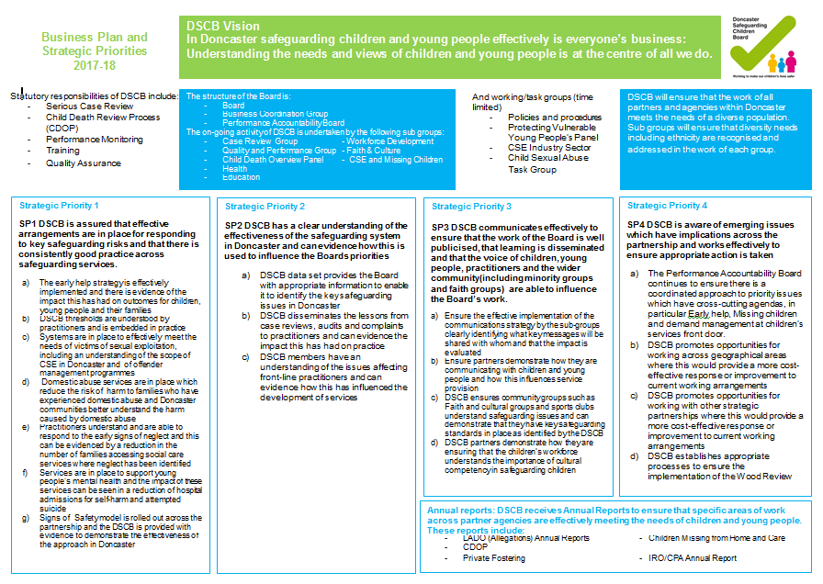

|  |  |
| --- | --- |
| **Glossary of Terms** | |
| AAPSW | Admissions, Attendance and Pupil Welfare Service |
| ACC | Assistant Chief Constable |
| ADs | Assistant Directors |
| ALMO | Arms-Length Management Organisation |
| ASB | Anti-Social Behaviour |
| ASD | Autistic Spectrum Disorder |
| ASDAN | Award Scheme Development and Accreditation Network |
| ASYE | Assessed Support Year in Education |
| AQRs | Area Quality Reviews |
| C&F | Child and Family |
| CAFCASS | Children and Family Court Advisory and Support Service |
| CAMHS | Children and Mental Health Service |
| CCG | Clinical Commissioning Group |
| CCP | Complex Cases Panel |
| CCPAS | Churches Child Protection Advisory Service |
| CDOP | Child Death Overview Panel |
| CEOP | Child Exploitation Online Protection |
| CHAP | Childrens Health and Protection Team |
| CIC | Children in Care |
| CIN | Child in Need |
| CLA | Child Looked After |
| Cllr | Councillor |
| CME | Children Missing Education |
| CMOG | Children Missing Operational Group |
| CMT | Corporate Management Team |
| CP | Child Protection |
| CPB | Corporate Parenting Board |
| CPP | Child Protection Plan |
| CQC | Care and Quality Commission |
| CRC | Community Rehabilitation Company |
| CRG | Case Review Group |
| CSE | Child Sexual Exploitation |
| CQC | Care Quality Commission |
| CWD | Children with Disabilities |
| CYPP | Children and Young People’s Plan |
| DA | Domestic Abuse |
| DANs | Domestic Abuse Navigators |
| DASH | Domestic Abuse, Stalking, Harassment and Honour Based Violence |
| DBTH | Doncaster Bassetlaw Hospital Foundation Trust |
| DCCG | Doncaster Clinical Commissioning Group |
| DfE | Department of Education |
| DMBC | Doncaster Metropolitan Borough Council |
| DoLS | Deprivation of Liberty Safeguards |
| DRASACS | Doncaster Rape & Sexual Abuse Counselling Service |
| DRI | Doncaster Royal Infirmary |
| DSAB | Doncaster Safeguarding Adults Board |
| DSCB | Doncaster Safeguarding Children Board |
| DCST | Doncaster Childrens Services Trust |
| DVA | Domestic Violence and Abuse |
| GP | General Practitioner |
| eCAF | Electronic Common Assessment Framework |
| ED | Emergency Department |
| EH | Early Help |
| EHA | Early Help Assessment |
| EHC | Education, Health and Care |
| EHE | Elected Home Education |
| EHITG | Early Help Implementation Task Group |
| EHM | Early Help Module |
| EMTAS | Ethnic Minority and Traveller Achievement Service |
| EWO | Education Welfare Officer |
| F4C | Foundation for Change |
| F&C | Faith and Culture |
| FCAs | Family Court Advisors |
| FGM | Female Genital Mutilation |
| FJYPO | Family Justice Young People’s Board |
| FM | Forced Marriage |
| FOI | Freedom of Information |
| GRT | Gypsy Roma and Traveller |
| HMPS | Her Majesty Prison Service |
| HMIC | Her Majesty’s Inspectorate of Constabulary |
| HMIC HBV | Her Majesty’s Inspectorate of Constabulary Honour Based Violence |
| HMIC JESIP | Joint Emergency Services Interoperability Principles |
| HMIC PEEL | Her Majesty’s Inspectorate of Constabulary Police Effectiveness Efficiency and Legitimacy Programme |
| HMIC VIPC | Her Majesty’s Inspectorate of Constabulary Vulnerability in Police custody |
| HR | Human Resources |
| IDVA | Independent Domestic Abuse Advisor |
| IFA | Independent Fostering Association |
| IFST | Intensive Family Support Team |
| IRO | Independent Reviewing Officer |
| IT | Information Technology |
| KCSIE | Keeping Children Safe in Education |
| LAC | Looked after Child |
| LOCYP | Learning and Opportunities: Children and Young People Directorate |
| L&I | Learning & Improvement |
| LA | Local Authority |
| LAC | Looked After Child |
| LADO | Local Authority Designated Officer |
| LDD | Learning Disabilities and Difficulties |
| LeDeR | Learning Disabilities Mortality Review |
| LGA | Local Government Association |
| LGBT | Lesbian Gay Bisexual and Transgender |
| LL | Liquid Logic |
| LOCYP | Learning and Opportunities for Children and Young People |
| LSCB | Local Safeguarding Children Board |
| LSOA | Lower Layer Super Output Area |
| MCA | Mental Capacity Act |
| MDT | Multi-Disciplinary Team |
| MOJ | Ministry of Justice |
| MALAP | Multi Agency Looked After Panel |
| MAPPA | Multi Agency Public Protection Arrangements |
| MARAC | Multi Agency Risk Assessment Conference |
| MASH | Multi Agency Safeguarding Hub |
| MISPER | Missing Person |
| MPACT | Moving Parents and Children Together |
| MST | Multi Systemic Therapy |
| NCALT | National Centre for Applied Learning Technologies |
| NEET | Not in Education, Employment or Training |
| NFA | No Further Action |
| NHS | National Health Service |
| NPS | National Probation Service |
| NSPCC | National Society for the Prevention of Cruelty to Children |
| NQTs | Newly Qualified Teachers |
| OASys | Offender Assessment System |
| OMT | Operational Management Team |
| OOA | Out of Authority |
| OSMC | Overview Scrutiny Management Committee |
| PAB | Performance Accountability Board |
| PACE | Police and Criminal Evidence |
| PAFSS | Parenting and Families Support Service |
| PbR | Payments by Request |
| PEP | Personal Education Plan |
| PGCE | Postgraduate Certificate in Education |
| PLRs | Performance Learning Reviews |
| PVI | Public Voluntary Industry |
| PVYP | Preventing Vulnerable Young People |
| QA | Quality Assurance |
| Q&P | Quality and Performance |
| R&R | Referral and Response Service |
| RAMs | Resources Allocation Meetings |
| RDaSH | Rotherham Doncaster and South Humber |
| PLO | Public Law Outline |
| SBU | Safeguarding Business Unit |
| SCR | Serious Case Review |
| SCPHN | Specialist Community Public Health Nurse |
| SEND | Special Educational Needs and Disability |
| SHOs | Senior Housing Nurse |
| SLHD | St Leger Homes of Doncaster |
| SMT | Senior Management Team |
| SoS | Signs of Safety |
| SP | Strategic Priority |
| SSDP | Safer Stronger Doncaster Partnership |
| SY | South Yorkshire |
| SYCRC | South Yorkshire Rehabilitation Company |
| SYEP | South Yorkshire Empower and Protect |
| SYF&R | South Yorkshire Fire and Rescue Service |
| SYP | South Yorkshire Police |
| SYTP | South Yorkshire Teaching Partnership |
| TAC | Team around the Child |
| TPAS | Tenants Participation Advisory Service |
| YAS | Yorkshire Ambulance Service |
| YH | Yorkshire and Humber |
| YOS | Youth Offending Service |
| VAA | Voluntary Adoption Agency |
| VAF | Vulnerability Assessment Framework |
| VCS | Voluntary and Community Support |
| VS | Virtual School |
| WAFH | Work After First Hearing |
| WRAP | Workshop to Raise Awareness of Prevent |
| YGAM | Young Gamblers Education Trust |
| YJB | Youth Justice Board |
| YWCA | Young Women’s Centre Association |